Special Educational Needs and Disabilities (SEND) Information Report
Charlton CE Primary School



Inclusion Team
SEND Governor:
Sue Vick

SENCO
Kat Martin
senco@charltonprimary.school

Approved by: | Kat Martin | Date: September 2026
Last reviewed on: | September 2026
Next statutory review due by: | September 2027

Contents
1. What types of SEND does the school provide for? 4
2. Which staff will support my child? 5
3. What should I do if I think my child has SEND? 7
4. What happens if the school identifies a need? 8
5. How will the school measure my child’s progress? 9
6. How will I be involved in decisions made about my child’s education? 10
7. How will my child be involved in decisions made about their education? 11
8. How will the school adapt its teaching for my child? 11
9. How will the school evaluate whether the support in place is helping my child? 13
10. How will the school ensure my child has appropriate resources? 13
11. How will the school make sure my child is included in activities alongside pupils who don’t have SEND? 14
12. How does the school make sure the admissions process is fair for pupils with SEN or a disability? 14
13. How does the school support pupils with disabilities? 15
14. How will the school support my child’s mental health and emotional and social development? 15
15. What support is in place for looked-after and previously looked-after children with SEN? 16
16. What support will be available for my child as they transition between classes or settings or in preparing for adulthood? 17
17. What support is available for me and my family? (Local Offer) 17
18. What should I do if I have a complaint about my child’s SEND support? 19
19. Supporting Documents…………………………………………………………………………………………………………….19
20. Glossary 20

Dear parents and carers,
The aim of this Information Report is to explain how we implement our SEND policy. In other words, we want to show you how SEND support works in our school.
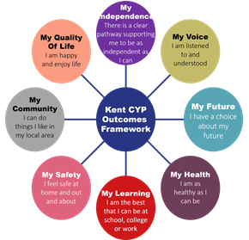
As educational professionals, we are all working towards the ultimate goal of growing independent young people as they prepare for adulthood. All provision and support we provide is working towards achieving the Kent Children and Young People (CYP) Outcomes Framework:

If you want to know more about our arrangements for SEND, read our SEND policy alongside this Information Report.
You can find our SEND policy on our website Policies | Charlton Church of England Primary School
Note: If there are any terms we’ve used in this information report that you’re unsure of, you can look them up in the Glossary at the end of the report.

1. What types of SEND does the school provide for?

Our school provides for pupils with the following needs (as outlined in the SEND Code of Practice 2015):

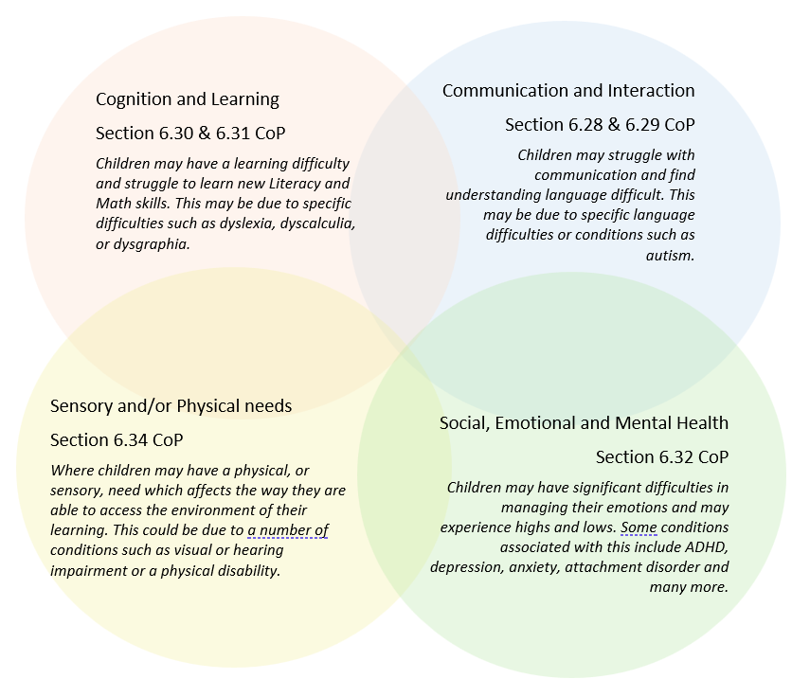
Often you will find that children’s needs overlap and are rarely confined to one area of need, which is why it is important to gain a wholistic overview of your child.
More information about the Areas of Need can be found in the Special educational needs and disability code of practice: 0 to 25 years (link below).
SEND_Code_of_Practice_January_2015.pdf (publishing.service.gov.uk)


2. Which staff will support my child, and what are their key responsibilities?

At Charlton CE Primary School all staff are considered responsible for supporting the needs of pupils with SEND. Our staff are committed to regular, high-quality training to ensure that they have the knowledge and skills to better meet a wide range of pupil needs.
Below outlines key staff who will be supporting your child. Please note that this list is not exhaustive.
Our Special Educational Needs Co-ordinator, or SENCO
The named SENCO is Kat Martin. She can be contacted via the school office, Class Dojo or via email at senco@charltonprimary.school
Kat is a qualified teacher and she has many years’ experience working with children with SEN: including working in specialist provisions.
Kat is currently working towards receiving a nationally recognised SENCO qualification. She has also engaged in a range of training in areas relevant to the role of SENCO: including Safeguarding Training.
Class/subject teachers
All of our teachers SEN training both in-house and from external specialists. Our staff are guided and supported by the SENCO to meet the needs of pupils who have SEN.
Previously, staff have received recent training in the TEACCH approach, Language through Colour, ACES and training from the Autism Education Trust and Inclusive Sport. More recently, all staff have had Speech and Language training through The Balanced System and De-escalation training through STLS (Specialist Teaching and Learning Services).

Teaching assistants (TAs)
We have a team of 11 TAs, including one higher-level teaching assistants (HLTAs) who are trained to deliver and support SEN provision. We are also fortunate to have a SEN Assistant, a Pastoral Lead and a Play Therapist. Our Pastoral Lead is responsible for our Nurture Team and ELSA.
We are very fortunate that a number of our teaching assistants are trained to deliver specific interventions such as Fizzy, Clever Hands, Sensory Circuits, Brick by Brick training and Attention Autism.
In the last academic year, TAs have been trained in Nurture UK, De-escalation training, Intensive Interaction, Attention Autism and Brick by Brick training. There is an extensive list of training last Tas have received.
We also have two therapy dogs, Rosa and Mavis.

External agencies
Sometimes we seek additional support to offer our pupils the provision that they need. Whenever necessary we will work with external support services to meet the needs of our pupils with SEND and to support their families. These services may include:

- Child and Young Person’s Mental Health Services (CYPMHS)
- Education welfare officers
- Emotional Wellbeing Team (EWT)
- Educational psychologists
- GPs or paediatricians
- NELFT practitioners
- Occupational therapists
- Therapeutic practitioners such as a Play Therapist
- Safeguarding services
- School Liaison Officer
- Kent School Health
- SALUS Therapeutic Services
- SEND Inclusion Advisor
- Specialist Teacher Service
- Speech and language therapists (The Balanced System)

- Voluntary sector organisations such as Samphire, Oasis, Kooth, Migrant Help and

3. What should I do if I think my child has SEND?

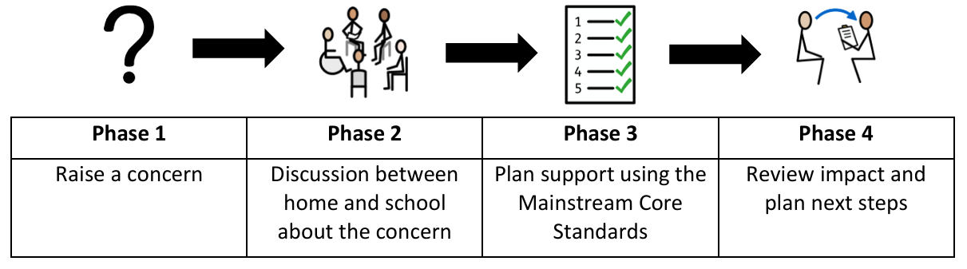

Phase 1 | If you think your child might have SEND, first raise your concern with your child’s Class Teacher who will ensure that the SENCO is aware.  Alternatively, you can contact the SENCO directly via email senco@charltonprimary.school.
Phase 2 | We will meet with you to discuss your concerns and try to get a better understanding of what your child’s strengths and difficulties are. Together we will decide what outcomes to seek for your child and agree on next steps. We will make a note of what’s been discussed and add this to your child’s record.
Phase 3 | We will implement the agreed strategies and monitor these over an agreed period of time. These are likely to be universal strategies set out in the mainstream core standards. A copy of this can be found here: https://www.kelsi.org.uk/__data/assets/pdf_file/0005/117257/Special-educational-needs-mainstream-core-standards-guide-for-parents.pdf . This will initiate the ‘Graduated Approach’ where support will be continually reviewed. See next page for more details.
Phase 4 | If we decide that your child needs SEND support, we will formally notify you and your child will be added to the school’s SEND register. They will receive additional support and this will be reviewed using the assess, plan, do, review model.

4. What happens if the school identifies a need?
The same process is followed if a concern is raised by the school.
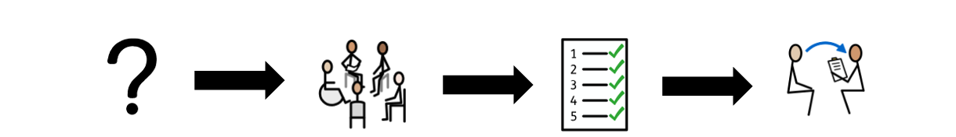
Phase 1 | Phase 2 | Phase 3 | Phase 4
Raise a concern | Discussions between professionals and recommendations advised | Implement strategies and advise | Review impact of the strategies and plan next steps.

All our class teachers are responsible for the monitoring of their pupils who have been identified as having SEND. They also review those who are not making the expected level of progress across the curriculum and during unstructured times. This might include reviewing children’s learning in key curriculum areas such as reading, writing and math. It may also include observations or by using questionnaires linked to key developmental areas such as communication and interaction or a child’s physical development. Pupil Progress Meetings and PiXL resources (our school assessment tool) are also used to identify children who may require additional support across the four broad areas of need.
If the teacher notices that a pupil is having difficulties, they will use various assessment for learning tools to discover if the pupil has any gaps in their learning. If a gap is discovered, the school will provide the appropriate support. Pupils who don’t have SEND usually make progress quickly once the gap in their learning has been filled.
If the pupil is still finding it difficult to make the expected progress, despite additional support, the teacher will talk to the SENCO to discuss further support. At this stage, the school will contact you to discuss the possibility that your child has SEND, and the school will follow the graduated approach (see below).

5. How will the school measure my child’s progress?

We will follow the ‘graduated approach’ to meeting your child’s SEND needs.
The graduated approach is a 4-part cycle of assess, plan, do, review.
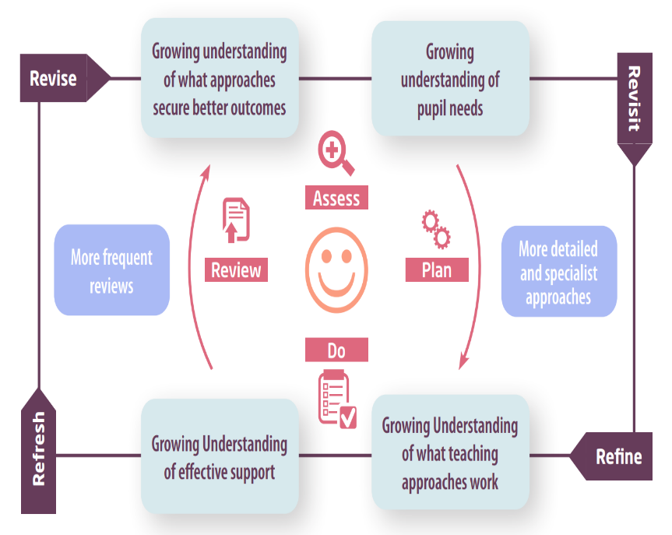

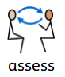 | If your child is not making the expected level of progress, we will make an assessment to find out what strengths and difficulties your child has. We will ask for you and your child’s input, as well as getting help from external professionals where necessary.
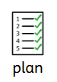 | In discussion with you and your child, we will decide what outcomes we are hoping to achieve. We will make a plan of the support we will offer your child to help them meet those outcomes. We will make a record of this and share it with you and all relevant school staff.
 | We will put our plan into practice.  The class teacher, with the support of the SENCO, will be responsible for working with your child on a daily basis, and making sure the support we put in place is having the impact we intended.
 | We will assess how well the support we put in place helped the pupil to meet the outcomes we set. We will use our improved understanding of your child’s needs to improve the support we offer; this may mean the Plan, Assess, Do, Review cycle continues.


6. How will I be involved in decisions made about my child’s education?

Each year, we will provide an annual written report on your child's progress.
In addition to the written report, a member of staff who knows your child well will meet you at least three times a year, to:
- Set clear outcomes for your child’s progress
- Review progress towards those outcomes
- Discuss the support we will put in place to help your child make that progress
- Identify what we will do, what we will ask you to do, and what we will ask your child to do
The SENCO may also attend these meetings to provide extra support where appropriate.
We know that you are the expert when it comes to your child’s needs and aspirations. With this in mind, we want you to have a full understanding of the provision that is in place to support your child. We know that you’re the expert when it comes to your child’s needs and aspirations. We want to make sure you have a full understanding of how we’re trying to meet your child’s needs, so that you can provide insight into what you think would work best for your child.

We also want to hear from you as much as possible so that we can build a better picture of how the SEND support we are providing is impacting your child outside of school.
If your child’s needs or aspirations change at any time, please let us know so we can keep our provision as relevant as possible.
If you have concerns that arise between these meetings, please contact your child’s class teacher via Class Dojo or the school office. You can also contact the SENCO, Kat Martin via email senco@charltonprimary.school.

7. How will my child be involved in decisions made about their education?

The level of involvement will depend on your child’s age and individual needs. We recognise that no two pupils are the same, so we will decide on a case-by-case basis, with your input.
We may seek your child’s views by asking them to:
- Attend meetings to discuss their progress and outcomes
- Prepare a presentation, written statement, video, drawing, etc.
- Discuss their views with a member of staff who can act as a representative during the meeting
- Complete a pupil voice survey


8. How will the school adapt its teaching for my child?

Your child’s teacher is responsible and accountable for the progress and development of all the pupils in their class.
High-quality teaching is our first step in responding to your child’s needs. We will make sure that your child has access to a broad and balanced curriculum in every year they are at our school.
We will adapt our approaches to how we teach to suit the way the pupil works best. There is no 'one size fits all’ approach to adapting the curriculum, we work on a case-by case basis to make sure the adaptations we make are meaningful to your child and are guided by the Mainstream Core Standards in the first instance.
These adaptations may include:
- Class Teachers may adapt their in-class provision, for example, giving longer processing times, pre-teaching of key vocabulary, opportunities to overlearn new concepts, reading instructions aloud and learning breaks.
- Class Teachers and Teaching Assistants support learning by working with groups of children. These groups are varied to include all children, ensuring all children have access to the teacher and TA throughout the day.
- Class Teachers may include pupils on individual and class provision maps to record and monitor outcomes.
- Involvement of outside agencies to support individual need as appropriate, such as speech and language provision.
- Adapting our resources and staffing
- Using recommended aids, such as laptops, coloured overlays, visual timetables, larger font, etc.
- Scaffolding lesson materials

A copy of our accessibility policy can be found here: Policies | Charlton Church of England Primary School

In additional to our classroom adaptations, we may also provide the following interventions:
- Sensory Circuits
- Heavy Work
- Attention Autism
- Fizzy
- Clever Hands
- Brick by Brick
- Speech and Language
- ELSA
- Nurture UK
- Precision Teaching

At Charlton CE Primary, we are passionate about promoting independence as a vital life skill and, where possible, we encourage this across our curriculum and school day. However, we understand that some children, despite intervention, require a higher level of support. In this instance, Teaching Assistants will support children who are otherwise unable to access the curriculum or our daily routines. Typically, the children who require a higher level of support have an EHCP. But, not all children with an EHCP require the individual support of an adult. Where there is a concern around a child’s progress, they will typically be supported in a small group.

These interventions are part of our contribution to Kent County Council’s local offer.

9. How will the school evaluate whether the support in place is helping my child?
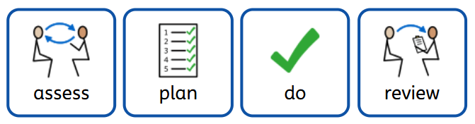
We will evaluate the effectiveness of provision for your child by:
- Reviewing their progress towards their goals each term
- Reviewing the impact of interventions after 6-12 weeks depending on the intervention
- Using pupil questionnaires
- Using relevant questionnaires and assessments
- Monitoring by the SENCO
- Using provision maps to measure progress
- Holding an annual review (if they have an education, health and care (EHC) plan)

10. How will the school ensure my child has appropriate resources?
It may be that your child’s needs mean we need to provide additional resources such as:
- Additional resources to support their learning
- Adaptations to in class support
- Further training for our staff
- External specialist expertise
Where appropriate, we will consult with external agencies to get recommendations on what will best help your child access their learning and use our best endeavours to ensure these are supplied. If it is deemed appropriate High Needs Funding (HNF) may be sought to further secure interventions and resources for children.

11. How will the school make sure my child is included in activities alongside pupils who don’t have SEND?


The expectation is that all schools providing an inclusive provision for all pupils. It may be necessary for some pupils to receive interventions in addition to a broad and balanced curriculum.
All of our extra-curricular activities and school visits are available to all our pupils, including our before and after-school clubs.
All pupils are encouraged to go on our school trips, including our residential trip in year 6.
All pupils are encouraged to take part in sports day, school events such as the Nativity or Harvest Festival and trips such as the Pantomime or other trips linked to the learning in class.
No pupil is ever excluded from taking part in these activities because of their SEN or disability and we will make whatever reasonable adjustments are needed to make sure that they can be included.


12. How does the school make sure the admissions process is fair for pupils with SEN or a disability?
Please find a copy of our Admissions Policies here: Policies | Charlton Church of England Primary School

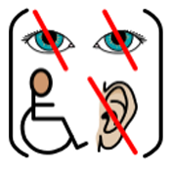
13. How does the school support pupils with disabilities?
See Accessibility Plan for more information: Policies | Charlton Church of England Primary School
You’re disabled under the Equality Act 2010 if you have a physical or mental impairment that has a ‘substantial’ and ‘long-term’ negative effect on your ability to do normal daily activities.

14. How will the school support my child’s mental health and emotional and social development?
We provide support for pupils to progress in their emotional and social development in the following ways:
- Pupils with SEND are encouraged to be part of the School Council
- We have two therapy dogs to support the SEMH needs of pupils
- We provide extra pastoral support for listening to the views of pupils with SEND. We have a Nurture Team and an ELSA
- We run a nurture lunchtimes and nurture sessions for pupils who need extra support with social or emotional development
- We work closely with external agencies such as School Health and the Emotional Wellbeing Team (EWT) to provide SEMH support
- We have a ‘zero tolerance’ approach to bullying. We prevent bullying in the school. Please see our anti-bullying here: https://www.charlton.kent.sch.uk/policies/
- Personal Social Health Education (PSHE) lessons and assemblies develops personal and social skills within all children.
- Parent consultations provide opportunities to discuss the well-being of each child alongside their academic progress.

15. What support is in place for looked-after and previously looked-after children with SEND?


Amy Moat, the Deputy Headteacher, is our designated teacher. She will make sure that all teachers understand how a looked-after or previously looked-after pupil’s circumstances and their SEND might interact, and what the implications are for teaching and learning.
Pupils who are looked-after or previously looked-after will be supported much in the same way as any other child who has SEND. However, looked-after pupils will also have a personal education plan (PEP). We will make sure that the PEP and any SEND support plans or EHC plans are consistent and complement one another.


16. What support will be available for my child as they transition between classes or settings or in preparing for adulthood?
Between years
To help pupils with SEND be prepared for a new school year we:
- Ask both the current teacher and the next year’s teacher to attend the final pupil progress meeting of the year when the pupil’s SEND is discussed
- Schedule time with the incoming teacher and TAs towards the end of the summer term
- Provide extra transition support, when required, tailored to the individual needs of pupils with SEND
Between schools
When your child is moving on from our school, we will ask you and your child what information you want us to share with the new setting.
Between phases (Primary to Secondary)
The SENCO of the secondary school will come into our school for a meeting with our SENCO. They will discuss the needs of all the pupils who are receiving SEND support.
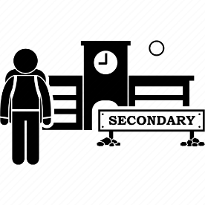
Pupils will be prepared for the transition by:
- Practising with a secondary school timetable
- Learning how to get organised independently
- Plugging any gaps in knowledge
- Attending taster sessions at the secondary school if appropriate

17. What support is available for me and my family?
If you have questions about SEND, or are struggling to cope, please get in touch to let us know. We want to support you, your child and your family.
To see what support is available to you locally, have a look at Kent Local Authority local offer. Kent Local Authority publishes information about the local offer on their website: Special educational needs and disabilities (SEND) - Kent County Council
Our local special educational needs and disabilities information advice and support services (SENDIASS) organisations are: Home | IASK
Local charities that offer information and support to families of pupils with SEND can be found on the link below:
https://www.kent.gov.uk/education-and-children/special-educational-needs/support-services-to-help-families-with-send-children

National charities that offer information and support to families of pupils with SEND are:
- IPSEA
- SEND family support
- NSPCC
- Family Action
- Special Needs Jungle

18. What should I do if I have a complaint about my child’s SEND support?
A copy of our complaints policy can be found here: https://www.charlton.kent.sch.uk/policies/
Complaints about SEND provision in our school should be made to the SENCO in the first instance. They will then be referred to the school’s complaints policy.
If you are not satisfied with the school’s response, you can escalate the complaint. In some circumstances, this right also applies to the pupil themselves.
To see a full explanation of suitable avenues for complaint, see pages 246 and 247 of the SEND Code of Practice.
If you feel that our school discriminated against your child because of their SEND, you have the right to make a discrimination claim to the first-tier SEND tribunal. To find out how to make such a claim, you should visit: https://www.gov.uk/complain-about-school/disability-discrimination
You can make a claim about alleged discrimination regarding:
- Admission
- Exclusion
- Provision of education and associated services
- Making reasonable adjustments, including the provision of auxiliary aids and services
Before going to a SEND tribunal, you can go through processes called disagreement resolution or mediation, where you try to resolve your disagreement before it reaches the tribunal.
Special Educational Needs and Disability - Global Mediation

19. Supporting documents

- Equality Information and Objectives Policy
- Child protection and safeguarding policy
- Behaviour Policy
- Accessibility Plan
- Attendance and punctuality policy
- SEND policy

- SEN & Disabilities Code Of Practice 2015
- Mainstream Core Standards

20. Glossary
- Access arrangements – special arrangements to allow pupils with SEND to access assessments or exams
- Annual review – an annual meeting to review the provision in a pupil’s EHC plan
- Area of need – the 4 areas of need describe different types of needs a pupil with SEND can have. The 4 areas are communication and interaction; cognition and learning; physical and/or sensory; and social, emotional and mental health needs.
- CAMHS – child and adolescent mental health services
- Differentiation – when teachers adapt how they teach in response to a pupil’s needs
- EHC needs assessment – the needs assessment is the first step on the way to securing an EHC plan. The local authority will do an assessment to decide whether a child needs an EHC plan.
- EHC plan – an education, health and care plan is a legally-binding document that sets out a child’s needs and the provision that will be put in place to meet their needs.
- First-tier tribunal/SEND tribunal – a court where you can appeal against the local authority’s decisions about EHC needs assessments or plans and against discrimination by a school or local authority due to SEND
- Graduated approach – an approach to providing SEND support in which the school provides support in successive cycles of assessing the pupil’s needs, planning the provision, implementing the plan, and reviewing the impact of the action on the pupil
- Intervention – a short-term, targeted approach to teaching a pupil with a specific outcome in mind
- Local offer – information provided by the local authority which explains what services and support are on offer for pupils with SEND in the local area
- Outcome – target for improvement for pupils with SEND. These targets don't necessarily have to be related to academic attainment
- Reasonable adjustments – changes that the school must make to remove or reduce any disadvantages caused by a child’s disability
- SENCO – the special educational needs co-ordinator
- SEN – special educational needs
- SEND – special educational needs and disabilities
- SEND Code of Practice – the statutory guidance that schools must follow to support pupils with SEND
- SEND information report – a report that schools must publish on their website, that explains how the school supports pupils with SEND
- SEND support – special educational provision which meets the needs of pupils with SEND
- Transition – when a pupil moves between years, phases, schools or institutions or life stages

