

Charlton CE Primary School

Physical Education Curriculum Booklet
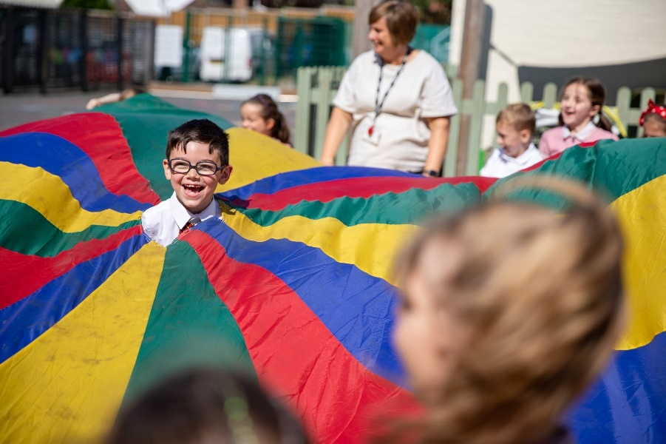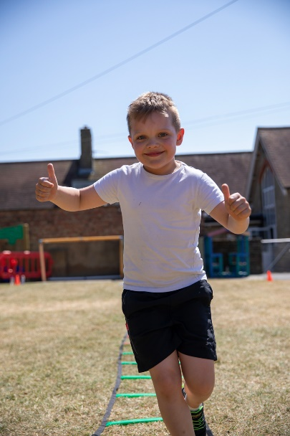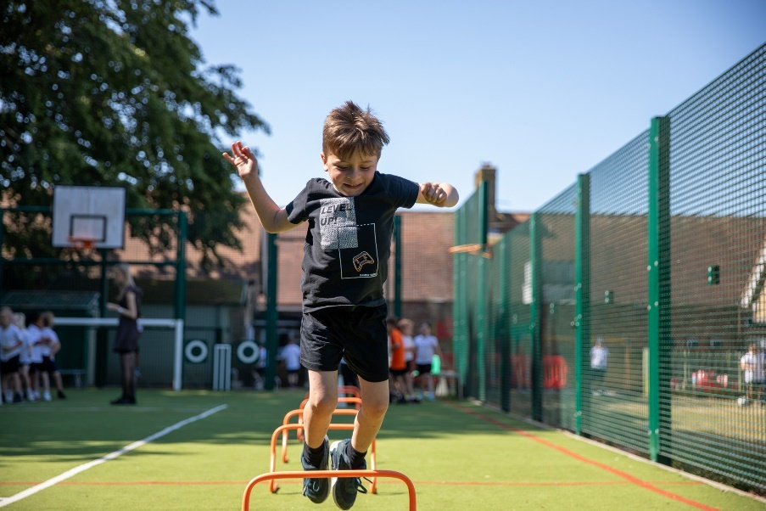

Contents
Page number | Contents
3-7 | Physical Education Vison and Statement of Intent, Implementation and Impact
8-9 | Spiritual, Moral, Social and Cultural Aspects of PE
10 | The Pedagogical Approach –The Spiral Curriculum
11 | The Pedagogical Approach – Cognitive Load Theory
12 | The Pedagogical Approach – Types of Knowledge
13-17 | Subject Leader Action Plan
18 | Sports Premium
10-21 | The Dover Games Sports Partnership Competition Calendar
22-29 | EYFS and The National Curriculum
30 | Enrichment Opportunities
31-33 | Inclusion in PE
34 | Early Years Overview
35 | Curriculum Overview
36 | Sport Specific Curriculum Overview
37-67 | Knowledge Progression
68-84 | Progression of Skills and Assessment
85-89 | Examples of Knowledge organisers
90 | Where to find the evidence

PE Vision, Intent, Implementation and Impact
Vision
Our school vision ‘Transforming lives through God’s embrace’ underpins and guides our vision for the learning opportunities children experience in PE at Charlton CE Primary School.
Today’s society sees our children living more inactive lives, making poorer lifestyle choices and experiencing poor nutrition. These issues could be affecting some of our children. Our locality and the deprivation within our community does not readily provide children with opportunities to be active and in turn raise their health and wellbeing.
Our PE curriculum broadens children’s horizons and transforms them into healthy well-rounded young people. Through sport and being physically active they learn to listen to each other and communicate in order to achieve goals and outcomes. They learn to share, not only equipment but views, ideas, experience and expertise. They learn to be thoughtful of others and their needs, both during team games and when learning as an individual. Children learn the skill of patience, especially when learning new skills or when working with others whose needs and skill level vary from their own. Through physical activity and sport children are encouraging of others and champion each other as well as learning to forgive.
It is important that children receive and have access to regular wider opportunities. This encourages a sense of community beyond school. Children of all ages and abilities have opportunities to participate in after school clubs, competitions and events, as well as forging links with other local sporting organisations and schools. Children also engage in physical activity and sport beyond the core national curriculum offer through opportunities such as, Learning Outside of the Classroom (LOTC).
Being outside, connecting with others and being physically active enables children to connect with their own spirituality. Not only that, through the experience of engaging with our PE curriculum our children can develop their health, wellbeing, emotional intuition and maturity, sense of community and belonging and increase their physical skill level.
Our PE curriculum encourages children to learn new skills, take risks, develop life skills and manage their own feelings and behaviours. We use the Bruner’s theory of learning- The Spiral Curriculum- so that children can form a good foundation of skills and then build upon these. We use our school vision and values, spirituality, the National Curriculum, the Dover School Games principles and the children’s own voices to guide our curriculum design.

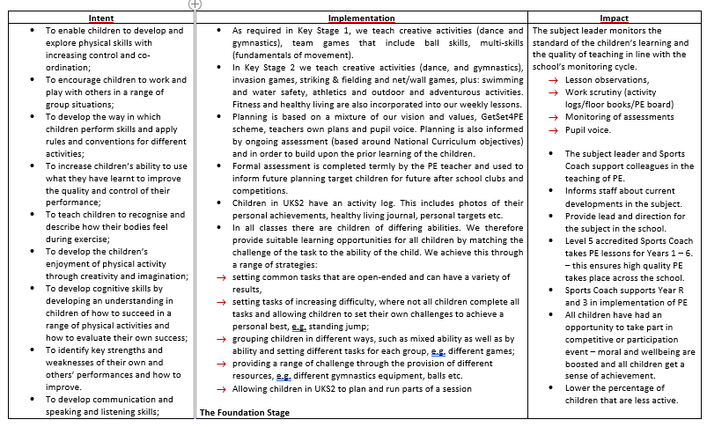
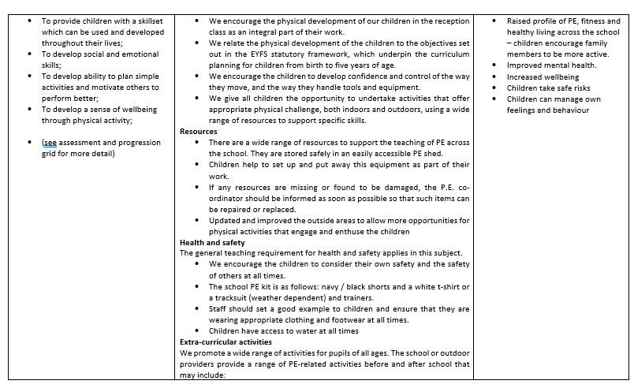

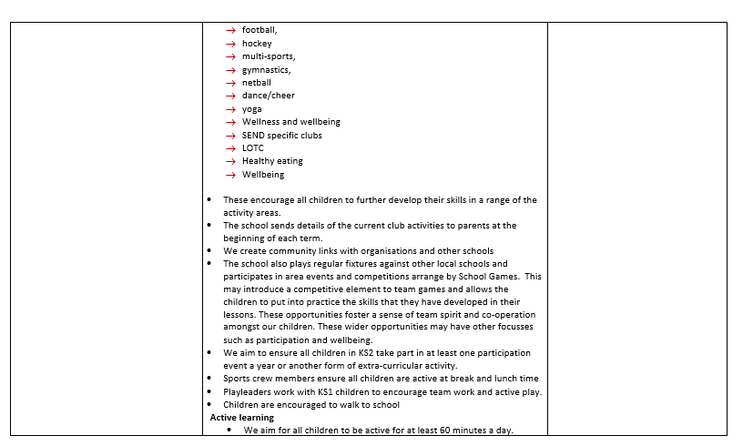
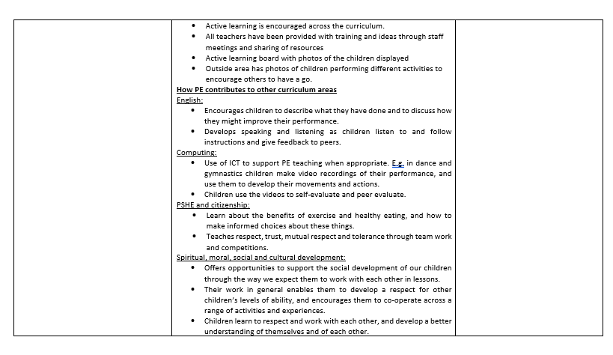
Spiritual, Moral, Social and Cultural Aspects of PE

Spiritual Development in Physical Education
During the range of lessons, clubs and competition our students participate in, our pupils develop a sense of enjoyment and intrigue about themselves and the world around them. Students at Charlton are consistently encouraged to use imagination and creativity in their learning, whilst being questioned and challenged in order to reflect the experiences of themselves and others.

Examples of Spiritual lessons in Physical Education:
- Explore, creativity through producing routines and displays.
- Creating and developing strategies for success within games.
- Reflecting on the impact of their and their peer roles.
- Displaying emotions.
- Questioning of themselves and eachother

Moral Development in Physical Education
Physical Education teaches pupils about sportsmanship. Pupils at Charlton are exposed to sporting etiquette and the impact that sport has on the individual. Students are taught to abide by the rules and regulations, understanding the consequences of their actions in game situations and their consequences on the individual and the team.
Examples of Moral lessons in Physical Education:
- Promote fair play and teamwork in lessons.
- Encourage good sportsmanship throughout.
- Respect the equipment used at all times.
- Following instructions and decisions made by officials/umpires/referees.
- Respecting the school environment.
- Listening to teacher and peer feedback on particular sporting skills.
- Promote trust with peers through team building activities.
- Using students as sports leaders/ambassadors e.g Active Team.

Social Development in Physical Education
Pupils at Charlton use of a range of social skills in different contexts, including working and socialising with pupils from different socio-economic backgrounds and levels of SEN. Pupils show a willingness to participate in a variety of social settings, cooperating well with others and being able to resolve conflicts effectively. Pupils can develop their friendship and social mixing through involvement in inter, intra school competition and extra-curricular clubs.

Examples of Social lessons in Physical Education:
- Developing community within clubs.
- Interact with the community and primary schools through inter school competitions.
- Encourage students to recognise and respect social differences and similarities.
- Celebrate sporting success both in and out of school.
- Use of sports leaders to facilitate activities.
- Encouraging the attendance to extracurricular activities.
- Promoting a collaborative ethos.
- Peer mentoring
- Engaging in community events such as with Dover Athletic.
- Engaging in The Aquila Cup and Aquila Games

Cultural Development in Physical Education
At Charlton we encourage pupils to develop positive attitudes towards different religious, ethnic and socio-economic groups in the local, national and global communities.

Examples of Cultural lessons in Physical Education:
- Learning about the developments of sports in different countries.
- Learning where different sports originate and what national sports are.
- World Cups and Olympic games.
- Exploring and respect a variety of different cultural dances.
- Use of international examples of different athletes and their achievements.
- Considering the cultural significance of sport across the world.
- Engaging in community events such as the Peace Run.

Pedagogical Approach
The Spiral Curriculum
The Spiral curriculum, a concept widely attributed to Jerome Bruner, refers to a curriculum design in which key concepts are presented repeatedly throughout the curriculum, but with deepening layers of complexity, or in different applications. We use scaffolding techniques to ensure that all children can achieve in PE.
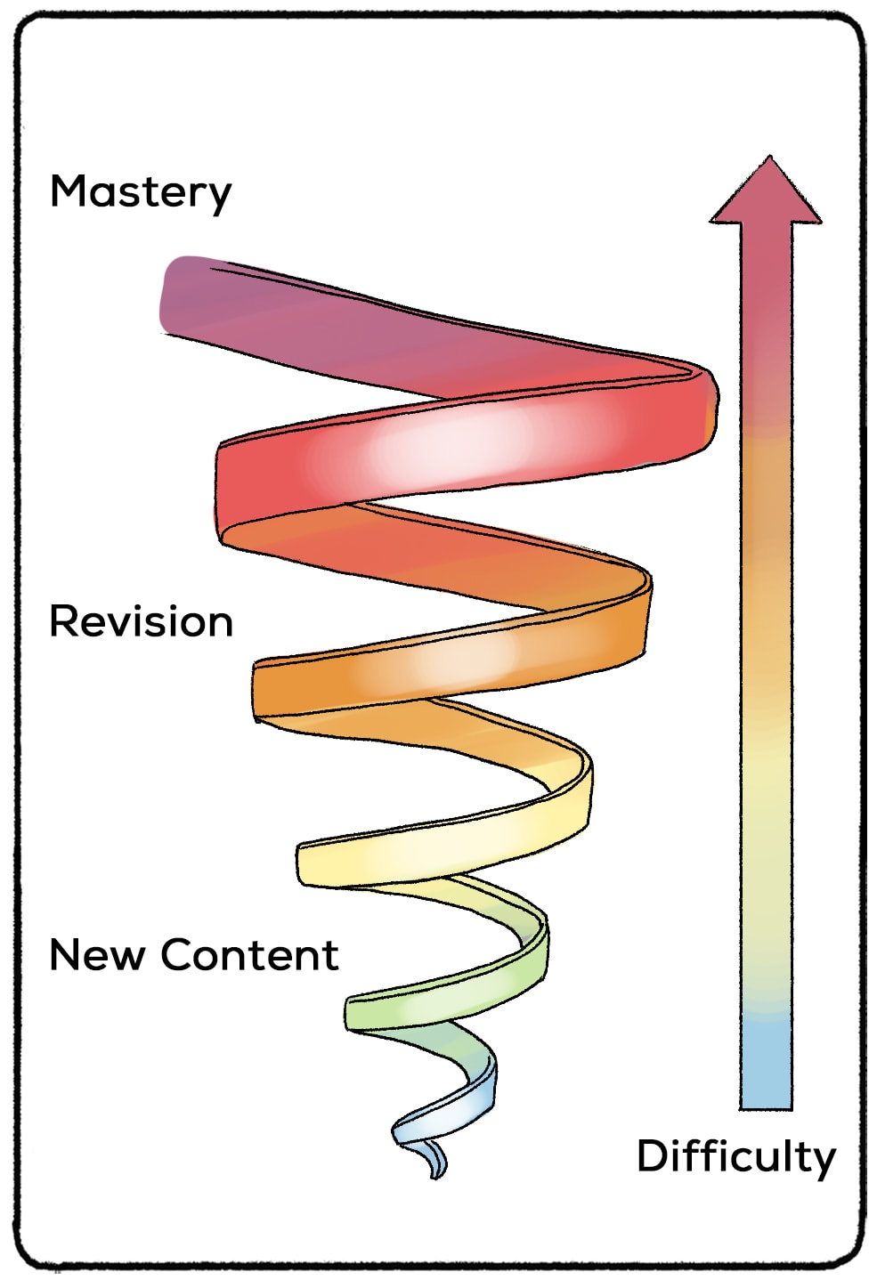

Pedagogical Approach
Cognitive Load Theory
Cognitive Load Theory — aim = to develop instructional techniques that fit within the characteristics of working memory in order to maximise learning.
Based on two principles:
1. There is a limit to how much new information the brain can hold. (Working memory—processing new information results in ‘cognitive load’ which can affect outcomes.)
2. There is no known limit to how much stored information that can be processed at one time. (Long term memory—stores information as schemas.)
Explicit instruction involves teachers clearly showing children what to do, rather than have them construct or discover it for themselves. To lessen cognitive load on working memory. This can be used for new information and learning. Independent learning also needs to be incorporated but with cognitive load managed through guidance, prior information, scaffolds and assistance if needed.
Long term memory relies on the formation of schemas where information can be processed automatically with minimal conscious effort. Automaticity happens after extensive practice. Thus, reducing working memory load. If working memory is overloaded, there is greater risk that the content will not be understood, be confused and not stored into the long-term memory. Ultimately, learning will be slowed down. Automation of schemas reduces the burden on working memory because when information can be accessed automatically, the working memory is freed up to process new information.
There are 3 types of Cognitive load—Intrinsic, Extraneous and Germane
Intrinsic —difficulty of subject matter being learnt; it depends on the complexity of the material and the prior learning—i.e. different people will have different levels of cognitive load depending on their experiences and knowledge.
Extraneous — how the subject matter is taught—we need to minimise extraneous cognitive load to free up working memory.
Germane—the load imposed on the working memory by the process of learning i.e. by transferring information into long-term memory through schema construction.

Pedagogical Approach
Types of Knowledge
Adapted from Ofsted: Research and Review Series: PE
‘In PE, pupils learn increasingly intelligent movement and important knowledge that can reduce barriers to participation and inform their own healthy, active lifestyle choices. PE provides a gateway into the world of sport and participation.’

Knowledge in PE can be split into two sections, declarative knowledge (knowing what) and procedural knowledge (knowing how). Both forms of knowledge, declarative and procedural, are vitally important in ensuring pupils are physically educated. Pupils need to be taught what the links are between declarative and procedural knowledge and apply to both their learning and participation in activities. Without the declarative knowledge of movement, rules, strategies, tactics and healthy participation pupils may not be able to fully engage critically in physical activity and instead just perform physically, therefore not enriching their experiences.

Declarative Knowledge - Declarative knowledge in PE is the factual knowledge concerning movement, rules, tactics, strategies, health and participation. It is important for the declarative knowledge to be linked to the content that is being taught in the lessons because it is not enough to physically educate pupils on its own. Declarative knowledge can be communicated though verbal or written means either as question and answers of as an observation of an activity. When pupils have a strong foundation of declarative knowledge, they can better verbalise their strengths and limitations as well as communicating their ideas, decisions and choices during an activity or an observation of one.

Procedural Knowledge - Procedural knowledge is knowing how to apply declarative knowledge. Procedural knowledge is applying the declarative knowledge into practice during participation in physical education lessons. Procedural knowledge is best gained through practice through physical demonstration or physical participation.

Subject Leader Action Plan

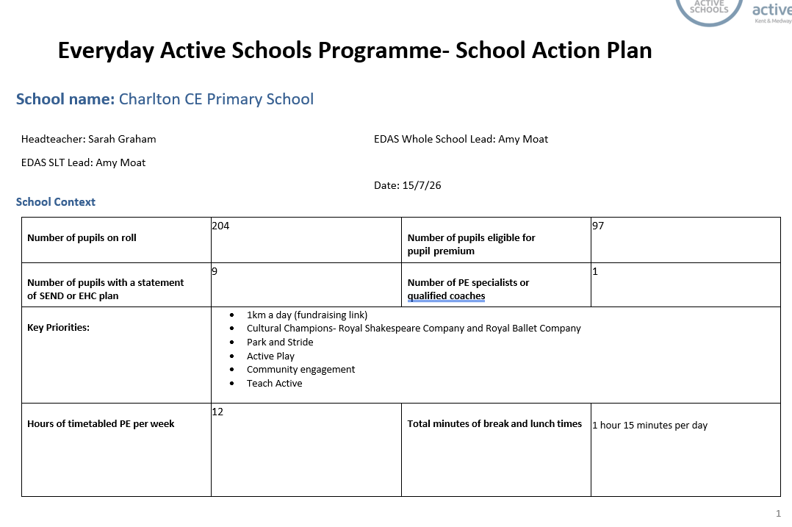

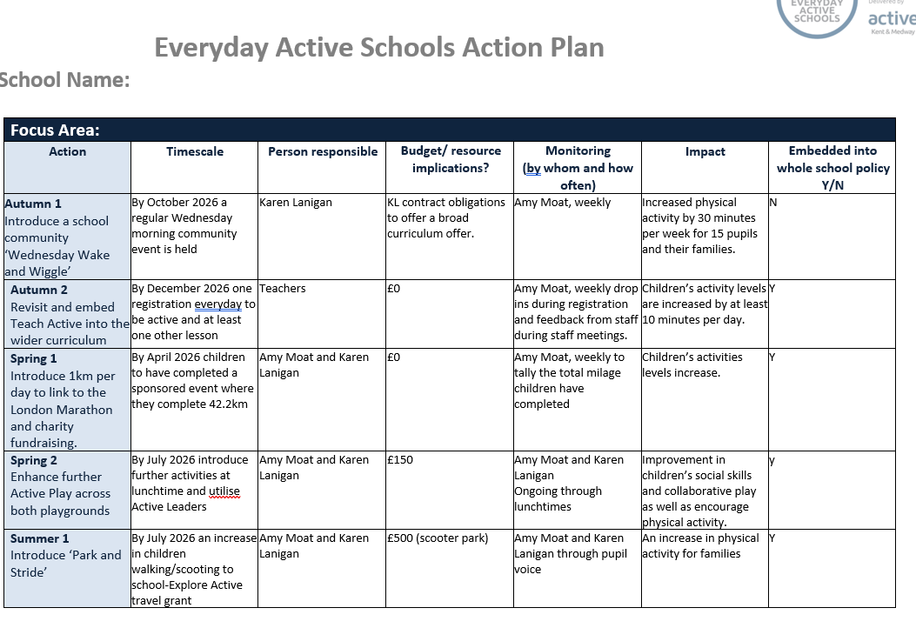

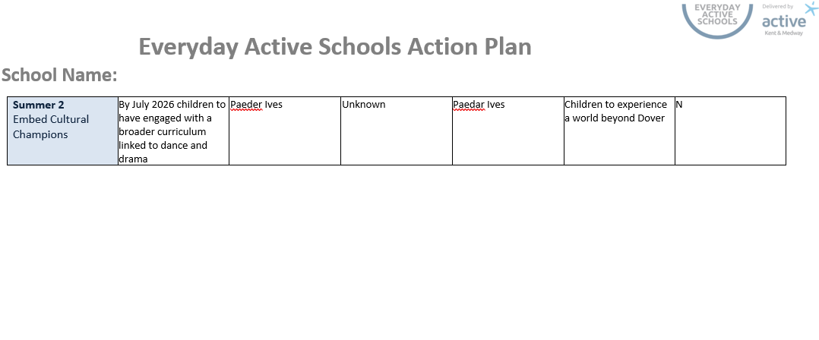

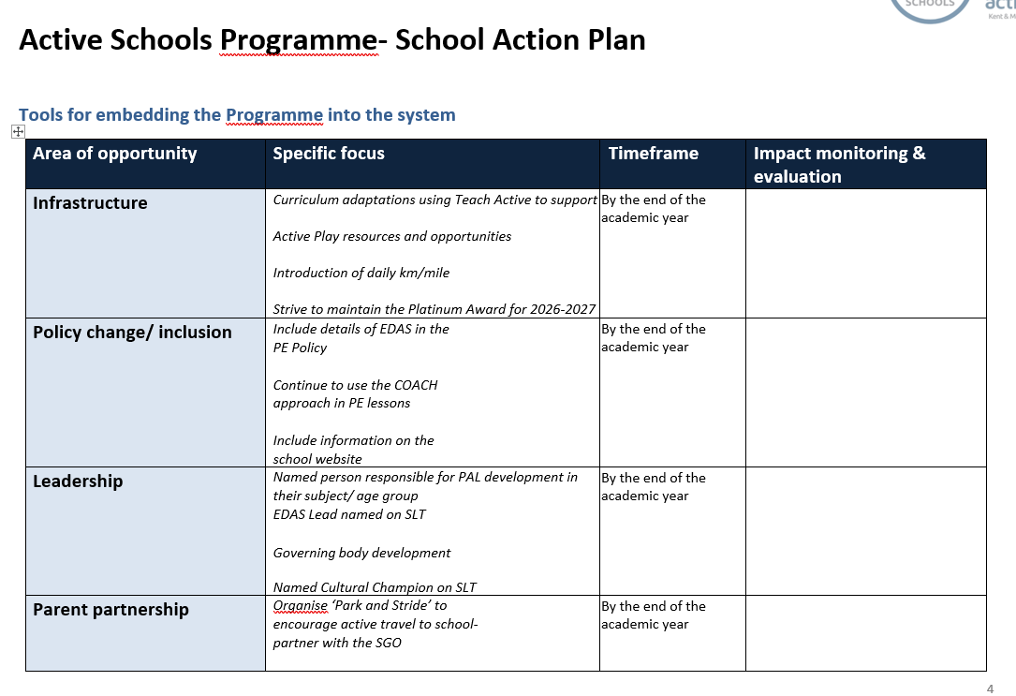
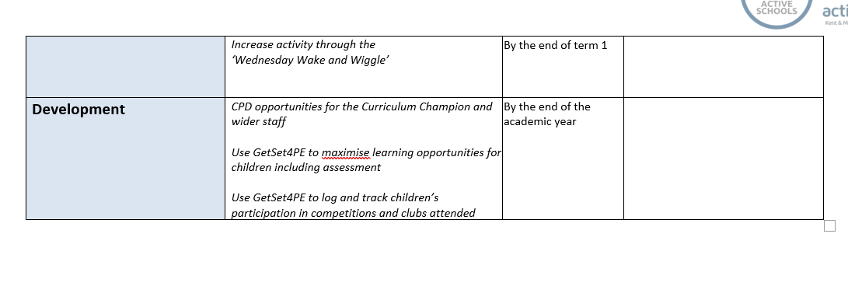

Sports Premium at Charlton CEP School

Charlton Church of England Primary School - Sports Premium

The link above takes you to the school web page which contains all the information about Sports Premium and the spending

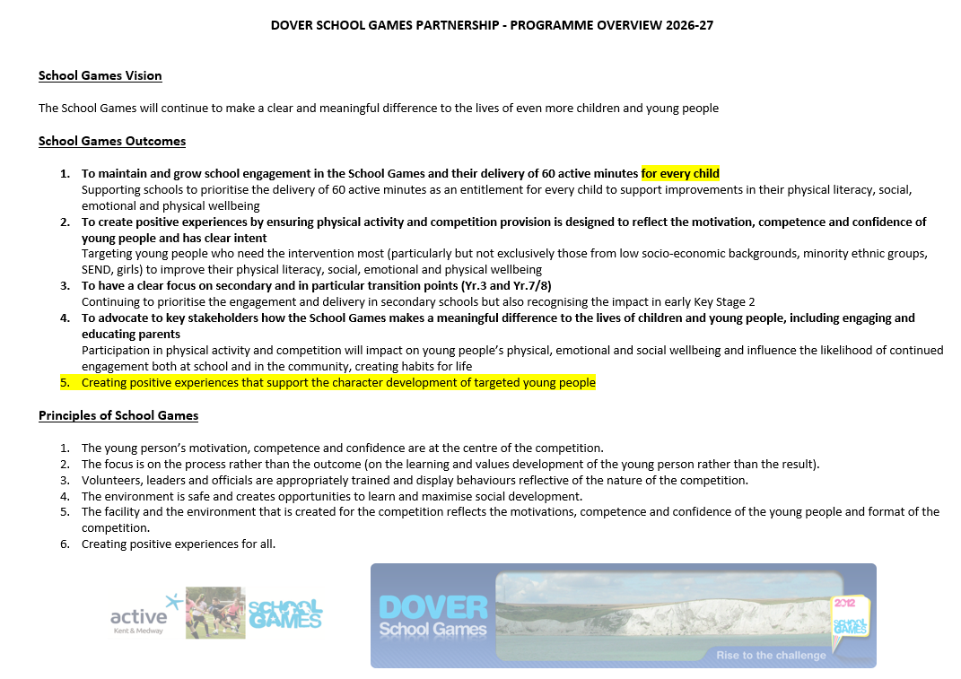
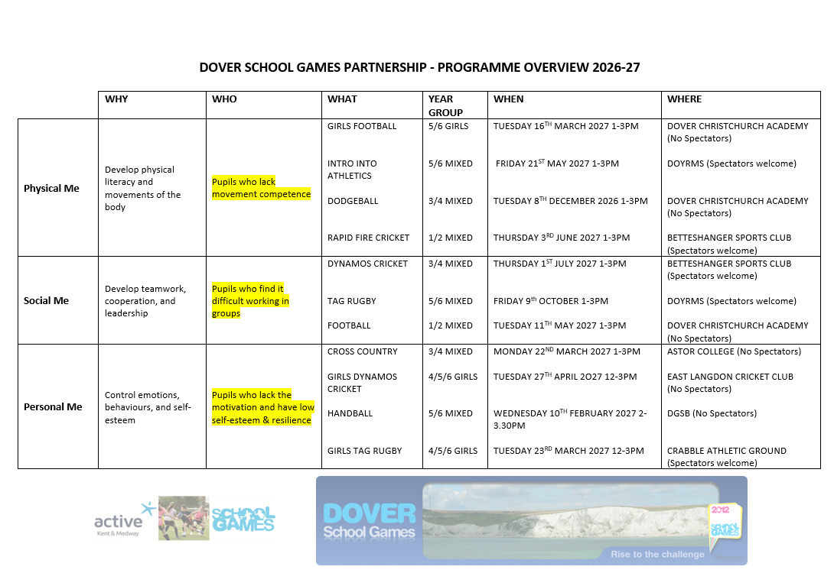
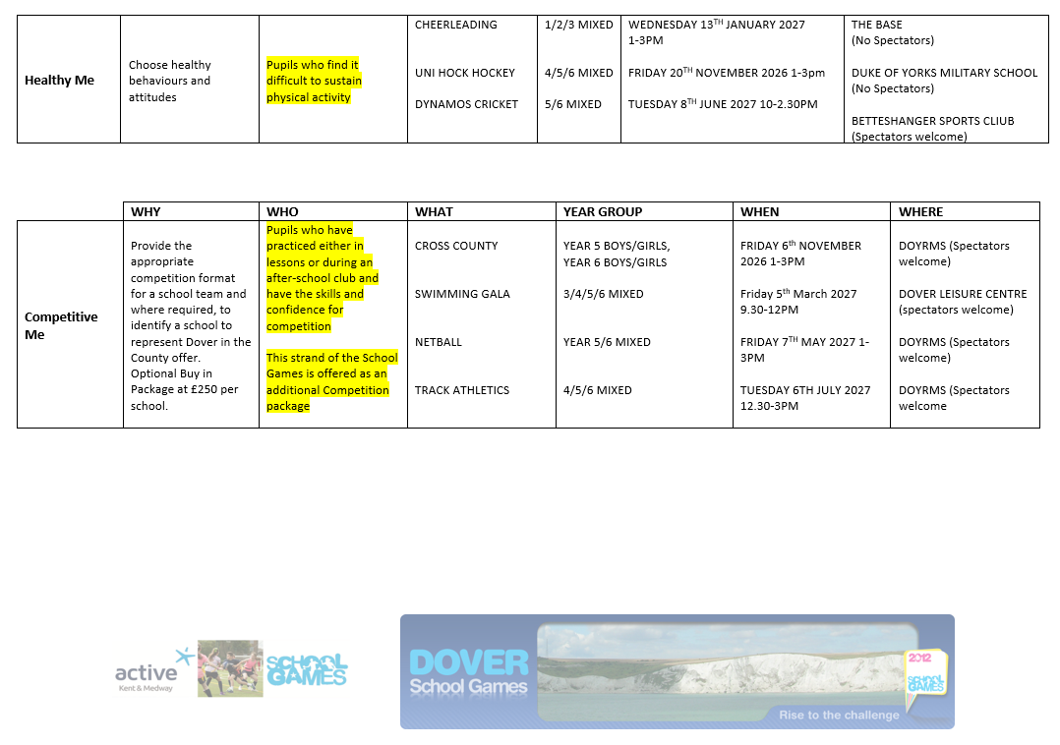

Physical Education – EYFS Statutory Framework 2023 and The National Curriculum
ELG: Self-Regulation
Children at the expected level of development will: - Show an understanding of their own feelings and those of others, and begin to regulate their behaviour accordingly; - Set and work towards simple goals, being able to wait for what they want and control their immediate impulses when appropriate; - Give focused attention to what the teacher says, responding appropriately even when engaged in activity, and show an ability to follow instructions involving several ideas or actions.
ELG: Managing Self
Children at the expected level of development will: - Be confident to try new activities and show independence, resilience and perseverance in the face of challenge; - Explain the reasons for rules, know right from wrong and try to behave accordingly; - Manage their own basic hygiene and personal needs, including dressing, going to the toilet and understanding the importance of healthy food choices.
ELG: Building Relationships
Children at the expected level of development will: - Work and play cooperatively and take turns with others; - Form positive attachments to adults and friendships with peers; - Show sensitivity to their own and to others’ needs. Physical Development
ELG: Gross Motor Skills
Children at the expected level of development will: - Negotiate space and obstacles safely, with consideration for themselves and others; - Demonstrate strength, balance and coordination when playing; - Move energetically, such as running, jumping, dancing, hopping, skipping and climbing.
ELG: Fine Motor Skills
Children at the expected level of development will: - Hold a pencil effectively in preparation for fluent writing – using the tripod grip in almost all cases; - Use a range of small tools, including scissors, paint brushes and cutlery; - Begin to show accuracy and care when drawing.
Characteristics of effective learning:
Playing & Exploring - Engagement |  | Active Learning - Motivation |  |  | Creating & Thinking Critically - Thinking
- Finding out & exploring  - Playing with what they know  - Being willing to ‘have a go’ |  | - Being involved & concentrating  - Keep on trying  - Enjoying achieving what they set out to do |  |  | - Having their own ideas (creative thinking)  - Making links (building theories)  - Working with ideas (critical thinking
ELG
- Negotiate space & obstacles safely, with consideration for themselves & others
- Demonstrate strength, balance & coordination when playing
- Move energetically, such as running, jumping, dancing, hopping, skipping & climbing
- Discusses the effect exercise/activity has on their body.
- Knows some healthy choices we can make with regard to physical activity, food, sleep and hygiene (including oral hygiene)
- Holds a pencil effectively in preparation for fluent writing – using the tripod grip in almost all cases.
- Uses a range of small tools, including scissors, paintbrushes and cutlery.
- Begins to show accuracy and care when drawing
Focus | Gymnastic movements |  | Basic movements, athletics and games | Dance |  | Other Physical , cognition, social and emotional
Nursery | - Can balance on one foot or in a squat momentarily, shifting body weight to improve stability  - Walks down steps, using alternate feet, or slopes whilst carrying a small object, maintaining balance & stability |  | - Can grasp & release with two hands to throw & catch a large ball, beanbag or object  - Runs with spatial awareness & negotiates space successfully, adjusting speed or direction to avoid obstacles  - Develop their movement, balancing, riding (scooters, trikes & bikes)  - Starting to use a spoon or fork to eat independently.  - Uses mark-making tools such as paintbrushes, pens and chalk.  - Attempts to write in a way that they can recognise.  - Starting to use tools safely such as scissors.  - Drawing pre-writing strokes using a form of pencil grip. | - Increasingly able to use & remember sequences & patterns of movements which are related to music & rhythm  - Use large muscle movements to wave flags & streamers |  | - Start to dress and undress independently.  - Start to follow directions from others.  - Can identify some changes to the body during exercise.  - Is usually clean and dry throughout the day.  - Can manage some basic hygiene routines e.g. washing hands after using the toilet.  - Starting to work with other children (teams) with adult input.  - Start to ask for a drink when they are thirsty.
Reception | - Revise & refine fundamental movements, making changes to body shape, position & pace of movement such as slithering, shuffling, rolling, skipping, hopping & sliding  - Combine different movements with ease & fluency  - Develop overall body strength, coordination, balance & agility  - Move in a range of different ways  - Jump from an object and land safely  - Travel with confidence and skill around, over, under and through balancing and climbing equipment  - Begin to work independently for short periods  developing control and grace Understanding why exercise is good for our bodies and what changes happen during exercise. Develop the overall body strength, co-ordination, balance and agility needed to engage successfully with future physical education sessions and other physical disciplines including dance, gymnastics (Exploring simple movements and equipment) Progress towards a more fluent style of moving, with developing control and grace Develop the overall body strength, co-ordination, balance and agility needed to engage successfully with future physical education sessions and other physical disciplines including dance, gymnastics Understanding why exercise is good for our bodies and what changes happen during exercise. (Passing, receiving, aiming at a target) Understanding why exercise is good for our bodies and what changes happen during exercise Further develop and refine a range of ball skills including: throwing, catching, kicking, passing, batting, and aiming. Develop confidence, competence, precision and accuracy when engaging in activities that involve a ball (Prepare for Sports day, running, relays, t  under/over) Understanding why exercise is good for our bodies and what changes happen during exercise. Year R – Fine motor activities Develop their small motor skills so that they can use a range of tools competently, safely and confidently. Suggested tools: pencils for drawing and writing, paintbrushes, scissors, knives, forks and spoons This could include: Threading, cutting, weaving, playdough, Fine Motor activities. Form letters correctly Cut a shape out using scissors Begin to draw diagonal lines, like in a triangle / Start to colour inside the lines of a picture Draw pictures that are recognisable Build things with smaller linking blocks, such as Duplo or Lego Use their core muscle strength to achieve a good posture when sitting at a table or sitting on the floor |  | - Negotiate space successfully when playing racing or chasing games, adjusting speed or changing direction to avoid obstacles  - Develop & refine a range of ball skills including: throwing, catching, kicking, batting & aiming  - Develop confidence, competence, precision & accuracy with activities that involve a ball  - Develop overall body strength, coordination, balance & agility e.g. wheelbarrows, balance bikes & pedal bikes  - Show increasing control over an object when pushing, patting, throwing catching or kicking it  - Uses a knife and fork, attempting to cut soft foods.  - Forms all letters of the alphabet with correct formation.  - Working towards or using a tripod grip.  - Uses scissors with effective hand-positioning and with control.  - Adds detail to drawings, e.g. eyelashes or windows on a house.  (Following Instructions, using space and different ways of moving- moving safely) Understanding why exercise is good for our bodies and what changes happen during exercise. (Agility, balance, coordination to develop running and stopping) Understanding why exercise is good for our bodies and what changes happen during exercise. Revise and refine the fundamental movement skills they have already acquired: - rolling - crawling - walking - jumping - running - hopping - skipping – climbing Confidently and safely use a range of large and small apparatus indoors and outside, alone and in a group. Develop overall body-strength, balance, coordination and agility movements and equipment) Progress towards a more fluent style of moving, with confidence  ELG: Fine Motor Skills Children at the expected level of development will: - Hold a pencil effectively in preparation for fluent writing – using the tripod grip in almost all cases; - Use a range of small tools, including scissors, paint brushes and cutlery; - Begin to show accuracy and care when drawing. | - Initiates new combinations of movements & gestures to express & respond to feelings, ideas & experiences  - Watch & talk about dance & performance art, expressing their feelings & responses  - Explore & engage in dance, performing solo or in groups  - • Work and play cooperatively and take turns with others. • Form positive attachments to adults and friendships with peers. • Show sensitivity to their own and to others’ needs. Show an understanding of their own feelings and those of others, and begin to regulate their behaviour accordingly. • Set and work towards simple goals, being able to wait for what they want and control their immediate impulses when appropriate. • Give focused attention to what the teacher says, responding appropriately even when engaged in activity  - Physical Development ELG: Gross Motor Skills Children at the expected level of development will: - Negotiate space and obstacles safely, with consideration for themselves and others; - Demonstrate strength, balance and coordination when playing; - Move energetically, such as running, jumping, dancing, hopping, skipping and climbing., and show an ability to follow |  | - Handle tools and objects safely and with increasing control  - Show a preference for a dominant hand  - Dress and undress independently  - Talk about what they are doing and their ideas  - Respond appropriately to tasks set  - Say whether they like some activities more than others and why  - Copy and observe others with support and guidance  - Form positive relationships with staff and adults and other children  - Initiate conversation, attend to and take account of what others say  - Ask appropriate questions of others  - Take steps to resolve conflicts with other children  - Begin to share and take turns  - Show an awareness of the changes to the way they feel when they exercise  - Washes hands independently.  - Understands that some foods are healthier for us and some are less so.  - Talks about how their body feels after exercise and knows that this activity is positive for our health.  - - Move freely using suitable spaces and speed. - Know equipment needs to be used safely. - Demonstrate increasing control over objects. - Move confidently. - Use safety measures without direct supervision. - Demonstrate good control and co-ordination in large and small movement. - Move freely in a variety of different ways. - Show a dominant hand. - Make anticlockwise movement. - Stand on one foot. - Catch a ball. - Experiment moving in different ways on equipment and jump landing safely. - Manage own risk assessment. - Help to put away equipment correctly - Participate in Sports day and physical activities that are included within this using a variety of equipment, taking turns and celebrating other’s successes. - Write some letters and copy their name. - Understand the need for varied and healthy food.  - Communication ELG: Listen attentively and respond to what they hear with relevant questions, comments and actions when being read to and during whole class discussions and small group interactions. • Make comments about what they have heard and ask questions to clarify their understanding. • Hold conversation when engaged in back-and-forth exchanges with their teacher and peers. Offer explanations for why things might happen, making use of recently introduced vocabulary from stories, non-fiction, rhymes and poems when appropriate. • Express their ideas and feelings about their experiences using full sentences, including use of past, present and future tenses and making use of conjunctions, with modelling and support from their teacher PSED ELG Be confident to try new activities and show independence, resilience and perseverance in the face of challenge. • Explain the reasons for rules, know right from wrong and try to behave accordingly. • Manage their own basic hygiene and personal needs, including dressing, going to the toilet and understanding the importance of healthy food choices.
Year 1 | - Begin to perform a range of required movements/shapes  - Begin to sequence simple movements together  - Begin to compare and contrast fundamental movement skills  - Children investigate movement, stillness, and how to find and use space safely.  - They explore basic gymnastic actions on the floor and basic vault apparatus.  - They copy or create, remember and repeat, short movement phrases of ‘like’ linked actions, e.g. two jumps, or two rolls.  - -I am confident to perform in front of others. -I can link simple actions together to create a sequence. -I can make my body tense, relaxed, stretched and curled. -I can recognise changes in my body when I do exercise. -I can remember and repeat actions and shapes. -I can say what I liked about someone else's performance. -I can use apparatus safely and wait for my turn. |  | - Begin to demonstrate and explain how to throw and kick the ball in different ways  - Begin to evaluate my own performance  - Children develop basic game-playing skills, in particular throwing and catching. They play games based on net games (like tennis) and games based on striking and fielding games (like rounders and cricket)  - They have an opportunity to play competitive sports one against one, one against two and one against three  - Children have the opportunity to be physically active for sustained periods of time.  - Children explore running, jumping and throwing activities, and take part in simple challenges and competitions.  - Children experiment with different ways of travelling, throwing and jumping, increasing their awareness of speed and distance.  - Children will be practising field events and different race types, specific to Year 1 in preparation for Sports Day.  -I am beginning to dribble a ball with my hands and feet. -I can change direction to move away from a defender. -I can recognise space when playing games. -I can send and receive a ball with hands and feet. -I can use simple rules to play fairly. -I move to stay with another player when defending. -I recognise changes in my body when I do exercise. -I understand when I am a defender and when I am an attacker  -I can catch a beanbag and a medium-sized ball. -I can roll a ball towards a target. -I can strike a ball using my hand. -I can track a ball that is coming towards me. -I know how to score points. -I understand the rules and I am beginning to use these to play honestly and fairly. -I understand when I am successful.  -I am beginning to catch with two hands. -I am beginning to dribble /send and receive a ball with my hands and feet. -I am beginning to understand simple tactics. -I can roll and throw with some accuracy towards a target. -I can say when someone was successful. -I can track a ball that is coming towards me. -I can work cooperatively with a partner. -I can throw a ball to a partner.  -I can hit a ball using a racket. -I can throw a ball to land over the net and into the court area. -I can track balls and other equipment sent to me. -I can use a ready position to move to the ball. -I know how to score points. -I recognise changes in my body when I do exercise. -I show honesty and fair play when playing against an opponent.  -I can change direction when moving at speed. -I can recognise changes in my body when I do exercise. -I can run at different speeds. -I can select my own actions in response to a task. -I can show hopping and jumping movements. -I can work cooperatively with others to complete tasks. -I show balance and co-ordination when static and moving at a slow speed.  -I can recognise changes in my body when I do exercise. -I can share my ideas with other people in the class. -I can talk about what exercise does to my body. -I recognise how exercise makes me feel. -I try my best in the challenges I am set. -I understand why it is important to warm up  -I am able to throw towards a target. -I am beginning to show balance and co -ordination when changing direction. -I am developing overarm throwing. -I can recognise changes in my body when I do exercise. -I can run at different speeds. -I can work with others and make safe choices. -I try my best. -I understand the difference between a jump, a leap and a hop and can choose which allows me to jump the furthest. | - Begin to perform controlled body movements  - Begin to compose dance movements made up of taught skills and invented ones  - .Begin to sequence simple movements together  - Children will focus on spatial awareness and being able to move confidently and safely in their own and general space whilst exploring basic agility, balance and coordination skills.  - They create and repeat a variety of short dances inspired by a range of stimuli.  - They work individually, in pairs, small groups and as a whole class.  - They will develop an awareness of different dances through a choice of themes.  - -I am beginning to use counts. -I can copy, remember and repeat actions. -I can move confidently and safely. -I can use different parts of the body in isolation and together. -I can work with others to share ideas and select actions. -I choose appropriate movements for different dance ideas. -I say what I liked about someone else's performance. -I show some sense of dynamic and expressive qualities in my dance. |  | - Copy single movements and skills with a reasonable degree of accuracy and developing control  - Send and receive a variety of objects with developing control  - Demonstrate good static balance across a range of different body shapes and positions and using bases of varying sizes  - Begin to develop simple dynamic balance  - Move in a range of different ways with increasing control  - Perform simple dances using simple movement patterns, with prompts  - Use appropriate vocabulary to talk about what they are doing  - Understand and follow simple rules  - Provide simple feedback to a partner on a specific focus  - Observe and copy others  - Follow simple instructions to achieve a task  - Identify appropriate movements to link to a given theme  - Understand key safety principles eg: using equipment safely, moving and landing safely  - Work independently on simple tasks, for short periods, asking for help when needed  - Work with a partner, sharing and taking turns  - Listen to feedback from a partner  - Watch while someone shows them an action  - Show an awareness of why exercise is good for health  - Talk about how their bodies feel before, during and after exercise  - Knows the importance of exercise and can manage personal hygiene.  - -I can communicate simple instructions. -I can follow instructions. -I can follow path and lead others. -I can listen to others' ideas. -I can suggest ideas to solve tasks. -I can work with a partner and a small group. -I understand the rules of the game

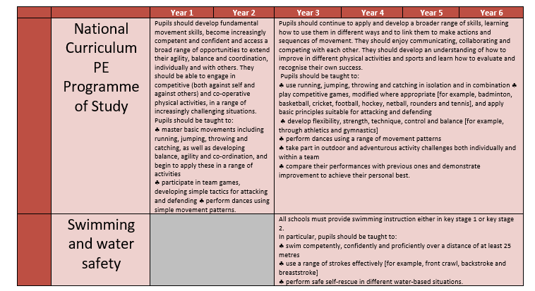

Enrichment Opportunities
Whole School Enrichment Opportunities
Whole School Enrichment Opportunities
Term | Event | PE link
1-6 | Competitions | See Dover Games Calendar, Links with other school DOY and Dover Collaboration
1-6 | After School Clubs | Linked to a range of sporting activities/ promotes inclusion
1-6 | Links with local organisations e.g. Vista Twistas, Peace Run, Dynamic Sport | Linked to a range of sporting activities/ promotes inclusion
1 | Peer Mentoring | Support successful play and activity
4 and 6 | Aquila Football and Aquila Games
6 | Sports Day | Whole school Event  Applying skills learnt throughout the year.
6 | Year 6 Residential | OAA
6 | Bikeability year 5 and 6

Parental Involvement 2023-2024
Term
1 | Launch new PE Curriculum—website, Newsletter, Dojo
Termly | PE Section on Newsletter
Termly | Invited to events such as between other schools
Termly | Feature Year Group—on Dojo—showcase the progress across a unit
6 | Invited in to watch and support Sports Day
Inclusion in PE
At Charlton CE Primary School, we strongly believe in inclusive education to ensure all pupils engage to the best of their ability. We worked closely with Inclusive Sport to adopt the COACH Approach.
In PE this will look like: adapted from: CSIE Legislation and Guidance for Inclusive Education and Ofsted– Research and Review Series: PE

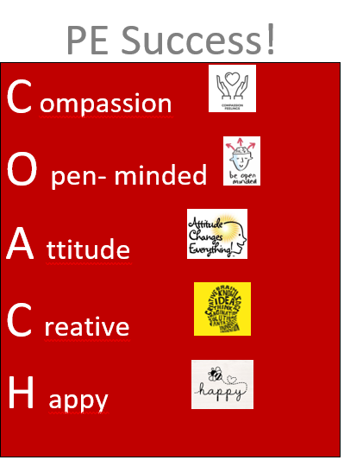

Learn About PE | Quality first teaching, using Charlton’s medium-term plans  Communication tools –e.g. Language through Colour  Wider picture offered to show how the learning fits into our world  VAK – a mixed approach for all learning styles  Adapt where needed, use targeted teaching— i.e. recognising that learning takes time. Ensure pupils have enough time to revisit and develop their knowledge within a context before moving too quickly onto a new sport or physical activity.  Pupils have opportunities to learn component knowledge. Teachers will move onto more complex knowledge once pupils have secured important foundational knowledge.
Learn about sports people and significant sports people journeys in reaching their goals. | Diverse selection of sports people studied throughout  Visiting artists, crafts people and designers – to represent our school community and the wider community  Different ways of thinking offered through diversity being celebrated  Encourage families to know where to go to see sporting activities and encourage interests to be developed beyond the class  Avoidance of stereotyping – show a global picture of sports and encourage a fusion of influences  Cognitive load—if needed, isolate important aspects
Technical Knowledge | Barriers to learning techniques are identified and removed so every child has access to equal opportunities.  Procedural knowledge  Procedural knowledge  Build confidence & interest - we are all seen as sports people
Engaging in sporting activities | Pupil Voice  Work collaboratively – peer to peer, child and adult  Active learning – practical  Provide opportunities beyond PE lessons to develop motor and social knowledge that pupils need to purposefully engage in PE with enjoyment.  Extra-curricular activities available for all pupils, offering opportunities to build, develop and refine knowledge.  Communication – self-express own ideas through pupil voice  Consider the space/area of the class that the child works in  Modified equipment—talk to the PE leader if we need to purchase or adapt equipment  TA and Adult support including outside agencies  COACH Approach and Inclusive Sport training utilised  Nurture Team
Assessment of skills | Charlton’s Progression in PE – offers clear progressive steps so all children can been identified as making progress  Self-confidence built by children being able to discuss their sporting journey because the learning has been a progressive process  Critical and reflective  Feedback for pupils focuses on helping pupils to improve their skills  For some children PAGs or the Engagement model may need to be considered for assessment.

Teacher responsibilities as laid out in the SEND Code of Practice:​
“6.12 All pupils should have access to a broad and balanced curriculum. The National Curriculum Inclusion Statement states that teachers should set high expectations for every pupil, whatever their prior attainment. Teachers should use appropriate assessment to set targets which are deliberately ambitious. Potential areas of difficulty should be identified and addressed at the outset. Lessons should be planned to address potential areas of difficulty and to remove barriers to pupil achievement. In many cases, such planning will mean that pupils with SEN and disabilities will be able to study the full national curriculum.​”

How this subject can support a pupil with a specific SEND – with reference to the Kent Mainstream Core Standards (Blue text example is PE Specific or generic)
Communication and Interaction (ASD, Articulation, fluency, willingness to communicate, vocabulary, understanding and language structure. Additional languages spoken, social skills and interaction)
Subject specific Support for this aspect of SEND  Minimal language load involved in achieving a successful outcome  Visual representation of intended outcome  A multisensory approach | Strategies to overcome potential barriers arising from this subject  “Now (you are doing this) and Next (you are going to be doing that)” boards and sequence strips  Communication support software such as Communicate in Print or Widgit  Use the learner’s name to gain their attention before giving instructions  Keep instructions simple  Awareness of own tone of voice (calm and not too loud)  Encourage ‘thinking time’.
Cognition & Learning ( Dyslexia, approaches and attitudes to learning, reasoning, organisational skills, problem solving skills and independent learning)
Subject specific Support for this aspect of SEND  Reduced memory load | Strategies to overcome potential barriers arising from this subject  Brain Breaks  Visuals to support instructions and concepts (e.g. real objects, photos, pictures, symbols, sign and gesture)  Task management boards  Visual support/reminders – multisensory approach.  Check suitability of placement in the room.  Chunk instructions
Social Emotional and Mental Health (ADHD, ADD, Self-image, confidence, anxiety, motivational factors, engagement with learning, classroom / playground behaviour)
Subject specific Support for this aspect of SEND  Opportunities for success / raised self-esteem through creativity | Strategies to overcome potential barriers arising from this subject  Help / exit cards  Positive relationships / support co-regulation  Evidenced ad specific praise  Peer grouping / support  Plan opportunities for success and celebrate those successes  Focus on reducing anxiety and thereby behaviours  Flexible and creative use of rewards and consequences. e.g. ‘catch them being good’
Physical and Sensory (motor skills, coordination, hearing or visual difficulties, daily living skills and self-help)
Subject specific Support for this aspect of SEND  Minimal language load involved in achieving a successful outcome  Visual representation of intended outcome  Multi-sensory learning opportunities | Strategies to overcome potential barriers arising from this subject  Increased ventilation to support hypersensitivity to smells from resources  Ear defenders to support hyper sensitivity to noise  Ensure that learners have easy access to the equipment they require.  Allow for differing stamina levels / tiredness  Staff have an awareness of background noise levels and reduce this wherever possible (HI)

Early Years Overview

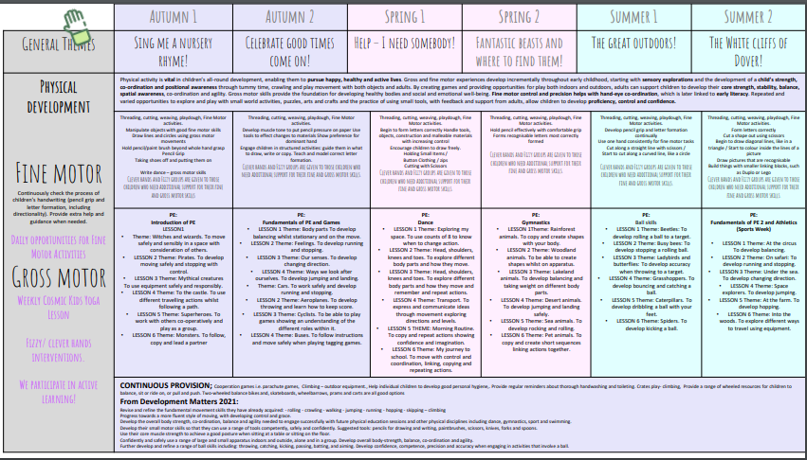

Curriculum Overview – PE at Charlton CE Primary School
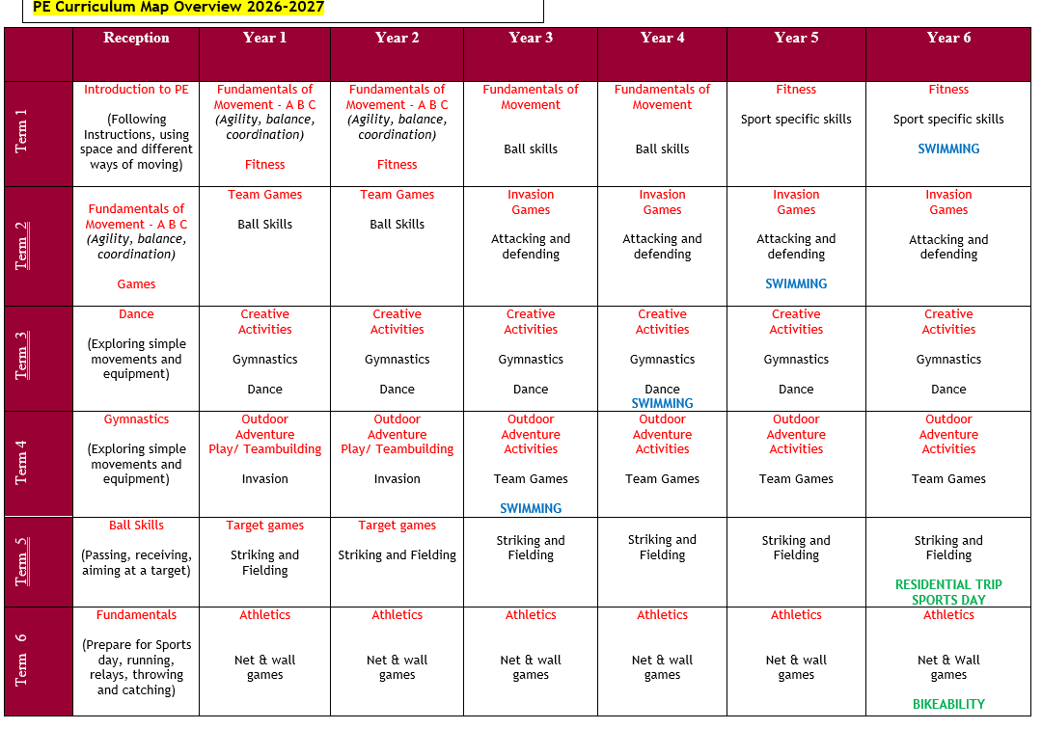

Sport Specific Curriculum Overview
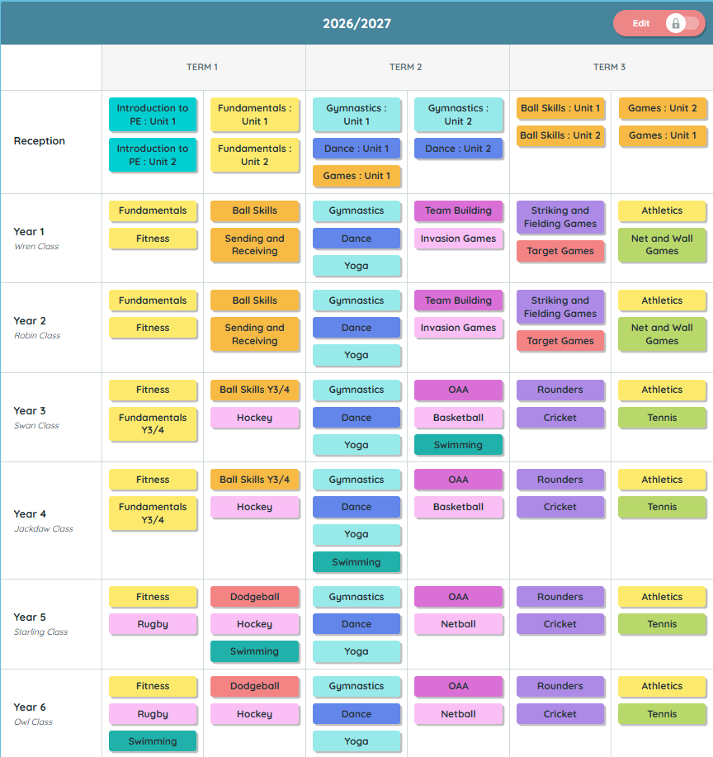

Knowledge Progression
Charlton CE Primary School
Transforming lives through God’s embrace
We are a place of sanctuary where we follow the teachings of Jesus to embrace, love, nurture and celebrate everyone in our school family. We encourage high aspirations for all, so that children flourish into confident, independent and reflective learners who go on to make a positive contribution to the world



Progression Document

Progression of Knowledge in Physical Education

Area of Learning | Year Group | Declarative Knowledge  ‘Knowing what’ | Procedural Knowledge  ‘Knowing how’
Athletics | EYFS | Running: know that I use big steps to run and small steps to stop. Know that moving into space away from others helps to keep me safe.  Jumping: know that bending my knees will help me to land safely.  Throwing: understand that bigger targets are easier to hit.  Rules: know that rules help us to stay safe. | Running: explore running and stopping safely. Jumping: explore jumping and hopping safely. Throwing: explore throwing to a target.
Athletics | Year 1 | Running: understand that if I swing my arms it will help me to run faster.  Jumping: know that landing on the balls of my feet helps me to land with control. Understand that if I bend my knees it will help me to jump further.  Throwing: know that stepping forward with my opposite foot to hand will help me to throw further.  Rules: know that rules help us to play fairly. | Running: explore running at different speeds.  Jumping: develop balance whilst jumping and landing. Explore hopping, jumping and leaping for distance.  Throwing: explore throwing for distance and accuracy.
Athletics | Year 2 | Running: know that running on the balls of my feet, taking big steps and having elbows bent will help me to run faster.  Jumping: know that swinging my arms forwards will help me to jump further.  Throwing: know that I can throw in a straight line by pointing my throwing hand at my target as I let go of the object.  Rules: know how to follow simple rules when working with others. | Running: develop the sprinting action.  Jumping: develop jumping, hopping and skipping actions. Explore safely jumping for distance and height.  Throwing: develop overarm throwing for distance.
Athletics | Year 3 | Running: understand that leaning slightly forwards helps to increase speed. Leaning my body in the opposite direction to travel helps to slow down.  Jumping: know that if I jump and land quickly it will help me to jump further. Throwing: understand that the speed of the movement helps to create power.  Rules: know the rules of the event and begin to apply them. | Running: develop the sprinting technique and apply it to relay events.  Jumping: develop technique when jumping for distance in a range of approaches and take off positions.  Throwing: explore the technique for a pull throw.
Athletics | Year 4 | Running: understand that I need to pace myself when running further or for a long period of time. Understand that a high knee drive, pumping my arms and running on the balls of my feet gives me power.  Jumping: understand that transferring weight will help me to jump further. Throwing: understand that transferring weight will help me to throw further.  Rules: know and understand the rules to be able to manage our own events. | Running: develop an understanding of speed and pace in relation to distance. Develop power and speed in the sprinting technique.  Jumping: develop technique when jumping for distance.  Throwing: explore power and technique when throwing for distance in a pull and heave throw.
Athletics | Year 5 | Running: understand that taking big consistent strides will help to create a rhythm that allows me to run faster. Understand that keeping a steady breath will help me when running longer distances.  Jumping: know that if I drive my knees high and fast I can build power and therefore distance in my jumps.  Throwing: know how to transfer my weight in different throws to increase the distance.  Rules: understand and apply rules in a variety of events using official equipment. | Running: apply fluency and co-ordination when running for speed in relay changeovers. Effectively apply speeds appropriate for the event.  Jumping: explore technique and rhythm in the triple jump.  Throwing: Develop technique and power in javelin and shot put.
Athletics | Year 6 | Running: understand that I need to prepare my body for running and know the muscle groups I will need to use.  Jumping: understand that a run up builds speed and power and enables me to jump further.  Throwing: understand that I need to prepare my body for throwing and know the muscle groups I will need to use.  Rules: understand and apply rules in events that pose an increased risk. | Running: demonstrate a clear understanding of pace and use it to develop their own and others sprinting technique.  Jumping: develop power, control and technique in the triple jump.  Throwing: develop power, control and technique when throwing discus and shot put.

Area of Learning | Year Group | Declarative Knowledge  ‘Knowing what’ | Procedural Knowledge  ‘Knowing how’
Ball Skills | EYFS | Sending: know to look at the target when sending a ball.  Catching: know to have hands out ready to catch.  Tracking: know to watch the ball as it comes towards me and scoop it with two hands.  Dribbling: know that keeping the ball close will help with control. | Sending: explore sending an object with hands and feet.  Catching: explore catching to self and with a partner.  Tracking: explore stopping a ball with hands and feet.  Dribbling: explore dropping and catching with two hands and moving a ball with feet.
Ball Skills | Year 1 | Sending: know to face my body towards my target when rolling and throwing underarm to help me to balance.  Catching: know to watch the ball as it comes towards me.  Tracking: know to move my feet to get in the line with the ball.  Dribbling: know that moving with a ball is called dribbling. | Sending: roll and throw with some accuracy towards a target.  Catching: begin to catch with two hands. Catch after a bounce.  Tracking: track a ball being sent directly.  Dribbling: explore dribbling with hands and feet.
Ball Skills | Year 2 | Sending: know that stepping with opposite foot to throwing arm will help me to balance.  Catching: know to use wide fingers and pull the ball in to my chest to help to securely catch.  Tracking: know that it is easier to move towards a ball to track it than chase it.  Dribbling: know to keep my head up when dribbling to see space/opponents. | Sending: roll, throw and kick a ball to hit a target.  Catching: develop catching a range of objects with two hands. Catch with and without a bounce.  Tracking: consistently track and collect a ball being sent directly.  Dribbling: explore dribbling with hands and feet with increasing control on the move.
Ball Skills | Year 3 | Sending: know that pointing my hand/foot/stick to my target on release will help me to send a ball accurately.  Catching: know to move my feet to the ball.  Tracking: know that using a ready position will help me to react to the ball.  Dribbling: know that dribbling is an attacking skill used in games which helps us to move towards a goal or away from defenders. | Sending: send a ball with accuracy and increasing consistency to a target.  Catching: catch a range of objects with increasing consistency.  Tracking: track a ball not sent directly.  Dribbling: dribble a ball with hands and feet with control.
Ball Skills | Year 4 | Sending: know that I can use a variety of ways to send the ball and it may depend on the situation e.g. distance, speed, if there is a defender.  Catching: know to adjust my hands to the height of the ball.  Tracking: know that tracking a ball is an important skill used in games activities and be able to give examples of this.  Dribbling: know that dribbling with soft hands/touches will help me to keep control. | Sending: accurately use a range of techniques to send a ball to a target.  Catching: catch different sized objects with increasing consistency with one and two hands.  Tracking: consistently track a ball sent directly and indirectly.  Dribbling: dribble a ball with increasing control and co-ordination.
Ball Skills | Year 5 | Sending: know that controlling a ball before sending it will allow me to send it accurately.  Catching: understand when to use different types of catching.  Tracking: know that tracking a ball will help me to collect/stop/receive it quickly and successfully.  Dribbling: know that dribbling in different directions will help me to lose a defender in game situations. | Sending: demonstrate clear technique when sending a ball under pressure.  Catching: demonstrate good technique under pressure.  Tracking: demonstrate a range of techniques when tracking and collecting a ball.  Dribbling: dribble with some control under pressure.
Ball Skills | Year 6 | Sending: understand and make quick decisions about when, how and who to pass to.  Catching: know how to catch a ball for different situations, considering trajectory, speed, height and size of the ball.  Tracking: know how to track a ball for different situations, considering trajectory, speed, height and size of the ball.  Dribbling: choose the appropriate skill for the situation under pressure e.g. a V dribble in basketball to keep the ball away from a defender. | Sending: show good technique when sending a ball with increasing control, accuracy and consistency under pressure.  Catching: demonstrate increasing consistency of catching under pressure in a variety of game situations.  Tracking: demonstrate a wider range of techniques when tracking a ball under pressure Dribbling: dribble consistently using a range of techniques with increasing control under pressure.

Area of Learning | Year Group | Declarative Knowledge  ‘Knowing what’ | Procedural Knowledge  ‘Knowing how’
Dance | EYFS | Actions: understand that I can move my body in different ways to create interesting actions.  Dynamics: understand that I can change my action to show an idea.  Space: know that if I move into space it will help to keep me and others safe.  Performance: know that when watching others I sit quietly and clap at the end.  Strategy: know that if I use lots of space, it helps to make my dance look interesting. | Actions: explore how my body moves. Copy basic body actions and rhythms.  Dynamics: explore actions in response to music and an idea.  Space: begin to explore pathways and the space around me and in relation to others.  Performance: perform short phrases of movement in front of others.
Dance | Year 1 | Actions: understand that actions can be sequenced to create a dance.  Dynamics: understand that I can create fast and slow actions to show an idea.  Space: understand that there are different directions and pathways within space.  Relationships: understand that when dancing with a partner it is important to be aware of each other and keep in time.  Performance: know that standing still at the start and at the end of the dance lets the audience know when I have started and when I have finished.  Strategy: know that if I use exaggerated actions it helps the audience to see them clearly. | Actions: copy, remember and repeat actions to represent a theme. Create my own actions in relation to a theme.  Dynamics: explore varying speeds to represent an idea.  Space: explore pathways within my performance.  Relationships: begin to explore actions and pathways with a partner.  Performance: perform on my own and with others to an audience
Dance | Year 2 | Actions: know that sequencing actions in a particular order will help me to tell the story of my dance.  Dynamics: understand that I can change the way I perform actions to show an idea.  Space: know that I can use different directions, pathways and levels in my dance.  Relationships: know that using counts of 8 will help me to stay in time with my partner and the music.  Performance: know that using facial expressions helps to show the mood of my dance.  Strategy: know that if I practice my dance my performance will improve. | Actions: accurately remember, repeat and link actions to express an idea.  Dynamics: develop an understanding of dynamics.  Space: develop the use of pathways and travelling actions to include levels.  Relationships: explore working with a partner using unison, matching and mirroring.  Performance: develop the use of facial expressions in my performance.
Dance | Year 3 | Actions: understand that sharing ideas with others enables my group to work collaboratively and try ideas before deciding on the best actions for our dance.  Dynamics: understand that all actions can be performed differently to help to show effect.  Space: understand that I can use space to help my dance to flow.  Relationships: understand that 'formation' means the same in dance as in other activities such as football, rugby and gymnastics.  Performance: understand that I can use timing techniques such as canon and unison to create effect.  Strategy: know that if I show sensitivity to the music, my performance will look more complete. | Actions: create actions in response to a stimulus individually and in groups.  Dynamics: use dynamics effectively to express an idea.  Space: use direction to transition between formations.  Relationships: develop an understanding of formations.  Performance: perform short, self-choreographed phrases showing an awareness of timing.
Dance | Year 4 | Actions: understand that some actions are better suited to a certain character, mood or idea than others.  Dynamics: understand that some dynamics are better suited to a certain character, mood or idea than others.  Space: understand that space can be used to express a certain character, mood or idea.  Relationships: understand that some relationships are better suited to a certain character, mood or idea than others.  Performance: know that being aware of other performers in my group will help us to move in time.  Strategy: know that I can select from a range of dance techniques to translate my idea. | Actions: respond imaginatively to a range of stimuli related to character and narrative.  Dynamics: change dynamics confidently within a performance to express changes in character.  Space: confidently use changes in level, direction and pathway.  Relationships: use action and reaction to represent an idea.  Performance: perform complex dances that communicate narrative and character well, performing clearly and fluently.
Dance | Year 5 | Actions: understand that different dance styles utilise selected actions to develop sequences in a specific style.  Dynamics: understand that different dance styles utilise selected dynamics to express mood.  Space: understand that space relates to where my body moves both on the floor and in the air.  Relationships: understand that different dance styles utilise selected relationships to express mood.  Performance: understand what makes a performance effective and know how to apply these principles to my own and others’ work.  Strategy: know that if I use dance principles it will help me to express an atmosphere or mood. | Actions: choreograph dances by using, adapting and developing actions and steps from different dance styles.  Dynamics: confidently use dynamics to express different dance styles.  Space: confidently use direction and patterning to express different dance styles.  Relationships: confidently use formations, canon and unison to express a dance idea.  Performance: perform dances expressively, using a range of performance skills, showing accuracy and fluency.
Dance | Year 6 | Actions: understand that actions can be improved with consideration to extension, shape and recognition of intent.  Dynamics: understand that selecting a variety of dynamics in my performance can help to take the audience on a journey through my dance idea.  Space and relationships: know that combining space and relationships with a prop can help me to express my dance idea.  Performance: understand how a leader can ensure our dance group performs together.  Strategy: know that if I keep in character throughout, it will help me to express an atmosphere or mood that can be interpreted by the audience. | Actions: show controlled movements which express emotion and feeling.  Dynamics: explore, improvise and combine dynamics to express ideas fluently and effectively on my own, with a partner or in a small group.  Space and relationships: use a variety of compositional principles when creating my own dances.  Performance: demonstrate a clear understanding of timing in relation to the music and other dancers throughout my performance.

Area of Learning | Year Group | Declarative Knowledge  ‘Knowing what’ | Procedural Knowledge  ‘Knowing how’
Fitness | EYFS | Agility: know that moving into space away from others helps to keep me safe.  Balance: know that I can hold my arms out to help me to balance.  Co-ordination: know that moving my arms and legs at the same time helps me to walk, run and jump.  Speed: know that I use big steps to run and small steps to stop.  Strength: understand that I can hold my weight on different parts of my body.  Stamina: understand that moving for a long time can make me feel tired | Agility: explore changing direction safely.  Balance: explore balancing whilst stationary and on the move.  Co-ordination: explore moving different body parts together.  Speed: explore moving and stopping with control.  Strength: explore taking weight on different body parts.  Stamina: explore moving for extended periods of time
Fitness | Year 1 | Agility: understand that bending my knees will help me to change direction.  Balance: know that looking ahead will help me to balance.  Co-ordination: know that using the opposite arm to leg at the same time helps me to perform skills such as running and throwing.  Speed: understand that if I swing my arms it will help me to run faster.  Strength: understand that exercise helps me to become stronger.  Stamina: understand that when I move for a long time it can make me feel hot and I breathe faster. | Agility: change direction whilst running.  Balance: explore balancing in more challenging activities with some success.  Co-ordination: explore co-ordination when using equipment.  Speed: explore running at different speeds.  Strength: explore exercises using my own body weight.  Stamina: explore moving for longer periods of time and identify how it makes me feel.
Fitness | Year 2 | Agility: know using small quick steps helps me to change direction.  Balance: understand that I can squeeze my muscles to help me to balance.  Co-ordination: understand that some skills require me to move body parts at different times such as skipping.  Speed: know that I take shorter steps to jog and bigger steps to run.  Strength: know that strength helps us with everyday tasks such as carrying our school bag.  Stamina: know that I need to run slower if running for a long period of time. | Agility: demonstrate improved technique when changing direction on the move.  Balance: demonstrate increased balance whilst travelling along and over equipment.  Co-ordination: perform actions with increased control when co-ordinating my body with and without equipment.  Speed: demonstrate running at different speeds.  Strength: demonstrate increased control in body weight exercises.  Stamina: show an ability to work for longer periods of time.
Fitness | Year 3 | Agility: understand how agility helps us with everyday tasks.  Balance: understand how balance helps us with everyday tasks.  Co-ordination: understand how co-ordination helps us with everyday tasks.  Speed: understand that leaning slightly forwards helps to increase speed. Leaning my body in the opposite direction to travel helps to slow down.  Strength: know that when completing strength activities they need to be performed slowly and with control to help me to stay safe.  Stamina: understand how stamina helps us in other life activities. | Agility: show balance when changing direction.  Balance: explore more complex activities which challenge balance.  Co-ordination: co-ordinate my body with increased consistency in a variety of activities.  Speed: explore sprinting technique.  Strength: explore building strength in different muscle groups.  Stamina: explore using my breath to increase my ability to work for longer periods of time
Fitness | Year 4 | Agility: know that keeping my elbows bent when changing direction will help me to stay balanced.  Balance: understand that I need to squeeze different muscles to help me to stay balanced in different activities.  Co-ordination: understand that if I begin in a ready position I can react quicker.  Speed: understand that a high knee drive, pumping my arms and running on the balls of my feet gives me power.  Strength: understand that strength comes from different muscles and know how I can improve my strength.  Stamina: understand that I need to pace myself when running further or for a long period of time. | Agility: show balance when changing direction at speed.  Balance: show control whilst completing activities which challenge balance.  Co-ordination: explore increased speed when co-ordinating my body.  Speed: demonstrate improved sprinting technique.  Strength: develop building strength in different muscle groups.  Stamina: demonstrate using my breath to maintain my work rate
Fitness | Year 5 | Agility: understand that to change direction I push off my outside foot and turn my hips.  Balance: understand that dynamic balances are harder than static balances as my centre of gravity changes.  Co-ordination: understand that people will have varying levels of co-ordination and that I can get better with practice.  Speed: understand that taking big consistent strides will help to create a rhythm that allows me to run faster.  Strength: know the muscles I am using by name.  Stamina: understand that keeping a steady breath will help me to move for longer periods of time. | Agility: demonstrate improved body posture and speed when changing direction.  Balance: change my body position to maintain a controlled centre of gravity.  Co-ordination: demonstrate increased speed when co-ordinating my body.  Speed: apply the best pace for a set distance or time.  Strength: demonstrate increased technique in body weight exercises.  Stamina: use a steady pace to be able to move for sustained periods of time
Fitness | Year 6 | Agility: understand that agility requires speed, strength, good balance and co-ordination.  Balance: know where and when to apply force to maintain control and balance.  Co-ordination: understand that co-ordination also requires good balance and know how to achieve this.  Speed: know that speed can be improved by training and know which speed to select for the distance.  Strength: understand that I can build up my strength by practicing in my own time.  Stamina: know which exercises can develop stamina and understand that it can be improved by training over time. | Agility: change direction with a fluent action and transition smoothly between varying speeds.  Balance: show fluency and control when travelling, landing, stopping and changing direction.  Co-ordination: co-ordinate a range of body parts with a fluent action at a speed appropriate to the challenge.  Speed: adapt running technique to meet the needs of the distance.  Strength: complete body weight exercises for increased repetitions with control and fluency.  Stamina: use my breath to increase my ability to move for sustained periods of time.

Area of Learning | Year Group | Declarative Knowledge  ‘Knowing what’ | Procedural Knowledge  ‘Knowing how’
Fundamentals | EYFS | Running: know that I use big steps to run and small steps to stop. Know that moving into space away from others helps to keep me safe.  Balancing: know that I can hold my arms out to help me to balance.  Jumping: know that bending my knees will help me to land safely.  Hopping: understand that i use one foot to hop.  Skipping: know that if I hop then step that will help me to skip. | Running: explore running and stopping. Explore changing direction safely.  Balancing: explore balancing whilst stationary and on the move.  Jumping: begin to explore take off and landing safely.  Hopping: explore hopping on both feet.  Skipping: explore skipping as a travelling action.
Fundamentals | Year 1 | Running: understand that bending my knees will help me to change direction. Understand that if I swing my arms it will help me to run faster.  Balancing: know that looking ahead will help me to balance. Know that landing on my feet helps me to balance.  Jumping: know that landing on the balls of my feet helps me to land with control.  Hopping: know that I should hop with a soft bent knee.  Skipping: know that I should use the opposite arm to leg when I skip. Know that jumping on the balls of my feet helps me to keep a consistent rhythm. | Running: explore changing direction and dodging. Discover how the body moves at different speeds.  Balancing: move with some control and balance. Explore stability and landing safely.  Jumping: demonstrate control in take off and landing when jumping.  Hopping: begin to explore hopping in different directions.  Skipping: show co-ordination when turning a rope. Use rhythm to jump continuously in a French rope
Fundamentals | Year 2 | Running: know that putting weight into the front of my feet helps me to stop in a balanced position. Know that running on the balls of my feet, taking big steps and having elbows bent will help me to run faster.  Balancing: understand that squeezing my muscles helps me to balance.  Jumping: know that swinging my arms forwards will help me to jump further.  Hopping: know that if I look straight ahead it will stop me falling over when I land.  Skipping: know that I should swing opposite arm to leg to help me balance when skipping without a rope. | Running: demonstrate balance when changing direction. Clearly show different speeds when running.  Balancing: demonstrate balance when performing movements.  Jumping: demonstrate jumping for distance, height and in different directions.  Hopping: demonstrate hopping for distance, height and in different directions.  Skipping: explore single and double bounce when jumping in a rope
Fundamentals | Year 3 | Running: understand that leaning slightly forwards helps to increase speed (acceleration). Leaning my body in the opposite direction to travel helps to slow down (deceleration). Understand how agility helps us with  everyday tasks.  Balancing: understand how balance helps us with everyday tasks.  Jumping and hopping: know that if I jump and land in quick succession, momentum will help me to jump further.  Skipping: understand that I should turn the rope from my wrists with wide hands to create a gap to step through. | Running: change direction. Show an increase and decrease in speed.  Balancing: demonstrate balance when performing other fundamental skills.  Jumping and hopping: link jumping and hopping actions.  Skipping: jump and turn a skipping rope.
Fundamentals | Year 4 | Running: know that keeping my elbows bent when changing direction will help me to stay balanced.  Balancing: understand that I need to squeeze different muscles to help me to stay balanced in different activities.  Jumping and hopping: know that swinging my non-hopping foot helps to create momentum.  Skipping: understand that keeping my chest up helps me to stay balanced. | Running: change direction quickly under pressure. Demonstrate when and how to accelerate and decelerate.  Balancing: demonstrate good balance and control when performing other fundamental skills.  Jumping and hopping: link hopping and jumping actions with other fundamental skills.  Skipping: consistently skip in a rope.
Fundamentals | Year 5 | Running: understand that to change direction, I push off my outside foot and turn my hips.  Balancing: understand that balance is a skill used in many different activities and everyday life.  Jumping and hopping: understand that there are different techniques for different situations.  Skipping: understand that people will have varying levels of skipping ability and that I can get better with practice. | Running: demonstrate improved body posture and balance when changing direction. Accelerate and decelerate appropriately for the situation.  Balancing: consistently demonstrate good balance when performing other fundamental skills.  Jumping and hopping: demonstrate good technique and co-ordination when linking jumps.  Skipping: show a range of skills when skipping in a rope.
Fundamentals | Year 6 | Running: know that running develops stamina and speed and both can be improved by training over time. Understand that agility requires speed, strength, good balance and co-ordination.  Balancing: know that balance underpins many skills in PE and everyday life and this feels different in different situations.  Jumping and hopping: understand when to jump for height or jump for distance in different activities and what to do to achieve this.  Skipping: understand that skipping helps to develop co-ordination, stamina and balance. | Running: change direction with a fluent action. Transition smoothly between varying speeds.  Balancing: show fluency and control when travelling, landing, stopping and changing direction.  Jumping and hopping: demonstrate good technique when jumping and hopping for distance and height. Fluently link jumps together.  Skipping: consistently show a range of skills when skipping in a rope

Area of Learning | Year Group | Declarative Knowledge  ‘Knowing what’ | Procedural Knowledge  ‘Knowing how’
Gymnastics | EYFS | Shapes: understand that I can make different shapes with my body.  Balances: know that I should be still when holding a balance.  Rolls: know that I can change my body shape to help me to roll.  Jumps: know that bending my knees will help me to land safely.  Strategy: know that if I hold a shape and count to five people will see it clearly. | Shapes: show contrast with my body including wide/narrow, straight/curved.  Balances: explore shapes in stillness using different parts of my body.  Rolls: explore rocking and rolling.  Jumps: explore jumping safely.
Gymnastics | Year 1 | Shapes: understand that I can improve my shapes by extending parts of my body.  Balances: know that balances should be held for 5 seconds.  Rolls: know that I can use different shapes to roll.  Jumps: know that landing on the balls of my feet helps me to land with control.  Strategy: know that if I use a starting and finishing position, people will know when my sequence has begun and when it has ended. | Shapes: explore basic shapes straight, tuck, straddle, pike.  Balances: perform balances making my body tense, stretched and curled.  Rolls: explore barrel, straight and forward roll progressions.  Jumps: explore shape jumps including jumping off low apparatus.
Gymnastics | Year 2 | Shapes: know that some shapes link well together.  Balances: understand that squeezing my muscles helps me to balance.  Rolls: understand that there are different teaching points for different rolls.  Jumps: understand that looking forward will help me to land with control.  Strategy: know that if I use shapes that link well together it will help my sequence to flow. | Shapes: explore using shapes in different gymnastic balances.  Balances: remember, repeat and link combinations of gymnastic balances.  Rolls: explore barrel, straight and forward roll and put into sequence work.  Jumps: explore shape jumps and take off combinations.
Gymnastics | Year 3 | Shapes: understand how to use body tension to make my shapes look better.  Balances: understand that I can make my balances look interesting by using different levels.  Rolls: understand the safety considerations when performing more difficult rolls.  Jumps: understand that I can change the take off and shape of my jumps to make them look interesting.  Strategy: know that if I use different levels it will help to make my sequence look interesting. | Shapes: explore matching and contrasting shapes.  Balances: explore point and patch balances and transition smoothly into and out of them.  Rolls: develop the straight, barrel, and forward roll.  Jumps: develop stepping into shape jumps with control.
Gymnastics | Year 4 | Shapes: understand how shapes can be used to improve my sequence.  Inverted movements: know that inverted movements are actions in which my hips go above my head.  Balances: know how to keep myself and others safe when performing partner balances.  Rolls: understand that I can keep the shape of my roll using body tension.  Jumps: know that I can control my landing by landing toes first, looking forwards and bending my knees.  Strategy: know that if I use different directions it will help to make my sequence look interesting. | Shapes: develop the range of shapes I use in my sequences.  Inverted movements: develop strength in bridge and shoulder stand.  Balances: develop control and fluency in individual and partner balances.  Rolls: develop the straight, barrel, forward and straddle roll and perform them with increased control.  Jumps: develop control in performing and landing rotation jumps.
Gymnastics | Year 5 | Shapes: understand that shapes underpin all other skills.  Inverted movements: understand that sometimes I need to move slowly to gain control and other times I need to move quickly to build momentum.  Balances: understand how to use contrasting balances to make my sequences look interesting.  Rolls: understand that I need to work within my own capabilities and this may be different to others.  Jumps: understand that I can use jumps to link actions and changing the shape of these will make my sequence look interesting.  Strategy: know that if I use different pathways it will help to make my sequence look interesting. | Shapes: perform shapes consistently and fluently linked with other gymnastic actions.  Inverted movements: explore progressions of a cartwheel.  Balances: explore symmetrical and asymmetrical balances.  Rolls: develop control in the straight, barrel, forward, straddle and backward roll.  Jumps: select a range of jumps to include in sequence work.
Gymnastics | Year 6 | Shapes: know which shapes to use for each skill.  Inverted movements: understand that spreading my weight across a base of support will help me to balance.  Balances: know where and when to apply force to maintain control and balance.  Rolls: understand that I can use momentum to help me to roll and where that momentum comes from.  Jumps: understand that taking off from two feet will give me more height and therefore more time in the air.  Strategy: know that if I use changes in formation it will help to make my sequence look interesting. | Shapes: combine and perform gymnastic shapes more fluently and effectively.  Inverted movements: develop control in progressions of a cartwheel bridge and shoulder stand  Balances: explore counter balance and counter tension.  Rolls: develop fluency and consistency in the straddle, forward and backward roll.  Jumps: combine and perform a range of gymnastic jumps more fluently and effectively

Area of Learning | Year Group | Declarative Knowledge  ‘Knowing what’ | Procedural Knowledge  ‘Knowing how’
Invasion Games  (e.g. handball, netball, basketball, football, tag rugby and hockey) | EYFS | Sending & receiving: know to look at the target when sending a ball and watch the ball to receive it.  Dribbling: know that keeping the ball close will help with control.  Space: know that being in a space gives me room to play.  Attacking & defending: know that there are different roles in games.  Tactics: make simple decisions in response to a task.  Rules: know that rules help us to stay safe. | Sending & receiving: explore s&r with hands and feet using a variety of equipment.  Dribbling: explore dropping and catching with two hands and moving a ball with their feet.  Space: recognise their own space.  Attacking & defending: explore changing direction and tagging games.
 | Year 1 | Sending & receiving: know to look at my partner before sending the ball.  Dribbling: know that moving with a ball is called dribbling.  Space: understand that being in a good space helps us to pass the ball.  Attacking: know that being able to move away from a partner helps my team to pass me the ball.  Defending: know that staying with a partner makes it more difficult for them to receive the ball.  Tactics: know that tactics can help us when playing games.  Rules: know that rules help us to play fairly. | Sending & receiving: explore s&r with hands and feet to a partner.  Dribbling: explore dribbling with hands and feet.  Space: recognise good space when playing games.  Attacking: explore changing direction to move away from a partner.  Defending: explore tracking and moving to stay with a partner
 | Year 2 | Sending & receiving: know to control the ball before sending it.  Dribbling: know that keeping my head up will help me to know where defenders are.  Space: know that moving into space away from defenders helps me to pass and receive a ball.  Attacking: know that when my team is in possession of the ball, I am an attacker and we can score.  Defending: know that when my team is not in possession of the ball, I am a defender and we need to try to get the ball. Know that standing between the ball and the attacker will help me to stop them from getting the ball.  Tactics: understand and apply simple tactics for attack and defence.  Rules: know how to score points and follow simple rules. | Sending & receiving: developing s&r with increased control.  Dribbling: explore dribbling with hands and feet with increasing control on the move.  Space: explore moving into space away from others.  Attacking: developing moving into space away from defenders.  Defending: explore staying close to other players to try and stop them getting the ball.
 | Year 3 | Sending & receiving: know that pointing my hand/foot/stick to my target on release will help me to send a ball accurately.  Dribbling: know that dribbling is an attacking skill which helps us to move towards a goal or away from defenders.  Space: know that by spreading out as a team we move the defenders away from each other.  Attacking and defending: know my role as an attacker and defender.  Tactics: know that using simple tactics will help my team to achieve an outcome e.g. we will each mark a player to help us to gain possession.  Rules: know the rules of the game and begin to apply them. | Sending & receiving: explore s&r abiding by the rules of the game.  Dribbling: explore dribbling the ball abiding by the rules of the game under some pressure.  Space: develop using space as a team.  Attacking: develop movement skills to lose a defender. Explore shooting actions in a range of invasion games.  Defending: develop tracking opponents to limit their scoring opportunities.
 | Year 4 | Sending & receiving: know that cushioning a ball will help me to control it when receiving it.  Dribbling: know that protecting the ball as I dribble will help me to maintain possession. Space: know that moving into space will help my team keep possession and score goals.  Attacking: recognise when to pass and when to shoot.  Defending: know when to mark and when to attempt to win the ball.  Tactics: know that applying attacking tactics will help to maintain possession and score goals. Know that applying defending tactics will help to deny space, gain possession and stop goals.  Rules: know and understand the rules to be able to manage our own game. | Sending & receiving: develop passing techniques appropriate to the game with increasing success. Catch a ball using one and two hands and receive a ball with feet/object with increasing success.  Dribbling: link dribbling the ball with other actions and change direction whilst dribbling with some  control.  Space: develop moving into space to help my team.  Attacking: change direction to lose an opponent with some success.  Defending: develop defending one on one and begin to intercept.
 | Year 5 | Sending & receiving: know that not having a defender between myself and a ball carrier enables me to s&r with better control.  Dribbling: know that dribbling in different directions will help to lose a defender.  Space: know that by moving to space even if not receiving the ball will create space for a teammate.  Tactics: understand the need for tactics and identify when to use them in different situations.  Rules: understand and apply rules in a variety of invasion games whilst playing and officiating. | Sending & receiving: develop control when s&r under pressure.  Dribbling: dribble with some control under pressure.  Space: explore moving to create space for themselves and others in their team.  Attacking: use a variety of techniques to lose an opponent e.g. change of direction or speed.  Defending: develop tracking and marking with increased success. Explore intercepting a ball using one and two hands.
 | Year 6 | Sending & receiving: understand and make quick decisions about when, how and who to pass to.  Dribbling: choose the appropriate skill for the situation under pressure e.g. a V dribble in basketball to keep the ball away from a defender.  Space: understand that transitioning quickly between attack and defence will help my team to maintain or gain possession.  Tactics: know how to create and apply a tactic for a specific situation or outcome.  Rules: understand, apply and use rules consistently in a variety of invasion games whilst playing and officiating. | Sending & receiving: s&r consistently using a range of techniques with increasing control under pressure.  Dribbling: dribble consistently using a range of techniques with increasing control under pressure.  Space: move to the correct space when transitioning from attack to defence or defence to attack and create and use space for self and others.  Attacking: confidently change direction to lose an opponent  Defending: use a variety of defending skills (tracking, interception, jockeying) in game situations.

Area of Learning | Year Group | Declarative Knowledge  ‘Knowing what’ | Procedural Knowledge  ‘Knowing how’
Net and Wall Games  (e.g. tennis, volleyball and badminton) | EYFS | Hitting: know to point my hand/object at my target when hitting a ball.  Feeding and rallying: know to look at the target when sending a ball and watch the ball  to receive it.  Footwork: know to use big steps to run and small steps to stop.  Tactics: make simple decisions in response to a task.  Rules: know that rules help us to stay safe. | Hitting: explore hitting a ball with hands and pushing with a racket.  Feeding and rallying: explore sending and tracking a ball with a partner.  Footwork: explore changing direction, running and stopping.
Net and Wall Games  (e.g. tennis, volleyball and badminton) | Year 1 | Hitting: know to use the centre of the racket for control.  Feeding: know to use an underarm throw to feed to a partner.  Rallying: know that throwing/hitting to my partner with not too much power will help them to return the ball.  Footwork: know that using a ready position will help me to move in any direction.  Tactics: know that tactics can help us to be successful when playing games.  Rules: know that rules help us to play fairly. | Hitting: explore hitting a dropped ball with a racket.  Feeding: throw a ball over a net to land into the court area.  Rallying: explore sending a ball with hands and a racket.  Footwork: use the ready position to move towards a ball.
Net and Wall Games  (e.g. tennis, volleyball and badminton) | Year 2 | Hitting: know to watch the ball as it comes towards me to help me to prepare to hit it.  Feeding: know to place enough power on a ball to let it bounce once but not too much so that my partner can't return it.  Rallying: know that sending the ball towards my partner will help me to keep a rally going.  Footwork: know that using a ready position helps me to react quickly and return/catch a ball.  Tactics: understand that applying simple tactics makes it difficult for my opponent.  Rules: know how to score points and follow simple rules. | Hitting: develop hitting a dropped ball over a net.  Feeding: accurately underarm throw over a net to a partner.  Rallying: explore underarm rallying with a partner catching after one bounce.  Footwork: consistently use the ready position to move towards a ball.
Net and Wall Games  (e.g. tennis, volleyball and badminton) | Year 3 | Shots: know that pointing the racket face/my hand where I want the ball to go and turning my body will help me to hit accurately.  Rallying: know that hitting towards my partner will help them to return the ball easier and keep the rally going.  Footwork: know that moving to the middle of my court will enable me to cover the most space.  Tactics: know that using simple tactics will help to achieve an outcome e.g. if we spread out, we can cover more space.  Rules: know the rules of the game and begin to apply them. | Shots: explore returning a ball using shots such as the forehand and backhand.  Rallying: explore rallying using a forehand.  Footwork: consistently use and return to the ready position in between shots.
Net and Wall Games  (e.g. tennis, volleyball and badminton) | Year 4 | Shots: understand when to play a forehand and a backhand and why.  Rallying: know that moving my feet to the ball will help me to hit in a more balanced position therefore increasing the accuracy of my shot.  Footwork: know that getting my feet in the right position will help me to balance before playing a shot.  Tactics: know that applying attacking tactics will help me to score points and create space. Know that applying defending tactics will help me to deny space, return a ball and limit points.  Rules: know and understand the rules to be able to manage our own game. | Shots: demonstrate technique when using shots playing co-operatively and beginning to execute this competitively.  Rallying: develop rallying using both forehand and backhand with increased technique.  Footwork: begin to use appropriate footwork patterns to move around the court.
Net and Wall Games  (e.g. tennis, volleyball and badminton) | Year 5 | Shots: know which skill to choose for the situation e.g. a volley if the ball is close to the net.  Serving: know that serving is how to start a game or rally and use the rules applied to the activity for serving.  Rallying: know that playing the appropriate shot will help to keep the rally going. Know that control is more important than power to keep a rally going.  Footwork: know that using small, quick steps will allow me to adjust my stance to play a shot.  Tactics: understand the need for tactics and identify when to use them in different situations.  Rules: understand and apply rules in a variety of net and wall games whilst playing and officiating. | Shots: develop the range of shots used in a variety of games.  Serving: develop the range of serving techniques appropriate to the game.  Rallying: use a variety of shots to keep a continuous rally.  Footwork: demonstrate effective footwork patterns to move around the court.
Net and Wall Games  (e.g. tennis, volleyball and badminton) | Year 6 | Shots: understand the appropriate skill for the situation under pressure e.g. choosing to play the ball short over the net if I have just moved my opponent to the back of the court.  Serving: begin to apply tactics when serving e.g. aiming to serve short on the first point and then long on the second point.  Rallying: understand how to play different shots depending on if a rally is co-operative or competitive.  Footwork: know that using the appropriate footwork will help me to react to a ball quickly and give me time to prepare to play a shot.  Tactics: understand when to apply some tactics for attacking and/or defending.  Rules: understand, apply and use rules consistently in a variety of net and wall games whilst playing and officiating. | Shots: demonstrate increased success and technique in a variety of shots.  Serving: serve accurately and consistently.  Rallying: successfully apply a variety of shots to keep a continuous rally.  Footwork: demonstrate a variety of footwork patterns relevant to the game I am playing.

Area of Learning | Year Group | Declarative Knowledge  ‘Knowing what’ | Procedural Knowledge  ‘Knowing how’
OAA | EYFS | Problem solving: make simple decisions in response to a task.  Navigational skills: know that moving into space away from others will help me to stay safe. Know to leave a gap when following a path will help me to stay safe.  Communication: know that talking with a partner will help me to solve challenges  e.g. 'let's go to the green hoop next'.  Reflection: begin to identify when I am successful.  Rules: know that rules help us to stay safe. | Problem solving: explore activities where I have to make my own decisions.  Navigational skills: explore moving in space and following a path.  Communication: develop confidence in expressing myself.
OAA | Year 1 | Problem solving: know that working collaboratively with others will help to solve challenges.  Navigational skills: know that deciding which way to go before starting will help me.  Communication: know that using short instructions will help my partner e.g. start/stop.  Rules: know that rules help us to play fairly. | Problem solving: suggest ideas in response to a task.  Navigational skills: follow a path and lead others.  Communication: communicate simple instructions and listen to others.
OAA | Year 2 | Problem solving: know that listening to each other's ideas might give us an idea we hadn't thought of.  Navigational skills: understand that the map tells us what to do.  Communication: know to use encouraging words when speaking to a partner or group to help them to trust me.  Reflection: verbalise when I am successful and areas that I could improve.  Rules: know how to follow and apply simple rules. | Problem solving: begin to plan and apply strategies to overcome a challenge.  Navigational skills: follow and create a simple diagram/map.  Communication: work co-operatively with a partner and a small group.
OAA | Year 3 | Problem solving: know that trying ideas before deciding on a solution will help us to come up with the best idea.  Navigational skills: know to hold the map so that the items on the map match up to the items that have been placed out.  Communication: know to take turns when giving ideas and not to interrupt each other.  Reflection: reflect on when and why I am successful at solving challenges.  Rules: know that using the rules honestly will help to keep myself and others safe. | Problem solving: discuss how to follow trails and solve problems. Work with others to select appropriate equipment for the task.  Navigational skills: identify where I am on a simple map. Use and begin to  create simple maps and diagrams and follow a trail.  Communication: follow and give instructions and accept other peoples' ideas.
OAA | Year 4 | Problem solving: know that discussing the advantages and disadvantages of ideas will help to guide us to a conclusion about which idea to use.  Navigational skills: understand how to use a key and use the cardinal points on a map to orientate it.  Communication: understand that there are different types of communication and that I can communicate without talking.  Reflection: with increased accuracy, critically reflect on when and why I am successful at solving challenges.  Rules: understand the importance of working with integrity. | Problem solving: plan independently and in small groups, implementing a strategy with increased success.  Navigational skills: identify key symbols on a map and follow a route.  Communication: confidently communicate ideas and listen to  others.
OAA | Year 5 | Problem solving: recognise that there may be more than one way to solve a challenge and that trial and error may help to guide me to the best solution.  Navigational skills: use a key to identify objects and locations.  Communication: know to be descriptive but concise when giving instructions e.g. 'two steps to the left'.  Reflection: reflect on when I am successful at solving challenges and alter my methods in order to improve.  Rules: know that abiding by rules will enable my classmates to complete the course e.g. not moving controls. | Problem solving: explore tactical planning within a team to overcome increasingly challenging tasks.  Navigational skills: develop navigational skills and map reading in  increasingly challenging tasks.  Communication: explore a variety of communication methods with increasing success.
OAA | Year 6 | Problem solving: understand that being able to solve problems is an important life skill.  Navigational skills: understand why having good navigational skills are important.  Communication: know that good communication skills are key to solving problems and working effectively as a team.  Reflection: with increasing accuracy, reflect on when and how I am successful at solving challenges and alter my methods in order to improve.  Rules: understand the rules and think creatively to solve the challenge whilst abiding by the rules. | Problem solving: pool ideas within a group, selecting and applying the best method to solve a problem.  Navigational skills: orientate a map efficiently to navigate around a course with multiple points.  Communication: inclusively communicate with others, share job roles and lead when necessary.

Area of Learning | Year Group | Declarative Knowledge  ‘Knowing what’ | Procedural Knowledge  ‘Knowing how’
Striking and Fielding  (e.g. cricket and rounders) | EYFS | Striking: know to point my hand at my target when striking a ball.  Fielding: know to scoop a ball with two hands.  Throwing and catching: know to point my hand at my target when throwing. Know to have hands out ready to catch.  Tactics: make simple decisions in response to a task.  Rules: know that rules help us to stay safe. | Striking: explore sending a ball to a partner.  Fielding: explore tracking and stopping a rolling ball.  Throwing and catching: explore rolling, throwing and catching using a variety of equipment.
Striking and Fielding  (e.g. cricket and rounders) | Year 1 | Striking: understand that the harder I strike, the further the ball will travel.  Fielding: know that throwing the ball back is quicker than running with it.  Throwing: know which type of throw to use to throw over longer distances.  Catching: know to watch the ball as it comes towards me.  Tactics: know that tactics can help us when playing games.  Rules: know that rules help us to play fairly. | Striking: explore striking a ball with their hand and equipment.  Fielding: develop tracking and retrieving a ball.  Throwing: explore technique when throwing over and underarm.  Catching: develop co-ordination and technique when catching.
Striking and Fielding  (e.g. cricket and rounders) | Year 2 | Striking: understand the role of a batter. Know that striking quickly will increase the power.  Fielding: understand that there are different roles within a fielding team. Know to move towards the ball to collect it to limit a batter's points.  Throwing: know that stepping with opposite foot to throwing arm will help me to balance.  Catching: know to use wide fingers and pull the ball in to my chest to help me to securely catch.  Tactics: understand and apply simple tactics for attack (batting) and defence (fielding).  Rules: know how to score points and follow simple rules. | Striking: develop striking a ball with their hand and equipment with some consistency.  Fielding: develop tracking a ball and decision making with the ball.  Throwing: develop co-ordination and technique when throwing over and underarm.  Catching: catch with two hands with some co-ordination and technique.
Striking and Fielding  (e.g. cricket and rounders) | Year 3 | Striking: know that striking to space away from fielders will help me to score.  Fielding: know to look at where a batter is before deciding what to do. Know to communicate with teammates before throwing them a ball.  Throwing: know that overarm throwing is used for long distances and underarm throwing for shorter distances.  Catching: know to move my feet to the ball.  Tactics: know that using simple tactics will help my team to achieve an outcome e.g. we will spread out to deny space.  Rules: know the rules of the game and begin to apply them. | Striking: begin to strike a bowled ball after a bounce with different equipment.  Fielding: explore bowling to a target and fielding skills to include a two-handed pick up.  Throwing: use overarm and underarm throwing in game situations.  Catching: catch with some consistency in game situations.
Striking and Fielding  (e.g. cricket and rounders) | Year 4 | Striking: know that using the centre of the bat will provide the most control and accuracy.  Fielding: know that it easier to field a ball that is coming towards me rather than away so set up accordingly.  Throwing: understand that being balanced before throwing will help to improve the accuracy of the throw.  Catching: know to track the ball as it is thrown to help to improve the consistency of catching.  Tactics: know that applying attacking tactics will help to score points and avoid getting out. Know that applying defending tactics will help to deny space, get opponents out and limit points.  Rules: know and understand the rules to be able to manage our own game | Striking: develop batting technique with a range of equipment.  Fielding: develop bowling with some consistency, abiding by the rules of the game.  Throwing: use overarm and underarm throwing with increased consistency in game situations.  Catching: begin to catch with one and two hands with some consistency in game situations
Striking and Fielding  (e.g. cricket and rounders) | Year 5 | Striking: understand that stance is important to allow me to be balanced as I hit.  Fielding: know that backing up a fielder as a ball is being thrown will help to increase the chances of fielding successfully.  Throwing: understand where to throw the ball in relation to where a batter is.  Catching: understand when to use a close catch technique or deep catch technique.  Tactics: understand the need for tactics and identify when to use them in different situations.  Rules: understand and apply rules in a variety of striking and fielding games whilst playing and officiating. | Striking: explore defensive and driving hitting techniques and directional batting.  Fielding: develop over and underarm bowling technique. Develop long and short barrier and two handed pick up.  Throwing: demonstrate good technique when using a variety of throws under pressure.  Catching: explore catching skills (close/deep and wicket keeping) and apply these with some consistency in game situations.
Striking and Fielding  (e.g. cricket and rounders) | Year 6 | Striking: understand that the momentum and power for striking a ball comes from legs as well as arms.  Fielding: know which fielding action to apply for the situation.  Throwing and catching: consistently make good decisions on who to throw to and when to throw in order to get batters out. Know that accuracy, speed and consistency of throwing and catching will help to limit a batter's score.  Tactics: understand and apply some tactics in the game as a batter, bowler and fielder.  Rules: understand, apply and use rules consistently in a variety of striking and fielding games whilst playing and officiating. | Striking: strike a bowled ball with increasing accuracy and consistency.  Fielding: use a wider range of fielding skills with increasing control under pressure.  Throwing: consistently demonstrate good technique in throwing skills under pressure.  Catching: consistently demonstrate good technique in catching skills under pressure

Area of Learning | Year Group | Declarative Knowledge  ‘Knowing what’ | Procedural Knowledge  ‘Knowing how’
Target Games  (e.g. golf and dodgeball) | EYFS | Throwing: know to point my hand at my target when throwing.  Catching: know to have hands out ready to catch.  Tactics: make simple decisions in response to a task.  Rules: know that rules help us to stay safe. | Throwing: explore throwing using a variety of equipment.  Catching: explore catching using a variety of equipment.
Target Games  (e.g. golf and dodgeball) | Year 1 | Throwing: know which type of throw to use for distance and accuracy. Know that my body position will affect the accuracy of my throw.  Tactics: know that tactics can help us when playing games.  Rules: know that rules help us to play fairly | Throwing overarm: explore technique when throwing overarm towards a target.  Throwing underarm: explore technique when throwing underarm towards a target.
Target Games  (e.g. golf and dodgeball) | Year 2 | Throwing: know that stepping with opposite foot to throwing arm will help you to balance. Know that moving my arm quicker will give me more power.  Striking: know to finish with my object/hand pointing at my target.  Tactics: understand and apply simple tactics.  Rules: know how to score points and follow simple rules. | Throwing overarm: develop co-ordination and technique when throwing overarm towards a target.  Throwing underarm: develop co-ordination and technique when throwing underarm towards a target.  Striking: develop striking a ball with equipment with some consistency.
Target Games  (e.g. golf and dodgeball) | Year 3 | Throwing: know to throw slightly ahead of a moving target.  Catching (dodgeball): know that beginning in a ready position will help me to react to the ball.  Striking: know that using a bigger swing will give me more power.  Tactics: know that using simple tactics will help my team to achieve an outcome e.g. spread out so that we are harder to aim for.  Rules: know the rules of the game and begin to apply them. | Throwing: explore throwing at a moving target. Catching (dodgeball): begin to catch whilst on the move.  Striking: begin to strike a ball with accuracy and balance.
Target Games  (e.g. golf and dodgeball) | Year 4 | Throwing: know that one handed throws are used for speed and accuracy. Know that keeping my elbow high and stepping with my opposite foot will help to increase the power.  Catching (dodgeball): know that moving my feet to a ball and pulling it in to my chest will help me to catch more consistently.  Striking: know that using a smooth action will help to increase accuracy.  Tactics: know that applying attacking tactics will help me to score points and get opponents out. Know that applying defending tactics will help me to stay in the game.  Rules: know and understand the rules to be able to manage our own game. | Throwing: throw with increasing accuracy at a target. Catching (dodgeball): catch with increasing consistency.  Striking: strike a ball with increasing consistency.
Target Games  (e.g. golf and dodgeball) | Year 5 | Throwing: know to aim low to make it difficult for an opponent to catch.  Catching (dodgeball): know to stay towards the back of the court area to give me more time to catch.  Striking: know that aligning my body and equipment before striking will help me to be balanced.  Tactics: understand the need for tactics and identify when to use them in different situations.  Rules: understand and apply rules in a variety of target games whilst playing and officiating. | Throwing: demonstrate clear technique and accuracy when throwing at a target.  Catching (dodgeball): demonstrate good technique and consistency in catching skills.  Striking: develop a wider range of striking techniques and begin to use them under pressure.
Target Games  (e.g. golf and dodgeball) | Year 6 | Throwing: know who to throw at and when to throw in order to get opponents out.  Catching (dodgeball): know that I need to make quick decisions on if to catch or if to dodge the ball.  Striking: know which skill to select for the situation.  Tactics: know how to create and apply a tactic for a specific situation or outcome.  Rules: understand, apply and use rules consistently in a variety of target games whilst playing and officiating. | Throwing: throw with increasing control under pressure.  Catching (dodgeball): catch with increasing control under pressure.  Striking: use a variety of striking techniques with control and under pressure.

Progression of skills and Assessment
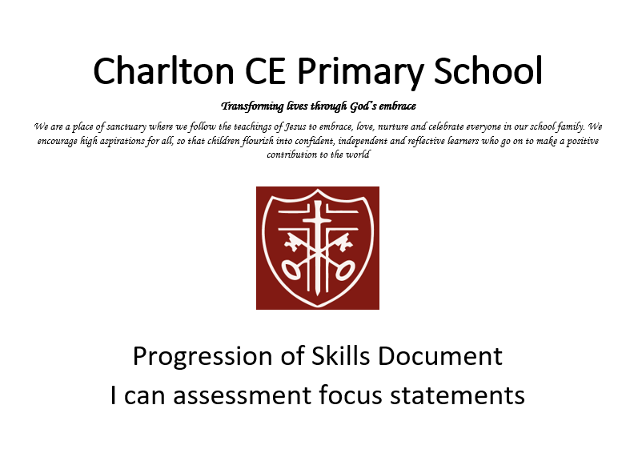

Skills | Year R |  |  | Year 1 | Year 2 | Year 3 | Year 4 | Year 5 | Year 6
National Curriculum PE Programme of Study |  |  |  | Pupils should develop fundamental movement skills, become increasingly competent and confident and access a broad range of opportunities to extend their agility, balance and coordination, individually and with others. They should be able to engage in competitive (both against self and against others) and co-operative physical activities, in a range of increasingly challenging situations.  Pupils should be taught to:  ♣ master basic movements including running, jumping, throwing and catching, as well as developing balance, agility and co-ordination, and begin to apply these in a range of activities  ♣ participate in team games, developing simple tactics for attacking and defending ♣ perform dances using simple movement patterns. |  | Pupils should continue to apply and develop a broader range of skills, learning how to use them in different ways and to link them to make actions and sequences of movement. They should enjoy communicating, collaborating and competing with each other. They should develop an understanding of how to improve in different physical activities and sports and learn how to evaluate and recognise their own success.  Pupils should be taught to:  ♣ use running, jumping, throwing and catching in isolation and in combination ♣ play competitive games, modified where appropriate [for example, badminton, basketball, cricket, football, hockey, netball, rounders and tennis], and apply basic principles suitable for attacking and defending  ♣ develop flexibility, strength, technique, control and balance [for example, through athletics and gymnastics]  ♣ perform dances using a range of movement patterns  ♣ take part in outdoor and adventurous activity challenges both individually and within a team  ♣ compare their performances with previous ones and demonstrate improvement to achieve their personal best.
Swimming and water safety |  |  |  |  |  | All schools must provide swimming instruction either in key stage 1 or key stage 2.  In particular, pupils should be taught to:  ♣ swim competently, confidently and proficiently over a distance of at least 25 metres  ♣ use a range of strokes effectively [for example, front crawl, backstroke and breaststroke]  ♣ perform safe self-rescue in different water-based situations.
Games  Invasion Games  Attacking and Defending | Physical Development: Moving and Handling/ Health and Self- care |  | - Move freely using suitable spaces and speed.  - Know equipment needs to be used safely.  - Demonstrate increasing control over objects.  - Move confidently.  - Use safety measures without direct supervision.  - Demonstrate good control and co-ordination in large and small movement.  - Move freely in a variety of different ways.  - Show a dominant hand.  - Make anticlockwise movement.  - Stand on one foot.  - Catch a ball.  - Experiment moving in different ways on equipment and jump landing safely.  - Manage own risk assessment.  - Help to put away equipment correctly  - Participate in Sports day and physical activities that are included within this using a variety of equipment, taking turns and celebrating other’s successes.  - Write some letters and copy their name.  - Understand the need for varied and healthy food.  - Use scissors and other tools safely.  - Draw lines and circles. Hold a pen correctly.  - Understand their own needs hunger/toilet/personal hygiene.  -Dress with support.  - Use tools to change to materials.  (Following Instructions, using space and different ways of moving- moving safely)  Understanding why exercise is good for our bodies and what changes happen during exercise.  (Agility, balance, coordination to develop running and stopping)  Understanding why exercise is good for our bodies and what changes happen during exercise.  Revise and refine the fundamental movement skills they have already acquired: - rolling - crawling - walking - jumping - running - hopping - skipping – climbing  Confidently and safely use a range of large and small apparatus indoors and outside, alone and in a group. Develop overall body-strength, balance, co-ordination and agility  (Exploring simple movements and equipment) Progress towards a more fluent style of moving, with developing control and grace  Understanding why exercise is good for our bodies and what changes happen during exercise.  Develop the overall body strength, co-ordination, balance and agility needed to engage successfully with future physical education sessions and other physical disciplines including dance, gymnastics  (Exploring simple movements and equipment) Progress towards a more fluent style of moving, with developing control and grace  Develop the overall body strength, co-ordination, balance and agility needed to engage successfully with future physical education sessions and other physical disciplines including dance, gymnastics  Understanding why exercise is good for our bodies and what changes happen during exercise.  (Passing, receiving, aiming at a target)  Understanding why exercise is good for our bodies and what changes happen during exercise.  Further develop and refine a range of ball skills including: throwing, catching, kicking, passing, batting, and aiming. Develop confidence, competence, precision and accuracy when engaging in activities that involve a ball  (Prepare for Sports day, running, relays, throwing and catching,  under/over)  Understanding why exercise is good for our bodies and what changes happen during exercise.  Year R – Fine motor activities Develop their small motor skills so that they can use a range of tools competently, safely and confidently. Suggested tools: pencils for drawing and writing, paintbrushes, scissors, knives, forks and spoons  This could include:  Threading, cutting, weaving, playdough, Fine Motor activities.  Form letters correctly  Cut a shape out using scissors  Begin to draw diagonal lines, like in a triangle / Start to colour inside the lines of a picture  Draw pictures that are recognisable  Build things with smaller linking blocks, such as Duplo or Lego  Use their core muscle strength to achieve a good posture when sitting at a table or sitting on the floor  Communication ELG:  Listen attentively and respond to what they hear with relevant questions, comments and actions when being read to and during whole class discussions and small group interactions. • Make comments about what they have heard and ask questions to clarify their understanding. • Hold conversation when engaged in back-and-forth exchanges with their teacher and peers.  Offer explanations for why things might happen, making use of recently introduced vocabulary from stories, non-fiction, rhymes and poems when appropriate. • Express their ideas and feelings about their experiences using full sentences, including use of past, present and future tenses and making use of conjunctions, with modelling and support from their teacher  PSED ELG  Be confident to try new activities and show independence, resilience and perseverance  in the face of challenge.  • Explain the reasons for rules, know right from wrong and try to behave accordingly.  • Manage their own basic hygiene and personal needs, including dressing, going to the  toilet and understanding the importance of healthy food choices.  • Work and play cooperatively and take turns with others.  • Form positive attachments to adults and friendships with peers.  • Show sensitivity to their own and to others’ needs.  Show an understanding of their own feelings and those of others, and begin to regulate  their behaviour accordingly.  • Set and work towards simple goals, being able to wait for what they want and control  their immediate impulses when appropriate.  • Give focused attention to what the teacher says, responding appropriately even when  engaged in activity, and show an ability to follow instructions involving several ideas  or actions  Physical Development ELG: Gross Motor Skills Children at the expected level of development will: - Negotiate space and obstacles safely, with consideration for themselves and others; - Demonstrate strength, balance and coordination when playing; - Move energetically, such as running, jumping, dancing, hopping, skipping and climbing.  ELG: Fine Motor Skills Children at the expected level of development will: - Hold a pencil effectively in preparation for fluent writing – using the tripod grip in almost all cases; - Use a range of small tools, including scissors, paint brushes and cutlery; - Begin to show accuracy and care when drawing. | -I am beginning to dribble a ball with my hands and feet.  -I can change direction to move away from a defender.  -I can recognise space when playing games.  -I can send and receive a ball with hands and feet.  -I can use simple rules to play fairly.  -I move to stay with another player when defending.  -I recognise changes in my body when I do exercise.  -I understand when I am a defender and when I am an attacker. | -I can describe how my body feels during exercise.  -I can dodge and find space away from the other team.  -I can move with a ball towards goal.  -I can sometimes dribble a ball with my hands and feet.  -I can stay with another player to try and win the ball.  -I know how to score points and can remember the score.  -I know who is on my team and I can attempt to send the ball to them. | -I am beginning to use simple tactics.  -I am learning the rules of the game and am beginning to use them honestly.  -I can dribble, pass, receive and shoot the ball with some control.  -I can find space away from others and near to my goal.  -I can provide feedback using key words.  -I can track an opponent to slow them down.  -I understand my role as an attacker and as a defender.  -I work co-operatively with my group to self-manage games. | -I can delay an opponent and help to prevent the other team from scoring.  -I can dribble, pass, receive and shoot the ball with increasing control.  -I can move to space to help my team to keep possession and score goals.  -I can provide feedback using key terminology and understand what I need to do to improve.  -I can use simple tactics to help my team score or gain possession.  -I share ideas and work with others to manage our game.  -I understand the rules of the game and I can use them often and honestly. | -I can communicate with my team and move into space to keep possession and score.  -I can dribble, pass, receive and shoot the ball with some control under pressure.  -I can identify when I was successful and what I need to do to improve.  -I can use tracking and intercepting when playing in defence.  -I understand the need for tactics and can identify when to use them in different situations.  -I understand the rules of the game and I can apply them honestly most of the time.  -I understand there are different skills for different situations and I am beginning to apply this. | -I can create and use space to help my team.  -I can dribble, pass, receive and shoot the ball with increasing control under pressure.  -I can select the appropriate action for the situation and make this decision quickly.  -I can use the rules of the game honestly and consistently.  -I can work collaboratively to create tactics with my team and evaluate the effectiveness of these.  -I can work in collaboration with others so that games run smoothly.  -I recognise my own and others strengths and areas for development and can suggest ways to improve.  -I understand when to use different styles of defence in game situations.
Games  Striking and Fielding |  |  |  | -I can catch a beanbag and a medium-sized ball.  -I can roll a ball towards a target.  -I can strike a ball using my hand.  -I can track a ball that is coming towards me.  -I know how to score points.  -I understand the rules and I am beginning to use these to play honestly and fairly.  -I understand when I am successful. | -I am beginning to provide feedback using key words.  -I am developing underarm and overarm throwing skills.  -I can hit a ball using equipment with some consistency.  -I can track a ball and collect it.  -I can use simple tactics.  -I know how to score points and can remember the score.  -I understand the rules of the game and can use these to play fairly in a small group. | -I am able to bowl a ball towards a target.  -I am beginning to strike a bowled ball.  -I am developing an understanding of tactics and I am beginning to use them in game situations.  -I am learning the rules of the game and I am beginning to use them.  -I can provide feedback using key words.  -I can use overarm and underarm throwing and catching skills.  -I work co-operatively with my group to self-manage games. | -I am able to bowl a ball with some accuracy, and consistency.  -I am learning the rules of the game and I am beginning to use them to play honestly and fairly.  -I can communicate with my teammates to apply simple tactics.  -I can explain what happens to my body when I exercise and how this helps to make me healthy.  -I can provide feedback using key terminology and understand what I need to do to improve.  -I can strike a bowled ball with adapted equipment (e.g. a tennis racket).  -I can use overarm and underarm throwing and catching skills with increasing accuracy.  -I share ideas and work with others to manage our game. | -I am beginning to strike a ball with a rounders bat.  -I am developing a wider range of fielding skills and I am beginning to use these under some pressure.  -I can identify when I was successful and what I need to do to improve.  -I can work co-operatively with others to manage our game.  -I understand the need for tactics and can identify when to use them in different situations.  -I understand the rules of the game and I can apply them honestly most of the time.  -I understand there are different skills for different situations and I am beginning to use this. | -I can strike a bowled ball with increasing consistency.  -I can use a wider range of skills with increasing control under pressure.  -I can use the rules of the game consistently to play fairly.  -I can work collaboratively with others to get batters out.  -I can work in collaboration with others so that games run smoothly.  -I recognise my own and others strengths and areas for development and can suggest ways to improve.  -I understand and can apply some tactics in the game as a batter, bowler and fielder.
Games  Ball Skills  (sending and receiving year 1 and 2) |  |  |  | -I am beginning to catch with two hands.  -I am beginning to dribble /send and receive a ball with my hands and feet.  -I am beginning to understand simple tactics.  -I can roll and throw with some accuracy towards a target.  -I can say when someone was successful.  -I can track a ball that is coming towards me.  -I can work co-operatively with a partner.  -I can throw a ball to a partner. | -I am beginning to provide feedback using key words.  -I am beginning to understand and use simple tactics.  -I can dribble a ball with my hands and feet with some control.  -I can roll and throw a ball to hit a target.  -I can send and receive a ball using both kicking and throwing and catching skills.  -I can track a ball and collect it.  -I can work co-operatively with a partner and a small group.  - I am beginning to trap and cushion a ball that is coming towards me.  -I can accurately throw and kick a ball to a partner.  -I can catch a ball passed to me, with and without a bounce.  -I can roll a ball to hit a target.  -I can track a ball and stop it using my hands and feet.  -I can work safely to send a ball towards a partner using a piece of equipment. | -I can catch different sized objects with increasing consistency with two hands.  -I can dribble a ball with control.  -I can persevere when learning a new skill.  -I can provide feedback using key words.  -I can show a variety of throwing techniques.  -I can throw with accuracy and increasing consistency to a target.  -I can track the path of a ball that is not sent directly to me. | -I can accurately use a range of throwing techniques to throw to a target.  -I can catch different sized objects with increasing consistency with one and two hands.  -I can consistently track the path of a ball that is not sent directly to me.  -I can dribble a ball with increasing control and co-ordination.  -I can persevere when learning a new skill.  -I can provide feedback using key terminology and understand what I need to do to improve.
Games  Net and Wall |  |  |  | -I can hit a ball using a racket.  -I can throw a ball to land over the net and into the court area.  -I can track balls and other equipment sent to me.  -I can use a ready position to move to the ball.  -I know how to score points.  -I recognise changes in my body when I do exercise.  -I show honesty and fair play when playing against an opponent. | -I can defend space on my court using the ready position.  -I can describe how my body feels during exercise.  -I can hit a ball over the net and into the court area.  -I can throw accurately to a partner.  -I can use simple tactics to make it difficult for an opponent.  -I know how to score points and can remember the score.  -I show good sportsmanship when playing against an opponent. | -I am learning the rules of the game and I am beginning to use them to play fairly.  -I can provide feedback using key words.  -I can return a ball to a partner.  -I can use basic racket skills.  -I understand the aim of the game.  -I understand the benefits of exercise.  -I work cooperatively with my group to self-manage games. | -I can communicate with my teammates to apply simple tactics.  -I can explain what happens to my body when I exercise and how this helps to make me healthy.  -I can provide feedback using key terminology and understand what I need to do to improve.  -I can return to the ready position to defend my own court.  -I can sometimes play a continuous game.  -I can use a range of basic racket skills.  -I share ideas and work with others to manage our game.  -I understand the rules of the game and I can use them often and honestly. | -I am developing a wider range of skills and I am beginning to use these under some pressure.  -I can identify how different activities can benefit my physical health.  -I can identify when I was successful and what I need to do to improve.  -I can use feedback provided to improve my work.  -I can work cooperatively with others to manage our game.  -I understand the need for tactics and can identify when to use them in different situations.  -I understand the rules of the game and I can apply them honestly most of the time.  -I understand there are different skills for different situations and I am beginning to apply this. | -I can select the appropriate action for the situation and make this decision quickly.  -I can use a wider range of skills with increasing control under pressure.  -I can use feedback provided to improve the quality of my work.  -I can use the rules of the game consistently to play honestly and fairly.  -I can work collaboratively to create tactics with my team and evaluate the effectiveness of these.  -I can work in collaboration with others so that games run smoothly.  -I recognise my own and others strengths and areas for development and can suggest ways to improve.  -I understand that there are different areas of fitness and how this helps me in different activities.
OAA/Team building |  |  |  | -I can communicate simple instructions.  -I can follow instructions.  -I can follow path and lead others.  -I can listen to others' ideas.  -I can suggest ideas to solve tasks.  -I can work with a partner and a small group.  -I understand the rules of the game. | -I can follow instructions carefully.  -I can say when I was successful at solving challenges.  -I can share my ideas and help to solve tasks.  -I can work co-operatively with a partner and a small group.  -I show honesty and can play fairly.  -I understand how to use, follow and create a simple diagram/map. | -I am developing map reading skills.  -I can follow and give instructions.  -I can listen to and am accepting of others' ideas.  -I can plan and attempt to apply strategies to solve problems.  -I can reflect on when and why I was successful at solving challenges and am beginning to understand why.  -I can work collaboratively with a partner and a small group. | -I can accurately follow and give instructions.  -I can confidently communicate ideas and listen to others.  -I can identify key symbols on a map and use a key to help navigate around a grid.  -I can plan and apply strategies to solve problems.  -I can reflect on when and why I was successful at solving challenges.  -I can work collaboratively and effectively with a partner and a small group. | -I am inclusive of others and can share job roles.  -I can navigate around a course using a map.  -I can orientate a map confidently.  -I can reflect on when I was successful at solving challenges and alter my methods in order to improve.  -I can use critical thinking to approach a task.  -I can work effectively with a partner and a small group, sharing ideas and agreeing on a team strategy. | -I am inclusive of others, can share job roles and lead when necessary.  -I can orientate a map efficiently to navigate around a course.  -I can pool ideas within a group, selecting and applying the best method to solve a problem.  -I can use critical thinking skills to form ideas and strategies to solve challenges.  -I can work effectively with a partner and a group to solve challenges.  -With increasing accuracy, I can reflect on when and how I successful at solving challenges and alter my methods in order to improve.
Fundamentals |  |  |  | -I can change direction when moving at speed.  -I can recognise changes in my body when I do exercise.  -I can run at different speeds.  -I can select my own actions in response to a task.  -I can show hopping and jumping movements.  -I can work co-operatively with others to complete tasks.  -I show balance and co-ordination when static and moving at a slow speed. | -I am beginning to provide feedback using key words.  -I am beginning to turn and jump in an individual skipping rope.  -I can describe how my body feels during exercise.  -I can show balance when changing direction.  -I can show hopping, skipping and jumping movements with some balance and control.  -I can work co-operatively with a partner and a small group.  -I show balance and co-ordination when running at different speeds. | -I am able to jump and turn a skipping rope.  -I can change direction quickly.  -I can identify when -I was successful.  -I can link hopping and jumping actions.  -I demonstrate balance when performing other fundamental skills.  -I understand how the body moves differently at different speeds.  -I understand why it is important to warm up. | -I can change direction quickly under pressure.  -I can explain what happens when I exercise.  -I can identify when I was successful and what I need to do to improve.  -I can link hopping and jumping actions with other fundamental skills.  -I can work with others to complete skipping challenges.  -I demonstrate good balance and control when performing other fundamental skills.  -I understand and can demonstrate how and when to speed up and slow down when running.
Fitness |  |  |  | -I can recognise changes in my body when I do exercise.  -I can share my ideas with other people in the class.  -I can talk about what exercise does to my body.  -I recognise how exercise makes me feel.  -I try my best in the challenges I am set.  -I understand why it is important to warm up. | -I can describe how my body feels during exercise.  -I can show hopping and jumping movements with some balance and control.  -I persevere with new challenges.  -I show determination to continue working over a longer period of time.  -I understand that running at a slower speed will allow me to run for a longer period of time.  -I work with others to turn a rope and encourage others to jump at the right time. | -I can collect and record my scores, recognising my strengths.  -I can complete exercises with control.  -I can persevere when I find a challenge hard.  -I can provide feedback using key words.  -I can use key points to help me to improve my sprinting technique.  -I can work safely with others.  -I show balance when changing direction.  -I understand that there are different areas of fitness. | -I can collect and record my scores and identify areas -I need to improve.  -I can use key points to help me to improve my sprinting technique.  -I share ideas and work with others to manage activities.  -I show balance when changing direction at speed.  -I show control when completing activities to improve balance.  -I show determination to continue working over a period of time.  -I understand there are different areas of fitness and that each area challenges my body differently. | -I can analyse my fitness scores to identify areas for improvement.  -I can choose the best pace for a running event and maintain speed.  -I can encourage and motivate others to work to their personal best.  -I can identify how different activities can benefit my physical health.  -I can work with others to manage activities.  -I understand the different components of fitness and how to test them.  -I understand what my maximum effort looks and feels like and I am determined to achieve it. | -I can change my running technique to adapt to different distances.  -I can collect, record and analyse scores to identify areas where I have made the most improvement.  -I can work with others to organise, manage and record information at a station.  -I encourage and motivate others to work to their best.  -I understand that there are different areas of fitness and how this helps me in different activities.  -I understand the different components of fitness and ways to test and develop them.  -I work to my maximum consistently when presented with challenges.
Gymnastics |  |  |  | -I am confident to perform in front of others.  -I can link simple actions together to create a sequence.  -I can make my body tense, relaxed, stretched and curled.  -I can recognise changes in my body when I do exercise.  -I can remember and repeat actions and shapes.  -I can say what I liked about someone else's performance.  -I can use apparatus safely and wait for my turn. | -I am beginning to provide feedback using key words.  -I am proud of my work and confident to perform in front of others.  -I can perform the basic gymnastic actions with some control and balance.  -I can plan and repeat simple sequences of actions.  -I can use directions and levels to make my work look interesting.  -I can use shapes when performing other skills.  -I can work safely with others and apparatus. | -I can adapt sequences to suit different types of apparatus.  -I can choose actions that flow well into one another.  -I can choose and plan sequences of contrasting actions.  -I can complete actions with increasing balance and control.  -I can move in unison with a partner.  -I can provide feedback using key words.  -I use a greater number of my own ideas for movements in response to a task.  -With help, I can recognise how performances could be improved. | -I can adapt sequences to suit different types of apparatus.  -I can choose actions that flow well into one another.  -I can choose and plan sequences of contrasting actions.  -I can complete actions with increasing balance and control.  -I can move in unison with a partner.  -I can provide feedback using key words.  -I use a greater number of my own ideas for movements in response to a task.  -With help, I can recognise how performances could be improved. | -I can create and perform sequences using apparatus, individually and with a partner.  -I can lead a partner through short warm-up routines.  -I can use canon and synchronisation, and matching and mirroring when performing with a partner and a group and say how it affects the performance.  -I can use feedback provided to improve my work.  -I can use set criteria to make simple judgments about performances and suggest ways they could be improved.  -I can use strength and flexibility to improve the quality of a performance.  -I can work safely when learning a new skill to keep myself and others safe. | -I can combine and perform gymnastic actions, shapes and balances with control and fluency.  -I can create and perform sequences using compositional devices to improve the quality.  -I can lead a small group through a short warm-up routine.  -I can use appropriate language to evaluate and refine my own and others’ work.  -I can work collaboratively with others to create a sequence.  -I understand how to work safely when learning a new skill.  -I understand what counter balance and counter tension is and can show examples with a partner.
Dance |  |  |  | -I am beginning to use counts.  -I can copy, remember and repeat actions.  -I can move confidently and safely.  -I can use different parts of the body in isolation and together.  -I can work with others to share ideas and select actions.  -I choose appropriate movements for different dance ideas.  -I say what I liked about someone else's performance.  -I show some sense of dynamic and expressive qualities in my dance. | -I am beginning to provide feedback using key words.  -I can copy, remember, repeat and create dance phrases.  -I can describe how my body feels during exercise.  -I can show a character and idea through the actions and dynamics I choose.  -I can use counts to stay in time with the music.  -I can work with a partner using mirroring and unison in our actions.  -I show confidence to perform. | -I am respectful of others when watching them perform.  -I can provide feedback using key words.  -I can repeat, remember and perform a dance phrase.  -I can use counts to keep in time with a partner and group.  -I can use dynamic and expressive qualities in relation to an idea.  -I can work with a partner and in a small group, sharing ideas.  -I create short dance phrases that communicate the idea. | -I can choose actions and dynamics to convey a character or idea.  -I can copy and remember set choreography.  -I can provide feedback using appropriate language relating to the lesson.  -I can respond imaginatively to a range of stimuli relating to character and narrative.  -I can use changes in timing and spacing to develop a dance.  I can use counts to keep in time with others and the music.  -I can use simple movement patterns to structure dance phrases on my own, with a partner and in a group.  -I show respect for others when working as a group and watching others perform. | -I can accurately copy and repeat set choreography.  -I can choreograph phrases individually and with others considering actions and dynamics.  -I can confidently perform different styles of dance, clearly and fluently, showing a good sense of timing.  -I can lead a group through short warm-up routines.  -I can refine the way I use actions, dynamics, relationships and space in my dance in response to a stimulus.  -I can suggest ways to improve my own and other people’s work using key terminology.  -I can use counts when choreographing to stay in time with others and the music.  -I can use feedback provided to improve my work. | -I can choreograph a dance and work safely using a prop.  -I can lead a small group through a short warm-up routine.  -I can perform dances confidently and fluently with accuracy and good timing.  -I can refine the way I use actions, dynamics and relationships to represent ideas, emotions, feelings and characters.  -I can use appropriate language to evaluate and refine my own and others’ work.  -I can use feedback provided to improve the quality of my work.  -I can work creatively and imaginatively on my own, with a partner and in a group to choreograph and structure dances.
Athletics |  |  |  | -I am able to throw towards a target.  -I am beginning to show balance and co-ordination when changing direction.  -I am developing overarm throwing.  -I can recognise changes in my body when I do exercise.  -I can run at different speeds.  -I can work with others and make safe choices.  -I try my best.  -I understand the difference between a jump, a leap and a hop and can choose which allows me to jump the furthest. | -I can describe how my body feels during exercise.  -I can identify good technique.  -I can jump and land with control.  -I can use an overarm throw to help me to throw for distance.  -I can work with others, taking turns and sharing ideas.  -I show balance and co-ordination when running at different speeds.  -I try my best. | -I am developing jumping for distance.  -I can identify when I was successful.  -I can take part in a relay activity, remembering when to run and what to do.  -I can throw a variety of objects, changing my action for accuracy and distance.  -I can use different take off and landings when jumping.  -I can use key points to help me to improve my sprinting technique.  -I can work with a partner and in a small group, sharing ideas.  -I show determination to achieve my personal best. | -I can demonstrate the difference in sprinting and jogging techniques.  -I can explain what happens in my body when I warm up.  -I can identify when I was successful and what I need to do to improve.  -I can jump for distance with balance and control.  -I can throw with some accuracy and power to a target area.  -I show determination to improve my personal best.  -I support and encourage others to work to their best. | -I can choose the best pace for a running event.  -I can identify good athletic performance and explain why it is good.  -I can perform a range of jumps showing some technique.  -I can show control at take-off and landing in jumping activities.  -I can take on the role of coach, official and timer when working in a group.  -I can use feedback to improve my sprinting technique.  -I persevere to achieve my personal best.  -I show accuracy and power when throwing for distance. | -I can compete within the rules showing fair play and honesty.  -I can help others to improve their technique using key teaching points.  -I can identify my own and others’ strengths and areas for development and can suggest ways to improve.  -I can perform jumps for distance using good technique.  -I can select and apply the best pace for a running event.  -I can show accuracy and good technique when throwing for distance.  -I understand that there are different areas of fitness and how this helps me in different activities.  -I use different strategies to persevere to achieve my personal best.

Examples of Knowledge Organisers
(Can be found on GetSet4PE and in PE Folders in classrooms)
EYFS
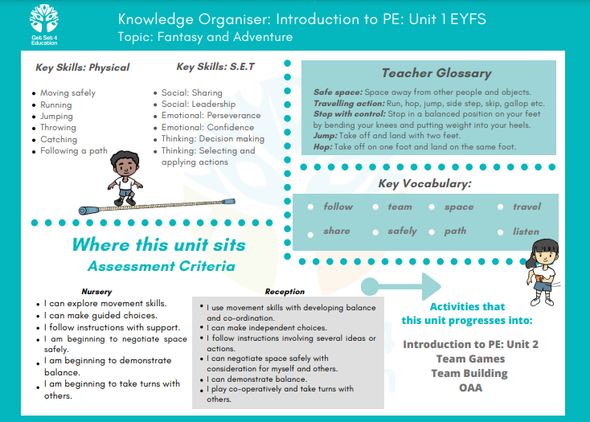
KS1
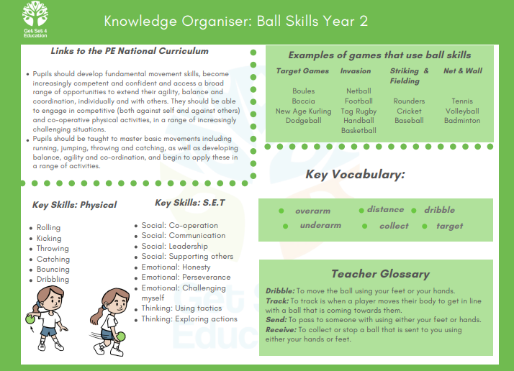

LKS2
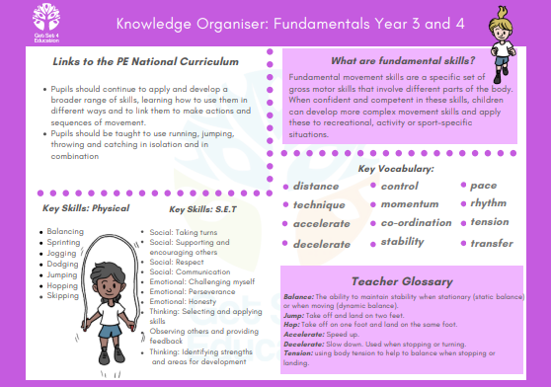

UKS2
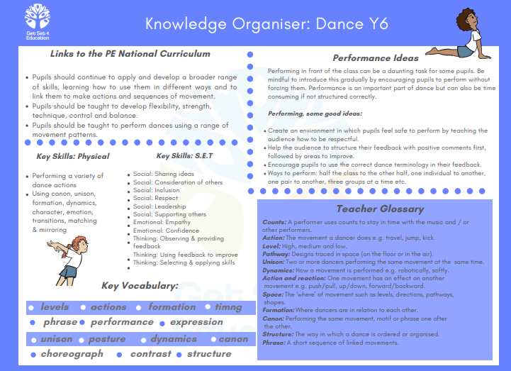

Evidence on Class Dojo, Tapestry, PE Boards and PE books for Year 5 and Year 6

