
‘They will soar on wings like eagles …’
Isaiah 40:31


collaborate | enrich | trust | innovate | aspire | nurture

Multi Academy Trust Policy
Common Trust Policy, Use as Published
Relationships and Sex Education Policy

Date adopted by Trust Board: 08/06/2026
Date of Review: May 2026
Date of next Review: 07/06/2027

Version | Date | Author | Change Description
V1 | 29.1.25 | AW & JAJ | New policy in draft for Sept 2026.
V2 | 29.05.2026 | JAJ | To take account of new policy and curriculum requirements from 9/26

Aquila Multi-Academy Trust RSE Policy

Policy Statement
Aquila Multi-Academy Trust is committed to providing high-quality Relationships and Sex Education (RSE) in line with statutory guidance from the Department of Education. This policy outlines the approach to RSE in our academies, supporting pupils to make informed choices, develop positive relationships, and build resilience. Our RSE curriculum reflects Aquila’s values of Collaborate, Enrich, Trust, Innovate, Aspire, and Nurture. This policy reflects the Department for Education statutory guidance on Relationships Education, Relationships and Sex Education and Health Education (updated 2026), and will be reviewed in line with any future revisions.

Our Church of England schools will approach RSE in a faith sensitive and inclusive way.

1. Aims
The aims of relationships and sex education (RSE) at our school are to:
- Provide a framework in which sensitive discussions can take place
- Prepare pupils for puberty, and give them an understanding of sexual development and the importance of health and hygiene
- Help pupils develop feelings of self-respect, confidence and empathy, and cultivate positive characteristics such as kindness and integrity
- Create a positive culture around issues of sexuality and relationships
- Teach pupils the correct vocabulary to describe themselves and their bodies

2. Statutory requirements
As a primary academy, we must provide relationships education to all pupils under section 34 of the Children and Social Work Act 2017.

We don’t have to follow the National Curriculum, but we are expected to offer all pupils a curriculum that is similar to the National Curriculum including requirements to teach science. This would include the elements of sex education contained in the science curriculum.
In teaching RSE, we’re required by our funding agreements to have regard to guidance issued by the secretary of state, as outlined in section 403 of the Education Act 1996.
We also have regard to legal duties set out in:
- Sections 404 to 407 of the Education Act 1996
- Part 6, chapter 1 of the Equality Act 2010
- The Public Sector Equality Duty (PSED) (as set out in section 149 of the Equality Act 2010). This duty requires public bodies to have due regard to the need to eliminate discrimination, advance equality of opportunity and foster good relations between different people when carrying out their activities
At Charlton CE Primary School we teach RSE as set out in this policy.

3. Policy development
This policy has been developed in consultation with staff, pupils and parents/carers. The consultation and policy development process involved the following steps:
- Review – a member of staff or working group pulled together all relevant information including relevant national and local guidance

- Staff consultation – all school staff were given the opportunity to look at the policy and make recommendations

- Parent/stakeholder consultation – parents/carers and any interested parties were invited to attend a meeting about the policy

- Pupil consultation – we investigated what exactly pupils want from their RSE

- Ratification – once amendments were made, the policy was shared with governors and ratified

4. Definition
For the purpose of this policy:
RSE is about the emotional, social and cultural development of pupils, and involves learning about relationships, sexual health, sexuality, healthy lifestyles, diversity and personal identity.
RSE involves a combination of sharing information, and exploring issues and values.
RSE is not about the promotion of sexual activity.

5. Curriculum
Our RSE curriculum is set out as per Appendices 1 and 2, but we may need to adapt it as and when necessary.
If pupils ask questions outside the scope of this policy, teachers will respond in an appropriate manner so that pupils are fully informed and don’t seek answers online.
Charlton CE Primary School is committed to working in partnership with parents/carers and being fully transparent about the RSE curriculum.

We will:
- Publish an overview of the RSE curriculum on the school website
- Provide parents/carers with clear information about what will be taught in each year group and when
- Share examples of teaching materials and resources in advance of delivery, particularly for sensitive topics
- Offer opportunities (e.g. information sessions, workshops or online materials) for parents/carers to view and discuss curriculum content

- Notify parents/carers in advance of any significant changes or additions to the planned curriculum

Parents/carers will:
- Be able to contact the school to discuss curriculum content at any time
- Be supported to understand how content is delivered in an age-appropriate way

We will ensure that all materials used in RSE can be shared with parents/carers, in line with our legal obligations.

6. Delivery of RSE
RSE is taught within the personal, social, health and economic (PSHE) education curriculum. Charlton CE Primary School uses the Jigsaw PSHE and RSE scheme of work to deliver lessons. Biological aspects of RSE are taught within the science curriculum, and other aspects are included in religious education (RE).
The school will make sure that:
- Core knowledge is sectioned into units of manageable size
- The required content is communicated to pupils clearly, in a carefully sequenced way and within a planned scheme of work
- Teaching includes sufficient and well-chosen opportunities and contexts for pupils to embed new knowledge, so that it can be used confidently in real-life situations
- Our Relationships and Sex Education (RSE) curriculum is planned and delivered with the needs of all pupils in mind, including those with special educational needs and disabilities (SEND). Teaching is adapted where appropriate to ensure that all pupils can access the curriculum, develop their understanding at an age-appropriate level, and build the knowledge and skills they need to form safe, healthy and respectful relationships and to understand the physical and emotional changes they experience as they grow.
Relationships education focuses on teaching the fundamental building blocks and characteristics of positive relationships including:
- Families and people who care for me
- Caring friendships
- Respectful, kind relationships
- Online safety and awareness
- Being safe
Primary sex education will focus on:
- Preparing boys and girls for the changes that adolescence brings
- How a baby is conceived and born (conception)
- Any teaching about human conception, pregnancy or birth that goes beyond the science curriculum will be clearly identified as non-statutory sex education. Parents/carers have the right to withdraw their child from these specific lessons. The school will notify parents in advance of when these lessons will take place and will share all teaching materials beforehand.
Throughout each year group we will use appropriate material to assist learning, such as:
- Diagrams
- Videos
- Books
- Games
- Discussions and practical activities
- Teachers will make sure that all pupils’ views are listened to, and will encourage them to ask questions and engage in discussion. Teachers will answer questions sensitively, honestly and appropriately for the age of the pupils. Staff will answer pupils’ questions in a factual, age-appropriate manner while maintaining appropriate boundaries. Where questions relate to contested or sensitive topics (e.g., gender identity, sexual orientation, or adult sexual behaviour), staff will:
- Provide simple, factual reassurance
- Avoid unnecessary detail
- Avoid teaching contested concepts as fact
- Redirect pupils to trusted adults if needed
- Inform parents/carers where appropriate
Staff will not introduce content that is not part of the planned curriculum.
The programme will be designed to focus on boys as much as girls, and activities will be planned to make sure both are actively involved.
The school will make sure that all teaching and materials are appropriate for the ages and needs of the pupils including any additional needs, such as special educational needs and disabilities (SEND).
Biological sex will be taught as a factual, scientific characteristic that is binary (male and female) and determined at birth. The school will not teach gender identity as a separate, contested belief system or present it as fact. Where pupils raise questions about gender identity, staff will respond factually, sensitively and age-appropriately, ensuring that contested concepts are not taught as objective truth. Teaching will always distinguish clearly between biological facts, legal rights, and individual beliefs or experiences. Teaching will always comply with the Equality Act 2010, ensuring that all pupils are treated with dignity and respect, regardless of protected characteristics.
Pupils will be assessed informally through discussion and observation.
The programme will be designed to focus on boys as much as girls, and activities will be planned to make sure both are actively involved.
The school will make sure that all teaching and materials are appropriate for the ages and needs of the pupils including any additional needs, such as special educational needs and disabilities (SEND).
All resources used are assessed as appropriate.
At all points of delivery of the curriculum, the school will consult parents and carers, and their views will be valued. What will be taught and how will be planned in conjunction with parents and carers.
We may amend our curriculum content to respond to the needs and context of our pupils, to discuss issues affecting them in an age-appropriate manner. We will inform parents and carers of any deviation from our published policy in advance, and share any relevant materials on request.
These areas of learning are taught within the context of family life, taking care to make sure that there is no stigmatisation of children based on their home circumstances (i.e. families can include single-parent families, same-sex parents, families headed by grandparents, adoptive parents and foster parents among other structures), along with reflecting sensitively that some children may have a different structure of support around them (for example, looked-after children, young carers or kinship carers).
Across our school, we will also be mindful of the law and legal requirements, taking care not to condone or encourage illegal activity, such as violent action against people, criminal damage to property or hate crime.
  - Age-appropriate sequencing and content safeguards
The school will ensure that all RSE content is delivered in a carefully sequenced, age-appropriate manner in line with statutory guidance and safeguarding principles. The school will follow the statutory age limits for RSHE content. No explicit sexual content will be taught in primary school, including descriptions of sexual acts. Before Year 5, teaching will focus on relationships, safety, respect, body awareness and privacy, not sexual content. Puberty will be taught before the average age of onset, typically in Year 4 or Year 5, to ensure pupils are prepared. Conception and birth will be taught factually and sensitively, without unnecessary detail, and only in the context of the science curriculum or clearly identified non-statutory sex education.

Staff will use professional judgement, supported by curriculum planning, to:
- Distinguish between what pupils *need to know now* and what should be taught later
- Adapt teaching in response to pupils’ questions while maintaining appropriate boundaries
- Avoid the use of detailed or explicit materials unless they are necessary, justified by the curriculum, and age-appropriate

Any decisions to adapt or accelerate content will be:
- Based on identified pupil need
- Agreed by the subject lead/DSL where content is sensitive
- Communicated to parents/carers in advance where appropriate

  - Inclusivity
We will teach about these topics in a manner that:
- Considers how a diverse range of pupils will relate to them
- Is sensitive to all pupils’ experiences
- During lessons, makes pupils feel:
  - Safe and supported
  - Able to engage with the key messages
We will also:
- Make sure that pupils learn about these topics in an environment that’s appropriate for them, for example in:
  - A whole-class setting
  - Small groups or targeted sessions
  - 1-to-1 discussions
  - Digital formats
- Give careful consideration to the level of adaption needed

  - Use of resources
We will consider whether any resources we plan to use:
  - Are aligned with the teaching requirements set out in the statutory RSE guidance
  - Would support pupils in applying their knowledge in different contexts and settings
  - Are age-appropriate, given the age and maturity of the pupils
  - Are evidence-based and contain robust facts and statistics
  - Fit into our curriculum plan
  - Are from credible sources
  - Are compatible with effective teaching approaches
  - Are sensitive to pupils’ experiences and won’t provoke distress
We will make sure that when we consult parents/carers we provide examples of the resources that the school plans to use.

7. Use of external organisations and materials
We will make sure that an agency and any materials used are accurate, age and stage appropriate and unbiased and in line with our legal duties around political impartiality.
We will:
- Make appropriate checks and engage with external agencies to make sure that their approach to teaching about RSE is balanced, and it and the resources they intend to use:
  - Are age-appropriate
  - Are in line with pupils’ developmental stage
  - Comply with:
    - This policy
    - The Teachers’ Standards
    - The Equality Act 2010
    - The Human Rights Act 1998
    - The Education Act 1996
- Only work with external agencies where we have full confidence in the agency, its approach and the resources it uses
- Make sure that any speakers and resources meet the intended outcome of the relevant part of the curriculum
- Review any case-study materials and look for feedback from other people the agency has worked with
- Be clear on:
  - What they’re going to say
  - Their position on the issues to be discussed
- Ask to see in advance any materials that the agency may use
- Know the named individuals who will be there, and follow our usual safeguarding procedures for these people
- Conduct a basic online search and address anything that may be of concern to us, or to parents and carers
- Check the agency’s protocol for taking pictures or using any personal data they might get from a session
- Remind teachers that they can say “no” or, in extreme cases, stop a session
- Make sure that the teacher is in the room during any sessions with external speakers
- Inform all external organisations that the school is legally obliged to share all content with parents and carers
- Share all external materials with parents and carers.
Parents and carers have the legal right to view all RSE materials, including lesson slides, videos, worksheets, and external-agency content. The school will provide access on request, and will not use any resource that cannot legally be shared with parents. The full RSE curriculum map and an outline of lesson content will be published on the school website and updated annually.
We won’t, under any circumstances:
- Work with external agencies that take or promote extreme political positions
- Use materials produced by such agencies, even if the material itself is not extreme
- Work with agencies who don’t allow their material to be shared with parents and carers
- The school will not use any materials that contain extreme, inappropriate, sexualised or ideologically biased content, or that present contested political or social concepts as fact. All materials will be checked for accuracy, age-appropriateness, neutrality and compliance with statutory guidance.

8. Roles and responsibilities
8.1 The role of the trustees and local governing body
The trustees will approve the RSE policy, and the local governing body will hold the headteacher to account for its implementation.
8.2 The headteacher
The headteacher is responsible for making sure that RSE is taught consistently across the school, for sharing all resources and materials with parents and carers, and for managing requests to withdraw pupils from non science components of RSE (see section 9).
8.3 Staff
Staff are responsible for:
- Delivering RSE in a way that is sensitive, high-quality and appropriate for each year group
- Modelling positive attitudes to RSE
- Monitoring progress
- Responding to the needs of individual pupils
- Responding appropriately to pupils whose parents/carers wish them to be withdrawn from the non-science components of RSE
- Modelling positive behaviour and avoiding language that might perpetuate harmful stereotypes, and being conscious of everyday sexism, misogyny, homophobia and stereotypes
- Reporting any safeguarding concerns or disclosures that pupils may make as a result of the subject content to the school’s designated safeguarding lead (DSL) Mrs. Amy Moat.
Staff do not have the right to opt out of teaching RSE. Staff who have concerns about teaching RSE are encouraged to discuss this with the headteacher.
The RSE subject leader is Ms. Lindsey Mitten.
8.4 Pupils
Pupils are expected to engage fully in RSE and, when discussing issues related to RSE, treat others with respect and sensitivity.
8.5 Safeguarding

RSE may lead to pupils asking questions or making disclosures that raise safeguarding concerns. All staff will follow the school’s safeguarding policy and procedures in such cases.

Staff will:

- Create a safe environment in which pupils feel able to ask questions, while making it clear that confidentiality cannot be guaranteed
- Remind pupils of appropriate ways to seek further help and support
- Respond to questions in a factual, age-appropriate manner without encouraging disclosure in a public setting
- Not ask leading questions or probe for additional detail beyond what is necessary

If a pupil makes a disclosure or raises a concern, staff will:

- Follow the school’s safeguarding procedures immediately
- Record the concern accurately and pass it to the Designated Safeguarding Lead (DSL) without delay
- Not promise confidentiality to the pupil
- Ensure the pupil is supported appropriately

The Designated Safeguarding Lead (DSL) will:

- Take appropriate action in line with Keeping Children Safe in Education (KCSIE)
- Liaise with external agencies where necessary
- Ensure staff receive appropriate guidance following any incident arising from RSE delivery

RSE teaching will be planned and delivered in a way that:

- Minimises the risk of distress or unnecessary disclosure
- Takes account of known vulnerabilities within the cohort
- Is aligned with the school’s wider safeguarding and child protection framework
All RSHE content will be delivered in a carefully sequenced progression that reflects statutory age limits, safeguarding principles and pupils’ developmental readiness. The school will ensure that no content is taught earlier than required or in a way that could cause distress, confusion or safeguarding concerns.

9. Parents’ right to withdraw
Parents/carers do not have the right to withdraw their child from relationships education or statutory Science education.
We do not cover sex education
Parents/carers have the right to withdraw their child from the non-statutory/non-science components of sex education within RSE.
Requests for withdrawal should be put in writing using the form found in Appendix 3 of this policy and addressed to the headteacher.
Alternative schoolwork will be given to pupils who are withdrawn from sex education.

10. Training
Staff are trained on the delivery of RSE as part of their induction and it is included in our continuing professional development calendar.
The headteacher will also invite visitors from outside the school, such as school nurses or sexual health professionals, to provide support and training to staff teaching RSE.

11. Monitoring arrangements
The delivery of RSE is monitored by Ms Lindsey Mitten through:
Planning scrutinies, learning walks, pupil voice and observations.
Pupils’ development in RSE is monitored by class teachers as part of our internal assessment systems.

Appendix 1: Curriculum map
Relationships and sex education curriculum map

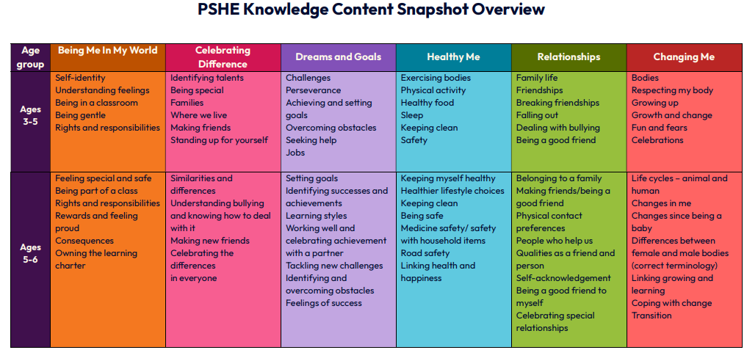
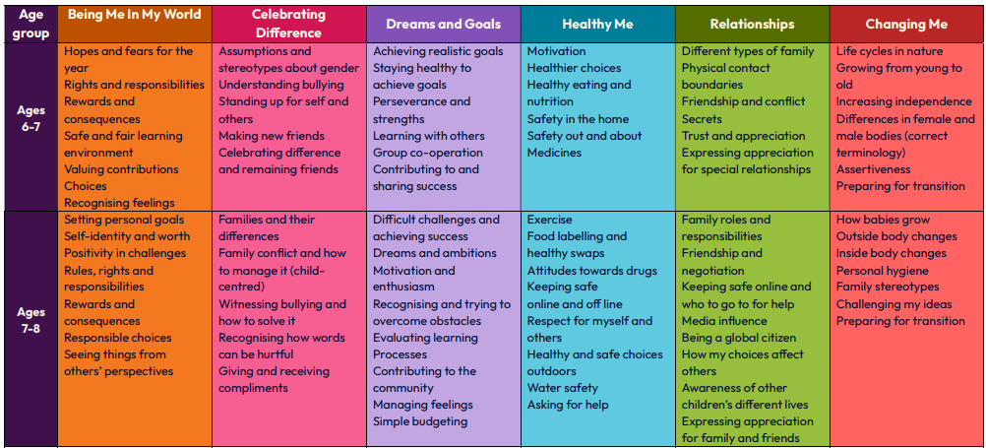
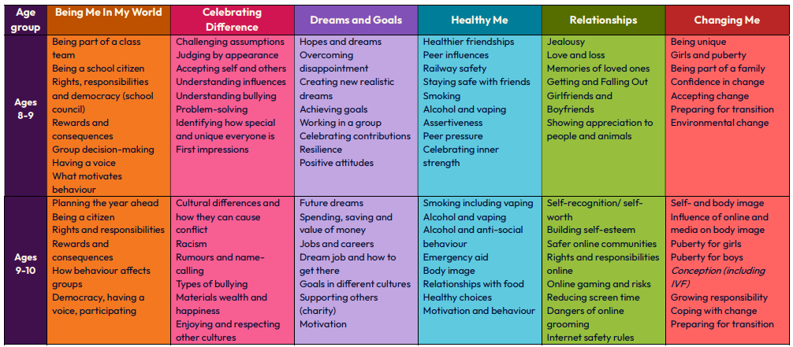
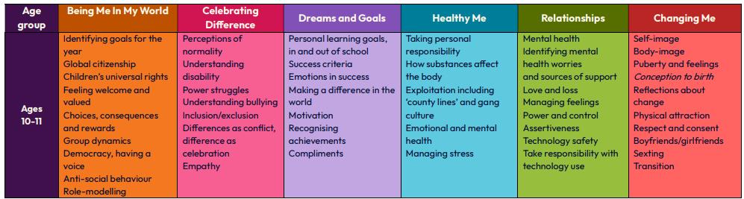

Appendix 2: By the end of primary school pupils should know
Topic | Pupils should know
Families and people who care for me | - That families are important for children growing up because they can give love, security and stability  - The characteristics of safe and happy family life, such as: commitment to each other, including in times of difficulty, protection and care for children and other family members, the importance of spending time together and sharing each other’s lives  - That other children’s families, either in school or in the wider world, sometimes look different from their own, but they should respect those differences and know that other families are also characterised by love and care  - That stable, caring relationships are at the heart of safe and happy families, and are important for children’s security as they grow up  - That marriage and civil partnerships represent a formal and legally recognised commitment of 2 people to each other which is intended to be lifelong  - How to recognise if family relationships are making them feel unhappy or unsafe, and how to seek help or advice from others if needed
Caring friendships | - How important friendships are in making us feel happy and secure, and how people choose and make friends  - The characteristics of friendships that lead to happiness and security, including: mutual respect, truthfulness, trust and trustworthiness, loyalty, kindness, generosity, sharing interests and experiences and support with problems and difficulties  - That healthy, caring and kind friendships are positive and welcoming towards others, and do not make others feel lonely or excluded. Pupils should learn skills for developing caring, kind friendships  - That not every child will have the friends they would like at all times, that most people feel lonely sometimes, and that there is no shame in feeling lonely or talking about it  - That most friendships have ups and downs, and that these can often be worked through so that the friendship is repaired or even strengthened  - About managing conflict with kindness and respect, and that violence is never right  - How to recognise when a friendship is making them feel unhappy or uncomfortable, and how to seek help or advice from others, if needed
Respectful, kind relationships | - The importance of respecting others, including in families and friendships. Pupils should be encouraged to discuss how we can balance the needs and wishes of different people, and why this can be complicated  - The importance of setting and respecting healthy boundaries in all relationships with friends, family, peers and adults  - How to communicate effectively: how to be assertive and express needs and boundaries and manage feelings, including disappointment and frustration  - That they can expect to be treated with respect and the importance of respecting others, including those who are different (for example: physically, in character, personality or background), or make different choices, or have different preferences or beliefs  - The practical steps they can take in a range of different contexts to improve or support their relationships  - The conventions of courtesy and manners  - The importance of self-respect and how this links to their own happiness. They should have opportunities to consider issues like self-esteem and building a sense of their own identity  - Pupils should have opportunities to discuss the difference between being assertive and being controlling, and the difference between being kind to other people and neglecting your own needs.  - About different types of bullying (including cyberbullying), the impact of bullying, responsibilities of bystanders (primarily reporting bullying to an adult) and how to get help  - How to seek help when needed, including when they are concerned about violence, harm, or when they are unsure who to trust  - What a stereotype is, and how stereotypes can be unfair, negative or destructive or lead to bullying and how to challenge a stereotype
Online safety and awareness | - That people sometimes behave differently online, including by pretending to be someone they are not and/or pretending to be a child  - That the same principles apply to online relationships as to face-to face relationships, including the importance of respect for others online including when we are anonymous  - The rules and principles for keeping safe online, how to recognise risks, harmful content and contact, and how to report them  - That there is a minimum age for joining most social media sites which protects children from inappropriate content or unsafe content with older social media users, who may be strangers, including other children and adults  - That it’s important to be cautious about sharing any information about themselves online, and how to use privacy and location settings to protect their information online  - How to critically consider their online friendships and sources of information, including awareness of the risks associated with people they have never met  - How information and data is shared and used online, including where pictures or words might be circulated  - Online risks, including that any material provided online might be circulated, and that once a picture or words has been circulated there is no way of deleting it everywhere and no control over where it ends up  - That the internet contains a lot of content that can be inappropriate and upsetting for children, and where to go for advice and support when they feel worried or concerned about something they have seen or engaged with online
Being safe | - What sorts of boundaries are appropriate in friendships with peers and others (including in a digital context). This can include learning about boundaries in play and in negotiations about space, toys, books, resources for example  - About the concept of privacy and the implications of it for both children and adults, including that it’s not always right to keep secrets if they relate to being safe  - That each person’s body belongs to them, and the differences between appropriate and inappropriate or unsafe physical, and other, contact  - How to respond safely and appropriately to adults they may encounter (in all contexts, including online) including those they do/don’t know  - How to recognise when a relationship is harmful or dangerous, including skills for recognising who to trust and who not to trust  - How to report concerns or abuse, about something seen online or experienced in real life, or feelings of being unsafe or feeling bad about any adult, and the vocabulary and confidence needed to do so  - Where to get advice, for example from their family, school and/or other sources

Appendix 3: Parent/carer form requesting their child’s withdrawal from sex education within RSE

To be completed by parents/CARERS
Name of child |  | Class
Name of parent/carer |  | Date
Reason for withdrawing from sex education within relationships and sex education
Any other information you would like the school to consider
Parent/carer signature

To be completed by the school
Agreed actions from discussion with parents/carers

