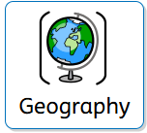
Geography Progression Overview
Year 1
How is the weather changing as it becomes Autumn?
Geography | National curriculum:  identify seasonal and daily weather patterns in the United Kingdom
Specific outcomes taught | Substantive Vocabulary | Disciplinary Vocabulary | Knowledge | Assessment  End points
 | 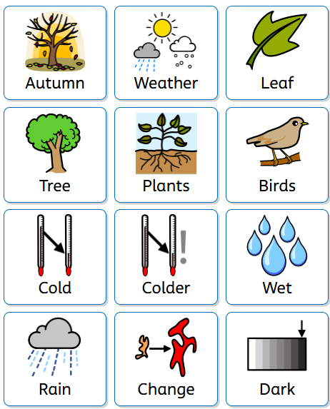 | 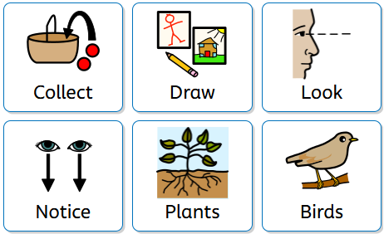 | - How is the year organised into months and seasons?  - What are the differences between the seasons?  - How can I show what season I am in?  - How do people dress for different kinds of weather?  - How can I tell the weathers story?  - How does the weather effect peoples work? | - I know how seasons are different  - I know some of the signs of the seasons  - I can identify the weather

Geography Progression Overview
Year 1 – Term 3
How has our school changed over time?
Geography | National Curriculum:  key human features, including: city, town, village, factory, farm, house, office, port, harbour and shop  use simple compass directions (North, South, East and West) and locational and directional language [for example, near and far; left and right], to describe the location of features and routes on a map  use simple fieldwork and observational skills to study the geography of their school and its grounds and the key human and physical features of its surrounding environment.
Specific outcomes taught | Substantive Vocabulary | Disciplinary Vocabulary | Knowledge | Assessment  End points
 | 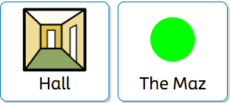  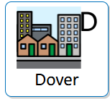  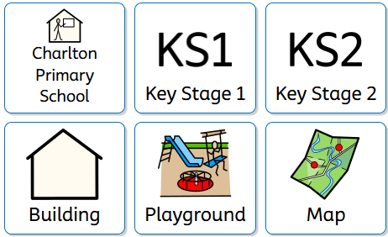 | 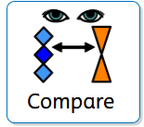  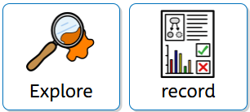  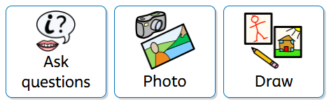 | - What is in ‘living memory’ of our school?  - What is our school and local area like today?  - What was it like in the past?  - How do we know?  - What has changed?  - What has stayed the same? | - I can find our school on a map  - I can explain what school was like in the past  - I know how our school has changed over time.

Geography Progression Overview
Year 1
What is the seaside like in Dover?
Geography | National Curriculum  understand geographical similarities and differences through studying the human and physical geography of a small area of the United Kingdom  use basic geographical vocabulary to refer to: key physical features, including: beach, cliff, coast, forest, hill, mountain, sea, ocean, river, soil, valley, vegetation, season and weather  use aerial photographs and plan perspectives to recognise landmarks and basic human and physical features; devise a simple map; and use and construct basic symbols in a key
Specific outcomes taught | Substantive Vocabulary | Disciplinary Vocabulary | Knowledge | Assessment  End points
 | 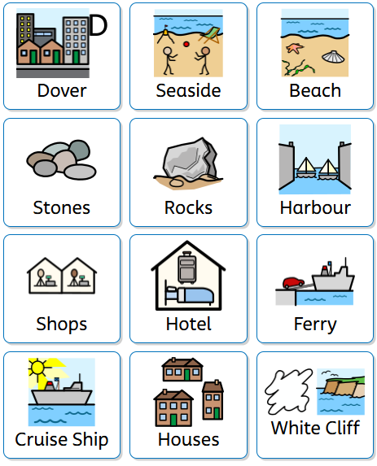 | 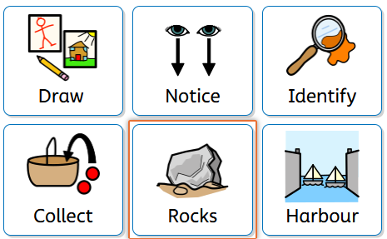 | - How are coasts and beaches different?  - How can we tell the difference between human and physical features at the seaside?  - How do animals survive in rockpools?  - How can we protect our seas and beaches?  - Why do beaches around the world look different?  - How do maps help us find places? | - I know how different the beach can be.  - I know what wildlife can be found at the beach.  - I can find key parts of the beach.

Geography Progression Overview
Year 2
How is the UK different to Kenya?
Geography | National Curriculum: name and locate the world’s seven continents and five oceans  name, locate and identify characteristics of the four countries and capital cities of the United Kingdom and its surrounding seas  understand geographical similarities and differences through studying the human and physical geography of a small area in a contrasting non-European country  use world maps, atlases and globes to identify the United Kingdom and its countries, as well as the countries, continents and oceans studied at this key stage
Specific outcomes taught | Substantive Vocabulary | Disciplinary Vocabulary | Knowledge | Assessment  End points
 | 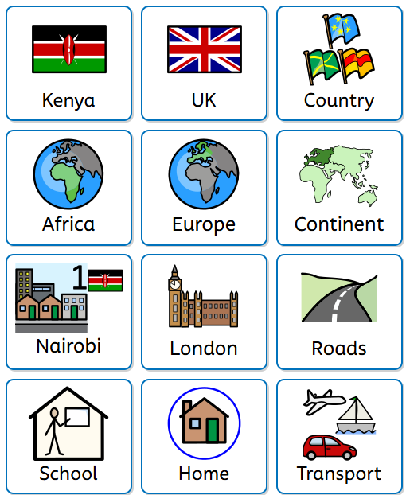 | 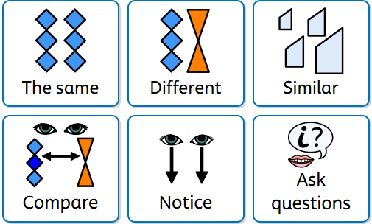 | - What are the four counties and capitals of the UK?  - What are the continents and seas of the world?  - Where is Kenya and what is it like there? (Homes, school, transport, weather, landscapes, jobs and communities )  - Climate and weather patterns, rivers, mountains, savannah  - How is Dover and Kenya similar/different? - climate | - I can name the four countries and parts of the UK  - I know that life in Kenya is different and similar to life in the UK.  - I know the continents and seas of the world.

Geography Progression Overview
Year 2
Why do animals live in different habitats?
Geography | National Curriculum: identify seasonal and daily weather patterns in the United Kingdom and the location of hot and cold areas of the world in relation to the Equator and the North and South Poles  use simple compass directions (North, South, East and West) and locational and directional language [for example, near and far; left and right], to describe the location of features and routes on a map
Specific outcomes taught | Substantive Vocabulary | Disciplinary Vocabulary | Knowledge | Assessment  End points
 | 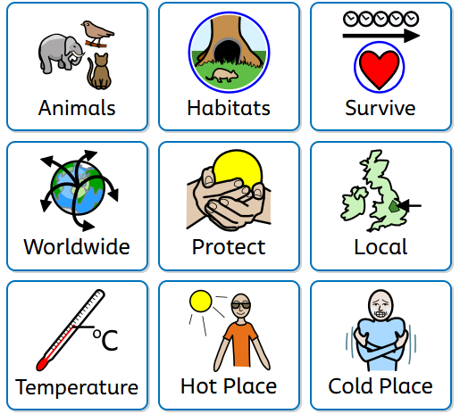 |  | - What is a habitat, and what makes it a good home for an animal?  - How are habitats around the world different from one another?  - Why do some animals live in hot places and others in cold places?  - How are animals adapted to survive in their habitats? | - I know how habitats are important to animals  - I can name different animal habitats

Geography Progression Overview
Year 2
How does living on an island change the way people live?
Geography | National Curriculum  understand geographical similarities and differences through studying the human and physical geography of a small area of the United Kingdom  key human features, including: city, town, village, factory, farm, house, office, port, harbour and shop
Specific outcomes taught | Substantive Vocabulary | Disciplinary Vocabulary | Knowledge | Assessment  End points
 | 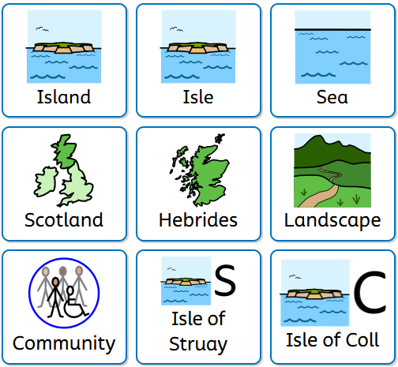 | 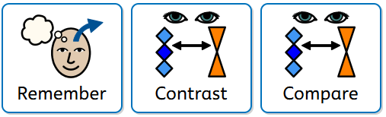 | - Where is Dover and where is Katie’s island the Isle of Coll (the island the book is based on)  - Where are the Hebrides, and what is island life like there?  - How is the Isle of Struay similar to and different from where we live?  - How does the landscape of an island affect how people travel and work?  - What is special about living in a small island community? | - I know how Island life is different to mainland life  - I can discuss how community is different.

Geography Progression Overview
Year 3
Why are rainforests important and who decides how they are used?
Geography | National Curriculum  locate the world’s countries, using maps to focus on North America concentrating on their environmental regions, key physical and human characteristics, countries, and major cities  physical geography, including: climate zones, biomes and vegetation belts
Specific outcomes taught | Substantive Vocabulary | Disciplinary Vocabulary | Knowledge | Assessment  End points
 | 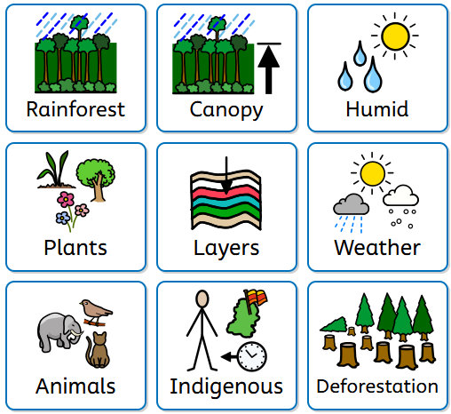 | 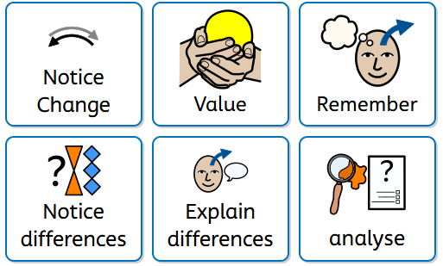 | - Where in the world are rainforests, and what makes them so hot and wet?  - What are the four layers of a rainforest, and how are plants/animals adapted to live in them?  - Why are rainforests sometimes called "the lungs of the planet?  - How do indigenous communities live in harmony with the rainforest?  - What is deforestation and how does it change the landscape?  - Who decides how the rainforest is used and can we save it? | - I can find where rainforests are in the world  - I know the names of different aspects of the rainforest  - I can decide how to care for the rainforest

Geography Progression Overview
Year 3
Volcanoes and Earthquakes – why do they happen and how do they affect people’s lives?
Geography | National Curriculum  understand geographical similarities and differences through the study of physical geography of a region of the United Kingdom, a region in a European country, and a region within North or South America  physical geography, including: volcanoes and earthquakes
Specific outcomes taught | Substantive Vocabulary | Disciplinary Vocabulary | Knowledge | Assessment  End points
 | 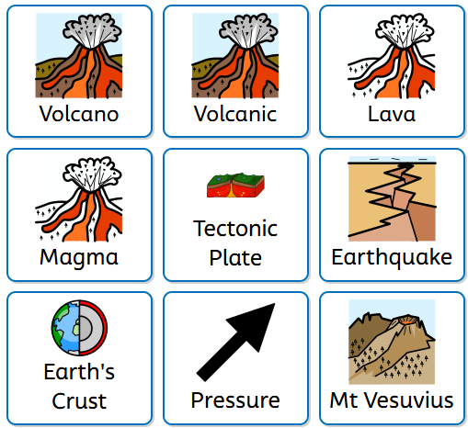 | 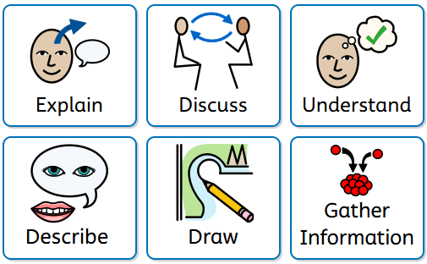 | - How do tectonic plates move?  - Where do volcanoes and earthquakes happen?  - What causes volcanoes and earthquakes?  - How do volcanoes and earthquakes affect people and places?  - What happened at Pompeii when Eruption of Mount Vesuvius took place?  - How can we use maps and evidence to understand natural disasters? | - I know how volcanic eruptions and Earthquakes can happen.  - I can name ways in which these events effect our lives today and in the past.

Geography Progression Overview
Year 3
How does the water cycle shape rivers, coasts and the lives of people in the UK?
Geography | National Curriculum  physical geography, including: rivers and the water cycle  use fieldwork to observe, measure, record and present the human and physical features in the local area using a range of methods, including sketch maps, plans and graphs, and digital technologies.
Specific outcomes taught | Substantive Vocabulary | Disciplinary Vocabulary | Knowledge | Assessment  End points
 | 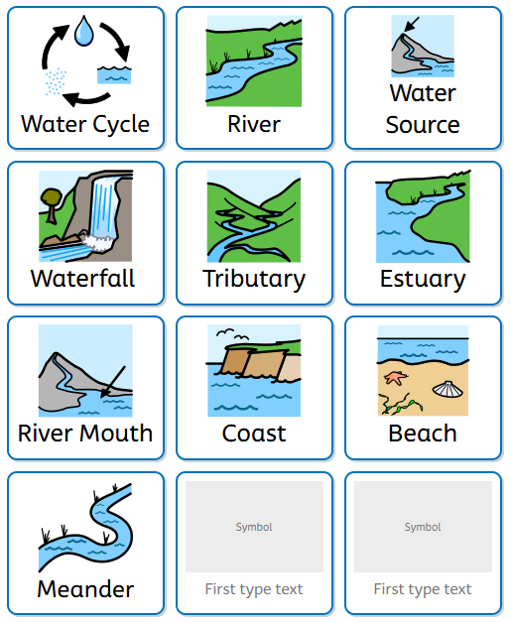 | 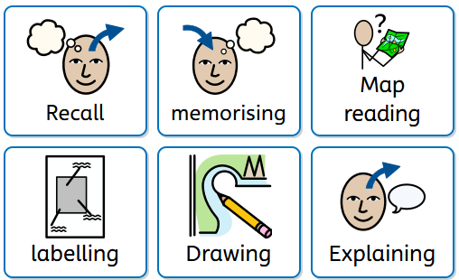 | - What is the water cycle?  - How do rivers form and flow?  - How does water shape coasts and landscapes?  - What causes flooding and coastal change?  - How do rivers and coasts affect people’s lives in the UK?  - How can maps, fieldwork and data help us understand rivers and coasts? | - I can name parts of the river and describe their function  - I know how our lives can be affected by rivers  - I can use fieldwork and maps to find our more about rivers and coasts.

Geography Progression Overview
Year 4
How do mountains shape the land and the way people live?
Geography | National Curriculum  understand geographical similarities and differences through the study of human and physical geography of a region of the United Kingdom, a region in a European country, and a region within North or South America  human geography, including: types of settlement and land use, the distribution of natural resources including minerals
Specific outcomes taught | Substantive Vocabulary | Disciplinary Vocabulary | Knowledge | Assessment  End points
 | 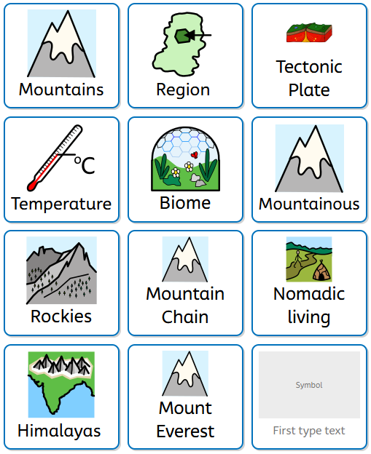 | 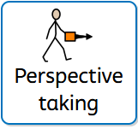  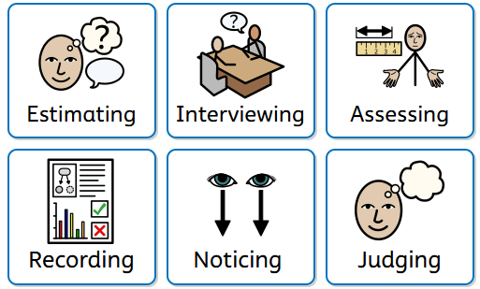 | - What is a mountain and how are they formed?  - Where are the world’s major mountains and what are the mountains of the UK like?  - How does being high up affect climate, plants and animals?  - Why do people choose to live in mountainous places?  - What is topography? | - I know how life in the mountains if different to Dover  - I know about the environment in mountain chains  - I know how mountains are formed

Geography Progression Overview
Year 4
Why is the Arctic such a challenging place to explore?
Geography | National Curriculum  identify the position and significance of latitude, longitude, Equator, Northern Hemisphere, Southern Hemisphere, Arctic and Antarctic Circle  use fieldwork to observe, measure, record and present the human and physical features in the local area using a range of methods, including sketch maps, plans and graphs, and digital technologies.
Specific outcomes taught | Substantive Vocabulary | Disciplinary Vocabulary | Knowledge | Assessment  End points
 | 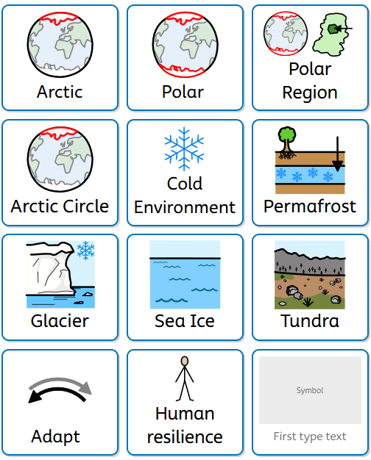 | 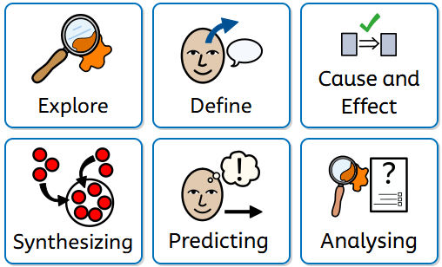 | - Where is the Arctic and what is it like there?  - What are the Key physical features?  - Who was Ernest Shackleton and what did he do?  - How do people explore and survive in extreme environments? | - I know what the key physical features of the arctic are  - I know about polar discovery in the past and present  - I can identify why the environment is ‘Extreme’

Geography Progression Overview
Year 4
How does our local landscape in Dover compare to Fort William, and how can we map and represent it?
Geography | National Curriculum  name and locate counties and cities of the United Kingdom, geographical regions and their identifying human and physical characteristics, key topographical features (including hills, mountains, coasts and rivers), and land-use patterns; and understand how some of these aspects have changed over time  use the eight points of a compass, four and six-figure grid references, symbols and key (including the use of Ordnance Survey maps) to build their knowledge of the United Kingdom and the wider world
Specific outcomes taught | Substantive Vocabulary | Disciplinary Vocabulary | Knowledge | Assessment  End points
 | 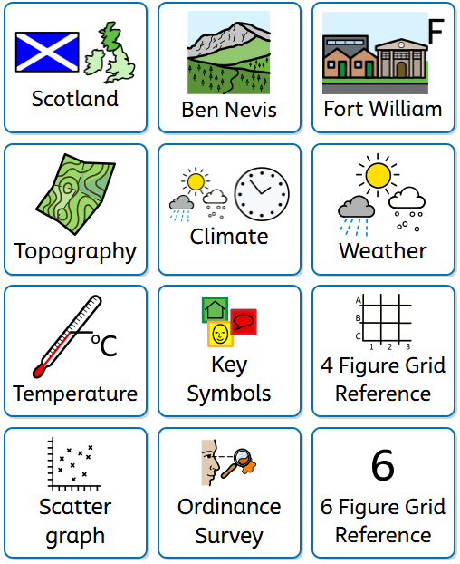  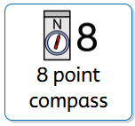 | 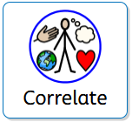  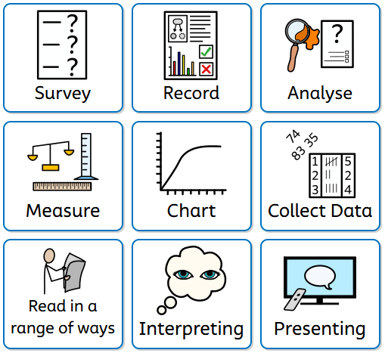 | - What is our local landscape like?  - How do maps help us understand places?  - How precise can we be with location?  - How does Dover compare to Ben Nevis?  - How can we present what we’ve found? | - I can use fieldwork to find out more about an area  - I can create presentations and data about a place  - I know how this data shows that Dover may be different to other places in the world.

Geography Progression Overview
Year 5
How does life in Mexico compare to life in the UK?
Geography | National Curriculum  locate the world’s countries, using maps to focus on North America concentrating on their environmental regions, key physical and human characteristics, countries, and major cities
Specific outcomes taught | Substantive Vocabulary | Disciplinary Vocabulary | Knowledge | Assessment  End points
 | 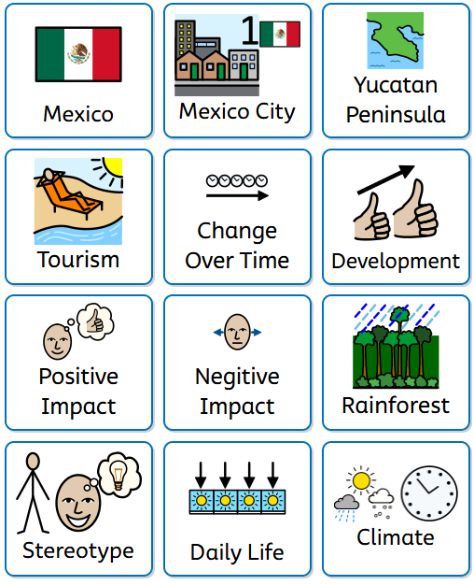  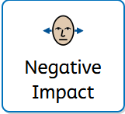 | 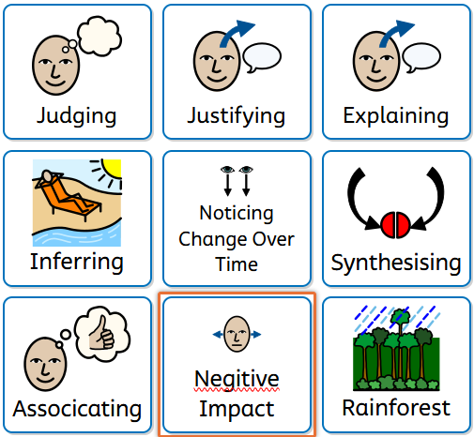 | - Where is Mexico and how does it compare geographically to the UK?  - What are the landscapes and climates like in Mexico?  - How do people live in different parts of Mexico?  - How are schools, homes and daily life similar and different?  - How does tourism affect Mexico?  - What can maps and data tell us about life in Mexico?  - Are common stereotypes about Mexico accurate? | - I know how life can be different in Central America  - I know how to use data to know more about a place  - I can explain how tourism can impact a place

Geography Progression Overview
Year 5
Why is water so important?
Geography | National Curriculum  human geography, including: the distribution of natural resources including energy and water
Specific outcomes taught | Substantive Vocabulary | Disciplinary Vocabulary | Knowledge | Assessment  End points
 | 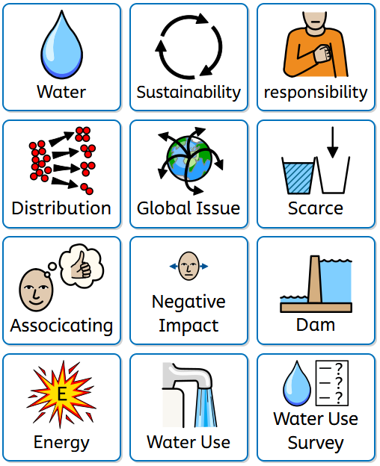 | 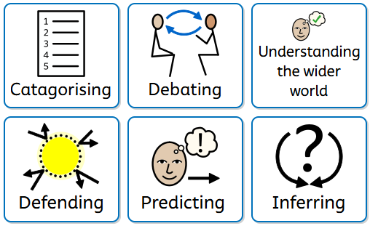 | - How do we use water every day?  - Why do some places have plenty of water while others do not?  - Where in the world has little amounts of water?  - How else can we use water?  - What happens when we use too much water?  - How can we best conserve the future? | - I know how water is an important resource beyond drinking  - I can list ways that water is could cause conflict in the world.  - I can name places with scarce amounts water

Geography Progression Overview
Year 5
Why do people trade across the world and how does it affect us?
Geography | National Curriculum  human geography, including: types of settlement and land use, economic activity including trade links, and the distribution of natural resources including energy, food, minerals and water  understand geographical similarities and differences through the study of human geography of a region of the United Kingdom, a region in a European country, and a region within North or South America
Specific outcomes taught | Substantive Vocabulary | Disciplinary Vocabulary | Knowledge | Assessment  End points
 |   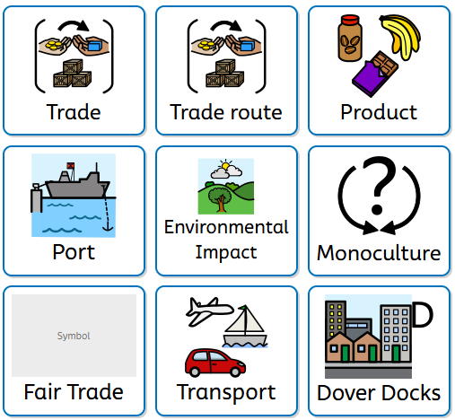  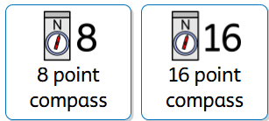 | 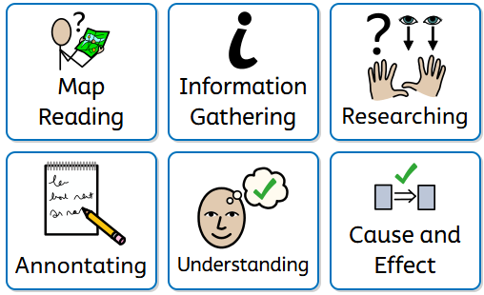 | - What is trade and why do countries trade?  - Where do the products we use come from?  - How are goods transported around the world?  - What role do ports and shipping play in global trade?  - How does trade affect people’s lives?  - What are the environmental impacts of global trade?  - Is global trade fair? | - I know why countries trade  - I know what fair trade means  - I can use maps to know that trade is global

Geography Progression Overview
Year 6
Why do natural disasters happen and how do they affect people?
Geography | National Curriculum  understand geographical similarities and differences through the study of human and physical geography of a region of the United Kingdom, a region in a European country, and a region within North or South America  identify the position and significance of latitude, longitude, the Tropics of Cancer and Capricorn, Arctic and Antarctic Circle, the Prime/Greenwich Meridian and time zones (including day and night)
Specific outcomes taught | Substantive Vocabulary | Disciplinary Vocabulary | Knowledge | Assessment  End points
 | 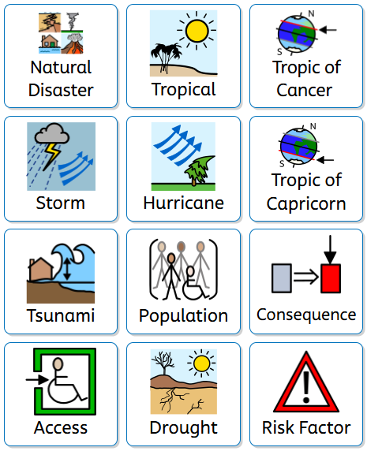 | 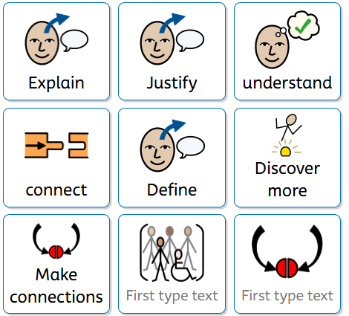 | - What causes earthquakes and why do they happen in certain parts of the world?  - How do volcanic eruptions occur and how do they change the landscape and communities?  - What causes tropical storms and hurricanes, and why are some regions more at risk than others?  - How do tsunamis form and why can they have such a devastating impact on coastal populations?  - What are the causes and consequences of droughts, and how do they affect people’s access to food and water? | - I know a range of different natural disasters  - I know what impacts natural disasters have  - I can list places in the world that face natural disasters

Geography Progression Overview
Year 6
How is Italy similar and different to the UK?
Geography | National Curriculum  locate the world’s countries, using maps to focus on Europe  use maps, atlases, globes and digital/computer mapping to locate countries and describe features studied
Specific outcomes taught | Substantive Vocabulary | Disciplinary Vocabulary | Knowledge | Assessment  End points
 | 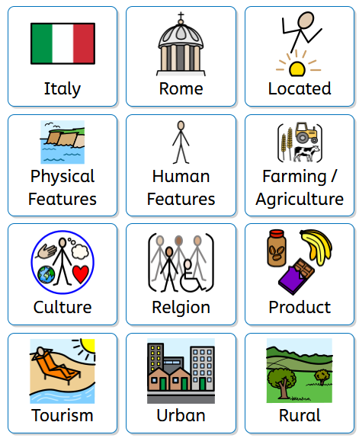  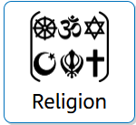 | 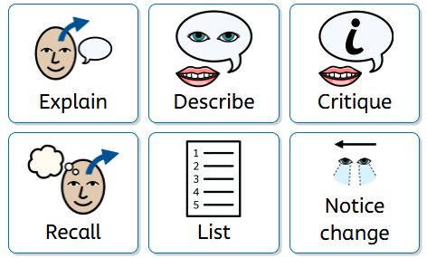 | - Where is Italy located and how does its position in Europe affect its climate and landscape?  - How do the physical features of Italy (mountains, volcanoes and coasts) compare with those in the UK?  - How does Italy’s climate differ from the UK and how does this affect daily life and farming?  - What are the main cities in Italy like, and how do they compare with major cities in the UK?  - How do people live, work and travel in Italy compared to the UK?  - What are the key similarities and differences between Italy and the UK in terms of culture, land use and tourism? | - I can use research to discover more about a place  - I know how life in other parts of Europe may differ or be similar from the Uk  - I know more about Italy’s landscape

Geography Progression Overview
Year 6
How did the British Empire change the world?
Geography | National Curriculum  understand geographical similarities and differences through the study of human geography of a region of the United Kingdom, a region in a European country, and a region within North or South America  name and locate counties and cities of the United Kingdom, geographical regions and their identifying human and physical characteristics, key topographical features (including hills, mountains, coasts and rivers), and land-use patterns; and understand how some of these aspects have changed over time
Specific outcomes taught | Substantive Vocabulary | Disciplinary Vocabulary | Knowledge | Assessment  End points
 | 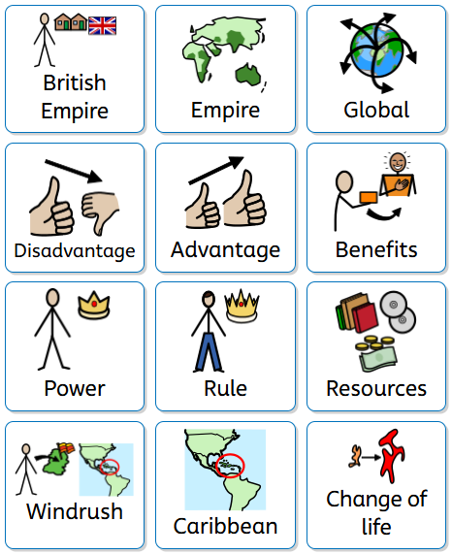  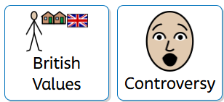 | 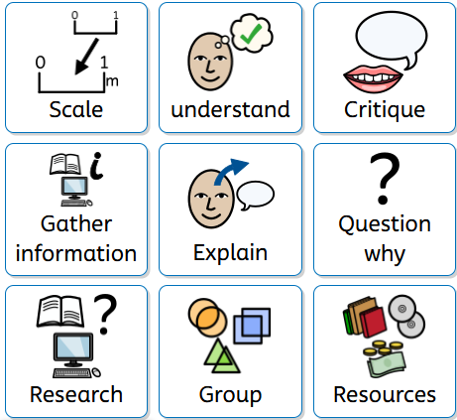 | - What was the British Empire and how did it become so large?  - Why did Britain build an empire and who benefit from it?  - How did the BE change the lives of people across the world?  - How did people respond to British rule?  - How has the BE shaped Britain today (Windrush) | - I know how places can change over time  - I can gather information to find out more about a place’s history  - I know how the British Empire has changed the lives of many across the world

