Website for young people seeking support
Company | What is it? | Website link
 | Kooth. A website which offers free, confidential support and advice. | https://www.kooth.com/
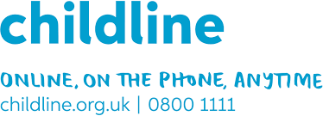 | Childline. A website offering free, confidential support and advice to children. | https://www.childline.org.uk/
 | Young Minds. A website that offers free, confidential support and advice about mental health and wellbeing. | https://youngminds.org.uk/find-help/get-urgent-help/#are-you-a-young-person-in-crisis
 | The Mix. This site offers a helpline, email, live chat, telephone counselling service and crisis text line for anyone under 25 years old wanting support. | https://www.themix.org.uk/
Websites for parents and carers seeking support
 | BBC SEND Parents’ Toolkit. A website with videos and clips to help parents to support children’s mental health and wellbeing. | https://www.bbc.co.uk/bitesize/articles/zh9v382
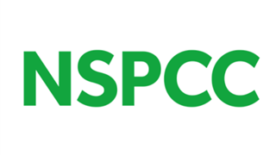 | NSPCC. A website to help keep children safe. | https://www.nspcc.org.uk/keeping-children-safe/our-services/nspcc-helpline/
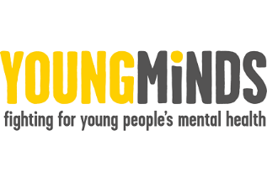 | Young Minds. A website to support young people’s wellbeing and mental health. There is a parent helpline. | https://youngminds.org.uk/contact-us/
 | Samaritans. A website, with phone number, for those who need support. | https://www.samaritans.org/
 | CAMHS Resources. This site was created for young people, carers and professionals to pool together lots of helpful resources from across the internet that are available to help support your mental health and well-being. | https://www.camhs-resources.co.uk/

